October 2nd Gathering of Leaders of Faith Formation and Youth Ministry

The next gathering for leaders of faith formation and youth ministry will be held on Thursday, October 2^{nd,} from 10:00 A.M. to 2:00 P.M. at the Nazareth Retreat House, 620 Summit Avenue, Crookston.

The topic for discussion will focus on ways to incorporate the Kerygma into our programs of Faith Formation and Youth Ministry.

Please RSVP if you plan on attending by emailing Bob Noel at bnoel@crookston.org.

There will not be a Zoom option for this gathering, but notes will be taken, and materials will be shared.

Mercy Hour | October 5th | 3:00 P.M. | St. Joseph’s Catholic Church | Ada, MN

This year’s first diocesan Mercy Hour with Bishop Cozzens will be hosted by Saint Joseph’s Catholic Church in Ada, MN. Please see the announcement below:

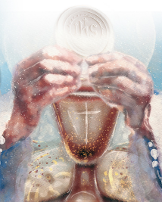
Saint Joseph's Catholic Church in Ada invites you to a Mercy Hour with Bishop Cozzens on Sunday, October 5th, at 3:00 PM. Mercy Hours are services of healing for individuals and families. Mercy Hours include exposition/adoration of the Blessed Sacrament, a talk by Bishop Cozzens, prayers and intercessions, music, and prayer stations, all culminating in an intimate moment of a Eucharistic encounter offered for you as an individual, a couple, or as a family. Saint Joseph's Catholic Church is located at 405 E Thorpe Ave, Ada, MN 56510. All are welcome. For more information, visit www.crookston.org/mercy-hours

Led by the Spirit Presentation for High School Youth

The Office of Missionary Discipleship invites you and your high school youth to a special presentation on Wednesday, October 29, at the Cathedral of the Immaculate Conception in Crookston.

Georgia Clarke, the Director of Youth Ministry at St Elizabeth of Portugal and Project Manager for Parish Renewal within the Archdiocese of Southwark, United Kingdom, will lead a special presentation on what it means to be docile to the Holy Spirit.

This presentation is designed for high school students and is ideal for those preparing for the Sacrament of Confirmation.

There is no charge for this event. Please register your group. This will allow us to plan for food accurately.

Details:

Led by the Spirit Presentation for High School Youth – Special Presentation by Georgia Clarke

Wednesday, October 29th at the Cathedral of the Immaculate Conception, Crookston, MN

6:15 – 6:45 P.M. Supper will be served

7:00 P.M. Presentation by Georgia Clarke

7:30 P.M. Adoration (with special music by Becca Peralta

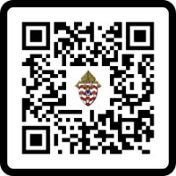
7:55 P.M. Benediction

Please register using this LINK or by scanning the QR Code:

Breaking the Mold Retreat for Leaders of Faith Formation, Catechists, and Youth Ministers

The Office of Missionary Discipleship invites you to a mid-autumn retreat, Thursday, October 30, from 9:00 A.M. to 3:00 P.M. at the Nazareth Retreat House in Crookston.

Georgia Clarke, the Director of Youth Ministry at St Elizabeth of Portugal and Project Manager for Parish Renewal within the Archdiocese of Southwark, United Kingdom, will lead us Georgia Clarke will lead us in a retreat that focuses on prayer experiences and charism discernment, while providing new, practical ways to bring these experiences to our youth in our Parish Faith Formation.

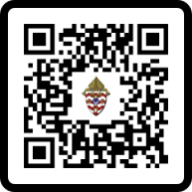
There is no charge for the retreat. There is a Wednesday evening overnight option for those who would prefer to stay at the Nazareth Retreat House the night before (at no charge).

Please register using this LINK or by scanning the QR Code:

Details

Breaking the Mold Retreat

Thursday, October 30, 2025*
9:00 A.M. – 3:00 P.M.

Nazareth Retreat House
620 Summit Avenue
Crookston, MN

*Anyone attending the retreat is welcome to stay at the Nazareth Retreat House on Wednesday evening. Please note when you register.

