HOMEBOUND MINISTRY
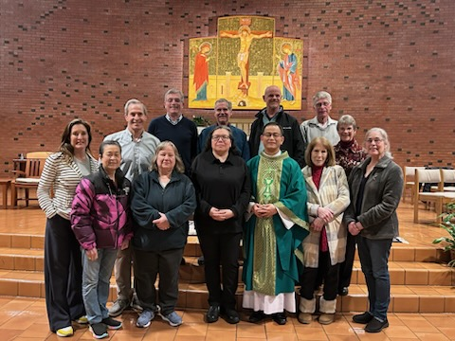
Our Homebound Ministers bring the Holy Eucharist to those in the NE Family Parish who are unable to attend Mass. This includes our seniors, the sick, and those disabled or recovering from an injury who are living at home or in a local care facility.
Homebound Ministers also provide companionship and serve as an essential link between the homebound and their parish community. This helps those who are unable to attend Mass stay connected with their parish family and allows our Eucharistic Ministers to keep a careful eye on the health and safety of our homebound friends. All of our ministers are trained and certified by the Seattle Archdiocese to work with vulnerable people.
If you are looking for an opportunity to serve our parishioners in this capacity, please contact Fr. Duc Nguyen. And if you know someone who is unable to attend Mass and wishes to receive Holy Communion, please let your parish office know!

