Dear Brothers and Sisters at Saint Andrew’s parish community,

Христос Воскрес! Christ is Risen! Saint Seraphim of Sarov greeted all he met with these words regardless of the season.

Inspired in this same conviction, followers of Jesus Christ move forward. Like believers everywhere and in all times, our daily lives in Central Asia are filled with those tasks shared by others with whom we live and work. I look so very forward to coming to visit St. Andrew’s and to continue sharing about the faith of our people with you soon.

In light of the most important element of our service, we experience the call to allow Christ to “re-found” His Church in this land. Indeed, the Jubilee Year of Hope, so inextricably linked to radical trust in God’s loving and perfect providence, urges us to keep our gaze on Christ within and before us in all things.

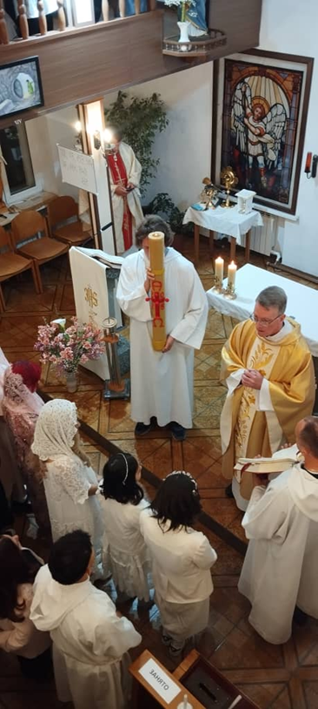
In spite of significant social and political changes here, the Catholic Church remains a small light, or germoglio (“seedling”) —as Pope Francis referred to us. With the continued emigration of many from traditional Catholic ethnic groups, the profile of Catholics is changed and, yet, renewed. Over the past weeks, we have welcomed several new Christians into the Church.

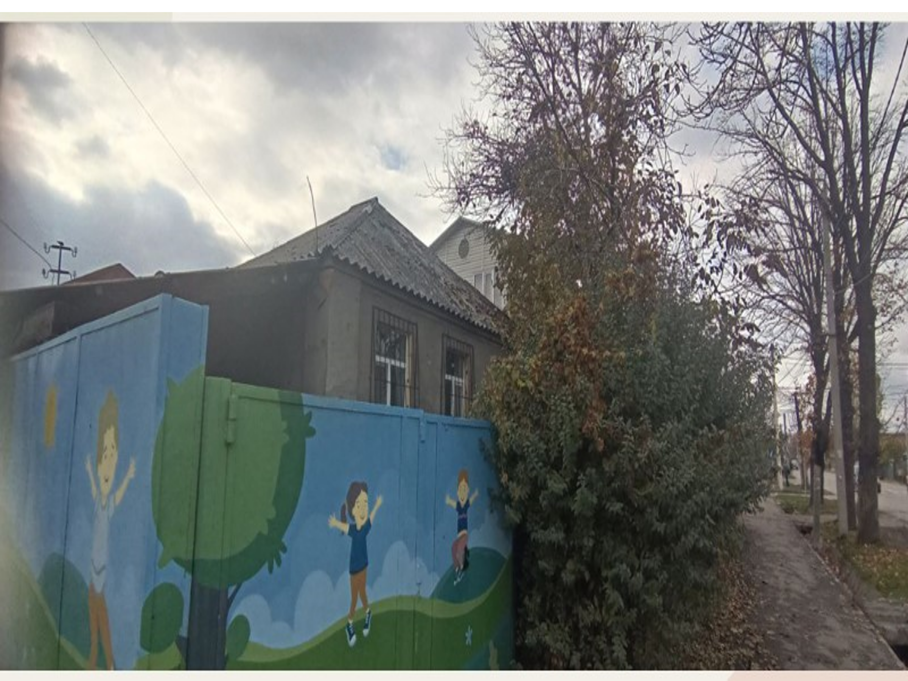
Our commitment to trust Christ in His intention to re-found the local Church has led, among other things, to the animation of the mission to the southern city of Osh—second in size within the country. As well, we are in the process of opening an early child center and kindergarten in the capital. In addition to offering the incomparable experience of Catholic formation to children and their families, this project serves as a stepping stone to the further development of Catholic education.

The assistance and support from your community play a key role in enabling some of these endeavors and in helping to make possible the operation of the mission in this country. We remain ever mindful of this generosity and express our deepest gratitude. Mass is celebrated regularly for your intentions in our parishes.

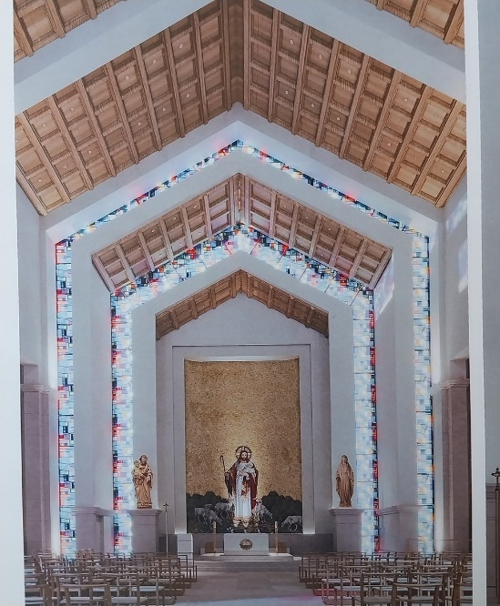
Moreover, plans to build a church in the center of the capital seek to meet a need of the Catholic community for decades. The three principal goals of this undertaking include: aiding the Church in its primary task of evangelization; assuring a greater stability vis-à-vis an increasingly challenging social and political landscape; and, making more accessible to the local population the Church’s remarkable academic, charitable, and cultural resources. Indeed, the urgency of these goals, articulated since the launching of this project, increases. Begun in mid-summer of 2024, the foundation and walls of the Good Shepherd Church and apostolic center will be completed within the next weeks. The next phase, for which we are now actively in the process of gathering support, includes roofing and necessary metallic structures. You can refer to our website to find more information, view photos, and receive ongoing updates at www.catholickg.org.

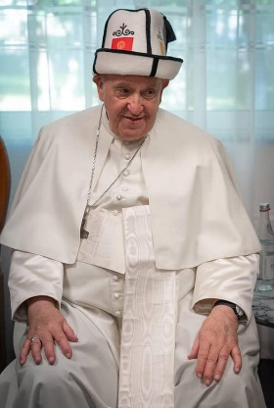
After Easter, we joined with Catholics across the world in mourning the passing of Pope Francis. In Bishkek, our community was joined by members of Muslim, Buddhist, and by Christians of other confessions in a Memorial Mass. The subsequent election of Pope Leo XIV provides a source of much consolation. Clearly, the legacy of placing mission in the center of the mind and heart of Christianity continues.

As we in Kyrgyzstan move forward, our community extends to you and your families warm greetings. Please continue to keep Christ’s Church here in your prayer, as we join together with you and others in the endeavor to better know, love, and serve Him during this time, in this land. As Saint Augustine reminds us, “’The Lord is very near; do not be anxious about anything…’. This is something tremendous, that He ascended above all the heavens but is still very near to those who dwell on earth, wherever they may be. Who can this be that is both far away and close at hand, except the one who became our near neighbor out of mercy?”

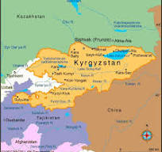
In Christ Risen,

Fr. Anthony Corcoran
Apostolic Administrator of Catholics in Kyrgyzstan
Summer 2025

