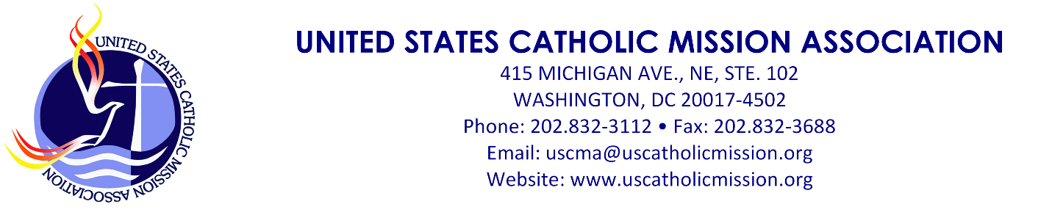
USCMA Book Service & Guidelines

USCMA receives books for review on mission-related themes. These books are offered to members for review. Attached is the current list of books available.

- Select one or two books that you are interested in reading. Send the title of those books to Ms. Nichole Petty, the USCMA Office Manager with your name and address where you can receive a UPS package. (associate@uscatholicmission.org). She will send your first choice or, if that has already been chosen, your second choice. You get to keep the book.

- You have up to three (3) months to read the book and write a review (500-750 words). Please send it in Microsoft Word, 12-point font. Please include a 2-3 sentence biography giving your current ministry or mission, what mission organization (parish, religious order, school, etc.) sponsors you, and any missions you served. Also include a picture – a headshot – that we can publish on the web. Send the review, the biography, and the picture to Ms. Petty at her email address above.

- Your review, if accepted, will be published by USCMA and forwarded to the publisher.

USCMA is pleased to make this service available to missionaries and mission leaders. Those of us in mission must continually reflect on our experiences to purify our intentions, our spirituality and theology, and our pastoral practices.

USCMA takes a broad view of the word “missionary” – anyone who witnesses to God’s reign of love, salvation and justice through word and deed. The missionary goes beyond themselves, moves outside of their comfort zone, crosses some type of border, risks a personal encounter with a stranger, and does so in the name of Jesus. In the words of Pope Francis, “mission is at once a passion for Jesus and a passion for his people.”

Introduce others you know, especially those with a missionary heart, to USCMA and our book review service. We love to get know missionaries and mission leaders.

Publishers who want to their have books reviewed are encouraged to send review copies directly to USCMA at the address above. Publishers may also promote books through USCMA. Contact Dr. Donald R. McCrabb, USCMA Executive Director, for advertisement and sponsorship options. His email address is dmccrabb@uscatholicmission.org.
 | Edmund Kee-Fook Chia, World Christianity encounters World Religions, Orbis Books, 2018
Sermons and Speeches of Rev. Jesse L Jackson SR. Keeping Hope Alive, Orbis Books, 2020 | John C Cort, Christian Socialism, Orbis Books, 1988
Jim Forest, Writing Straight with Crooked Lines: A memoir, Orbis Books, 2020 | Rabbi Zalman Schachter-Shalomi, Essential Teachings
Jon M Sweeney, Jesus Wasn’t Killed by The Jews: Reflections for Christians in Lent, Orbis Books, 2020 | Peter C Phan, The Joy of Religious Pluralism,  Orbis Books, 2017
Carlo Maria Marini, Once More From Emmaus, Orbis Books,1995 | James Martin SJ, This Our Exile: A Spiritual Journey With the Refugees of East Africa, Orbis Books,1999
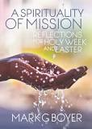Mark G Boyer A Spirituality of Mission Reflections for Holy Week and Easter, Orbis Books 2017 | 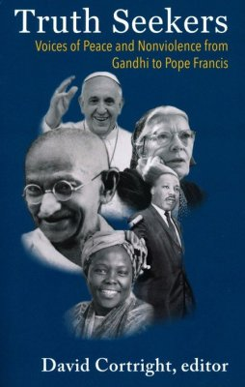 David Cortright. Truth Seekers: Voices of Peace and Nonviolence from Gandhi to Pope Francis Orbis Books, 2020, 9/14/2020
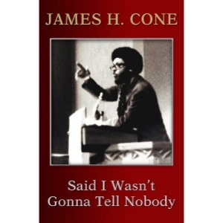 James H. Cone. Said I Wasn’t Gonna Tell Nobody: The Making of a Black Theologian , Orbis Books, 2018, 9/3/20 | 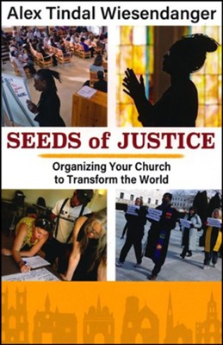 Alex Tindal Wiesendanger, Seeds of Justice: Organizing Your Church to Transform the World, Orbis, 2020, 9/3/20
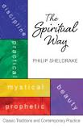Philip Shedrake. The Spiritual Way, Orbis Books,2019 | 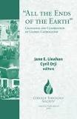Jane E. Linahan and Cyril Orji. “All the Ends of The Earth” Challenge and Celebration of Global Catholicism, Orbis Books, 2019
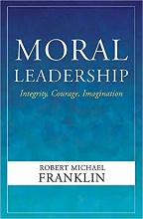 Robert Michael Franklin, Moral Leadership: Integrit, Courage, Imagination, Orbis, 2020, 9/3/20 | 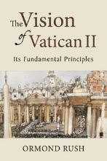 Ormond Rush, The Vision of Vatican ii: Its Fundamental Principles, Liturgical Press Academic, 2019, 9/3/20
Books for Review
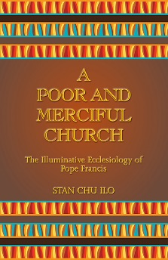

Stab Chu Ilo, A Poor and Merciful Church: The Illuminative Ecclesiology of Pope Francis, Orbis Books, 2018

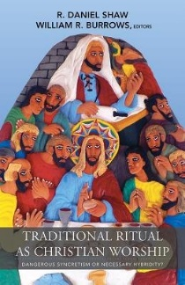
R. Daniel Shaw and William R Burrows, Traditional Ritual as Christian Worship: Dangerous Syncretism or Necessary Hybridity, Orbis Books, 2018

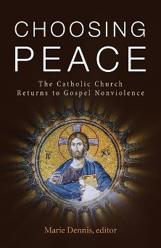
Marie Dennis, Choosing Peace the Catholic Church Returns to Gospel Nonviolence, Orbis Books, 2018

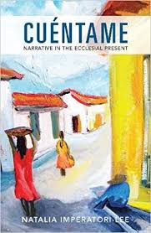
Natalia Imperatori-Lee Cuentame Narrative in the Ecclesial Present, Orbis Books, 2018

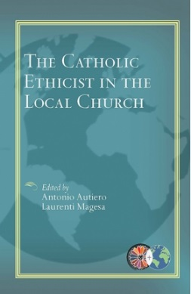
Antonio Autiero, Laurenti Magesa, The Catholic Ethicist in The Local Church, Orbis Books, 2018

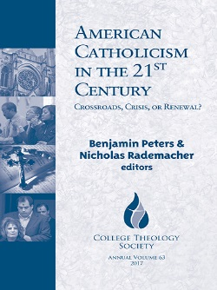
Benjamin T Peters, Nicholas Rademacher, American Catholicism in the 21st Century Crossroads, Crisis, or Renewal, Orbis Books, 2018

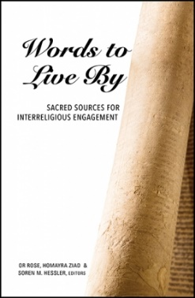
Or N. Rose, Homayra Ziad, & Soren M. Hessler, Words to Live By, Orbis Books, 2018

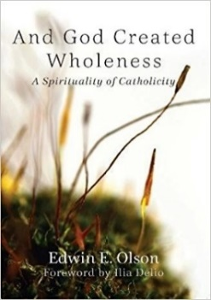
*Featured Book (June 2019)
Edwin E. Olson, And God Created Wholeness a Spirituality of Catholicity, Orbis Books, 2018
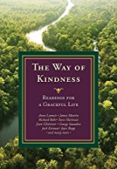
Anne Lamott, James Martin, Richard Rohr, Steve Hartman, Joan Chittister, George Saunders, Jack Kerouac, Joyce Rupp, The Way of Kindness Reading for a Graceful Life, Orbis Books, 2018

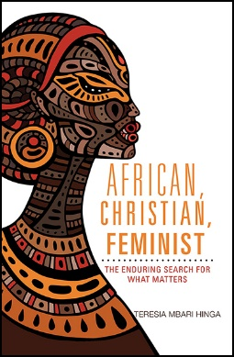
Teresa Mbari Hinga, African, Christian, Feminist, Orbis Books, 2017

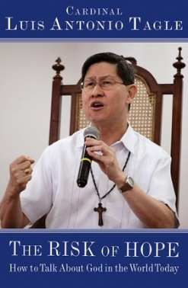
Cardinal Luis Antonio Tagle, The Risk of Hope, Orbis Books, 2018

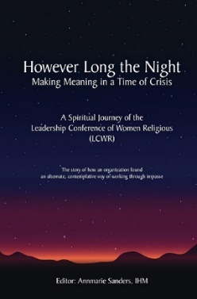
Annmarie Sanders, IHM, However Long the Night: Making Meaning in a Time of Crisis, Leadership Conference of Women Religious, 2018

John Dear, They Will Inherit the Earth, Orbis Books, 2018

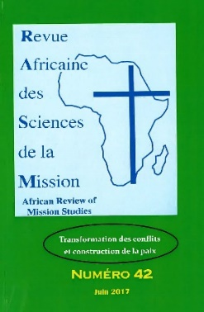
African Review of Mission Studies, Revue Africaine des Sciences de la Mission, Baobab, 2017

Peter C. Phan, Asian Christianities: History, Theology, Practice, Orbis Books, 2018

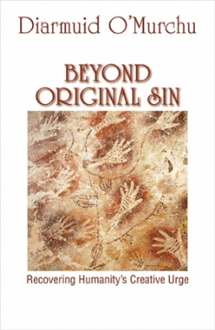
Diarmuid O’Murchu, Beyond Original Sin: Recovering Humanity’s Creative Urge, Orbis Books, 2018

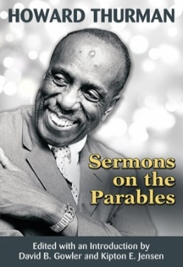
Howard Thurman, Sermons on the Parables, Orbis Books, 2018

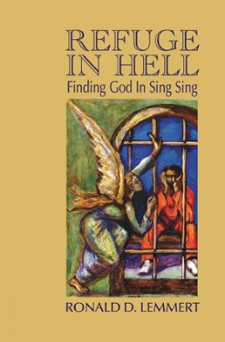
Ronald D. Lemmert, Refuge in Hell: Finding God in Sing Sing, Orbis Books, 2018

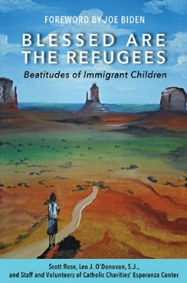
Joe Biden, Blessed are Refugees, Beatitudes of Immigrant Children, Orbis Books, 2018

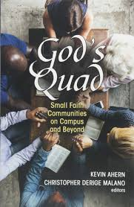
Ahern Malano, God’s Quad: Small Faith Communities on Campus and Beyond, Orbis Books, 2018

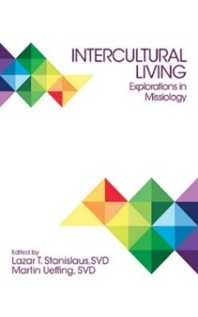
*Featured Book (February 2019)
Lazar T. Stanislaus, SVD Martin Ueffing, SVD, Intercultural living: Explorations in Missiology, Orbis Books, 2018

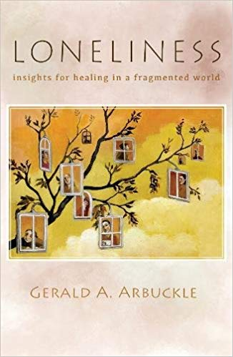
*Featured Book (May/March 2019) Gerald A. Arbuckle, Loneliness: Insight for healing in a fragmented world, Orbis Books, 2018

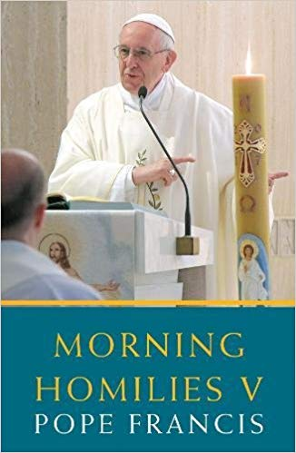
Pope Francis, Morning Homilies V, Orbis Books, 2018

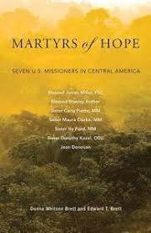
Brett and Brett, Martyrs of Hope: Seven U.S. Missionaries in Central America, Orbis Books, 2018
Lynd & Lynd, Nonviolence in America, Orbis Books, 2018

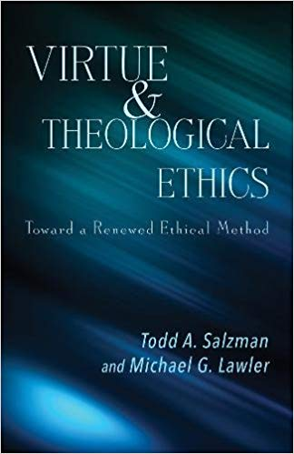
Salzman/ Lawler, Virtue & Theological Ethics, Orbis Books, 2018

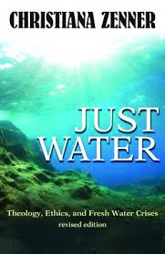
Christiana Zenner, JustsWater, Orbis Books, 2018

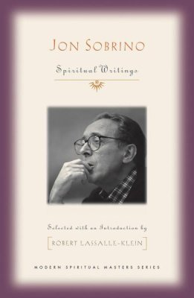
Jon Sobrina, Spiritual Writings, Orbis Books, 2018

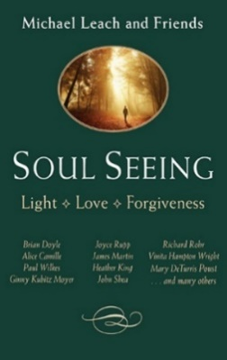
Michael Leach and Friends, Soul Seeing, Orbis Books, 2018

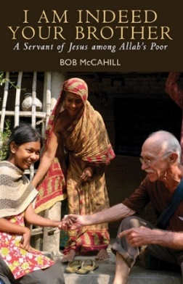
Bob McCahill, I am Indeed Your Brother, Orbis Books, 2018

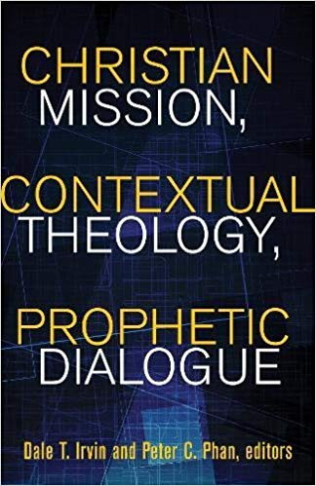
Dale T. Irvin and Peter C. Phan, Christian Mission, Contextual Theology, Prophetic Dialogue, Orbis Books, 2018

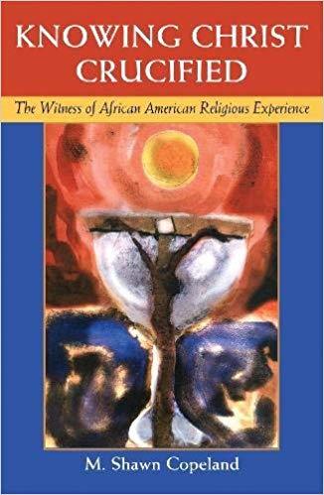
M. Shawn Copeland, Knowing Christ Crucified, Orbis Books, 2018

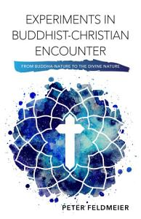
Peter Feldmeier, Experiments in Buddhist- Christian encounter form Buddha-Nature to the divine nature, Orbis Books, 2019

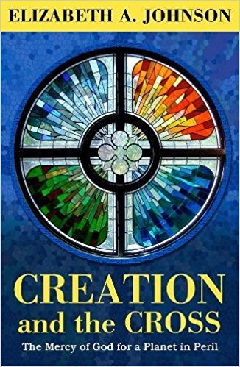
Elizbeth A. Johnson, Creation and the Cross the Mercy of God for a Planet in Peril, Orbis Books, 2019

Elizabeth McAnally, Loving Water Across Regions Contributions to an Integral Water Ethic, Orbis Books, 2019
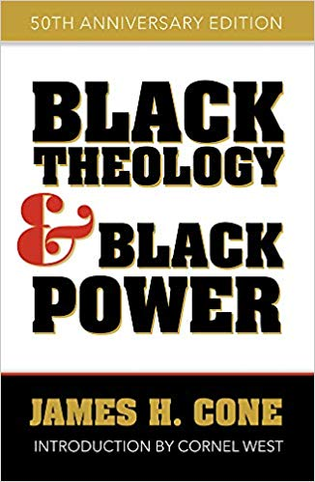
James H. Cone Introduction by Cornel West, Black Theology and Black Power, Orbis Books, 2019

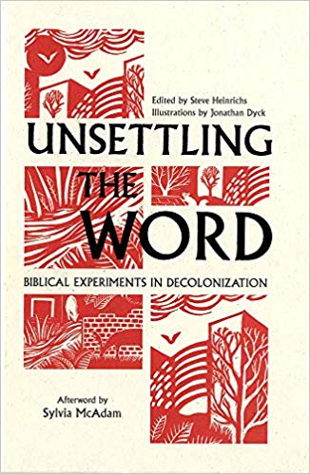
Sylvia McAdam, Unsettling Word, Orbis Books, 2019

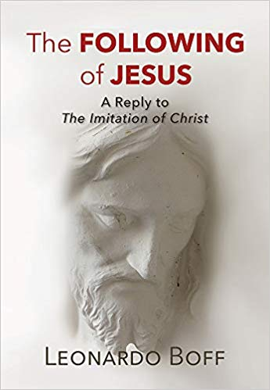
Leonardo Boff, The Following of Jesus, Orbis Books, 2019

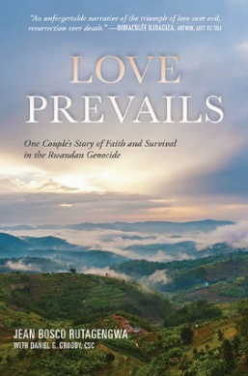
Jean Bosco Rutagengwa & Daniel G. Groody, Love Prevails, Orbis Books, 2019

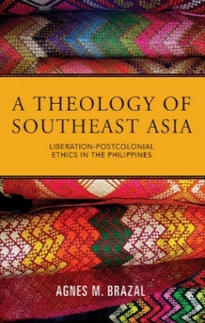
Agnes M. Brazal, A Theology of Southeast Asia, Orbis Books, 2019

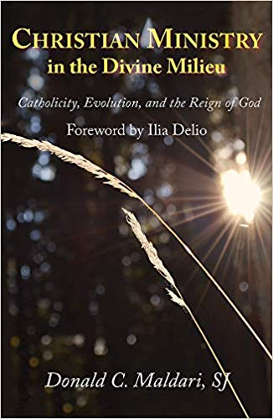
Donald C. Maldari, Christian Ministry in the Divine Milieu, Orbis Books, 2019

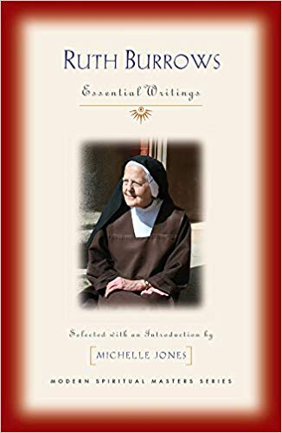
Michelle Jones, Ruth Burrows, Orbis Books, 2019

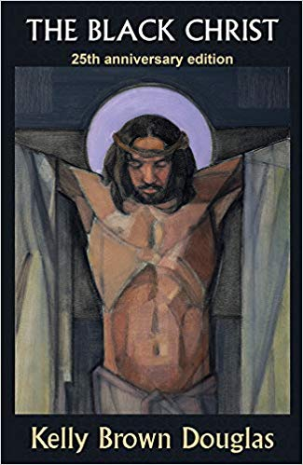
Kelly Brown Douglas, The Black Christ 25th Anniversary edition, Orbis Books, 2019

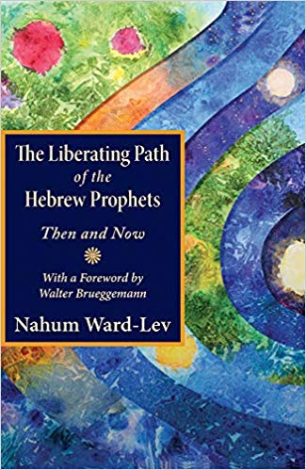
Nahum Ward-Lev, The Liberating Path of the Hebrew Prophets Then and Now with a Foreword by Walter Brueggemann, Orbis Books, 2019

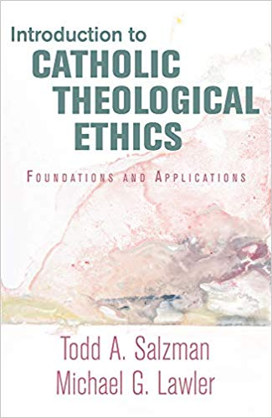
Todd A. Salzman, Michael G. Lawler, Introduction to Catholic Theological Ethics Foundation and Applications, Orbis Books, 2019

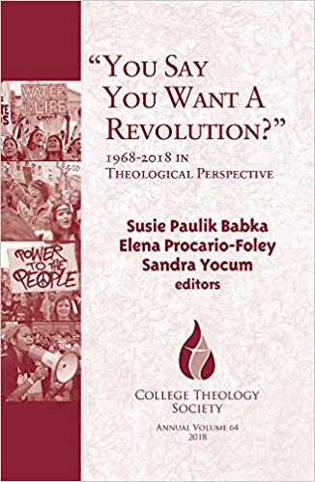
Susie Paulik Babka, Elena Procario-Foley, Sandra Yocum, “You Say You Want A Revolution?” 1968-2018 in Theological Perspective, Orbis Books, 2019

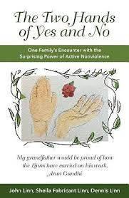
John Linn, Sheila Fabricant Linn, Dennis Linn, The Two Hands of Yes and No, Orbis Books, 2019
Paul Hertig, Young Lee Hertig, Sarita Gallagher Edwards, Robert L. Gallagher, Breaking through the Boundaries Biblical Perspectives on Mission from the Outside In, Orbis, 2019

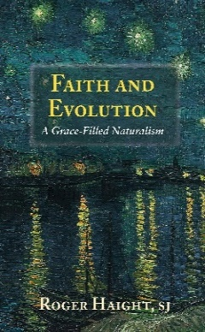
Roger Haight, SJ, Faith and Evolution A Grace-Filled Naturalism, Orbis Books, 2019

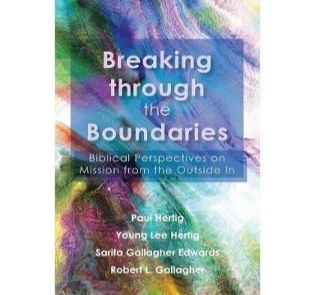
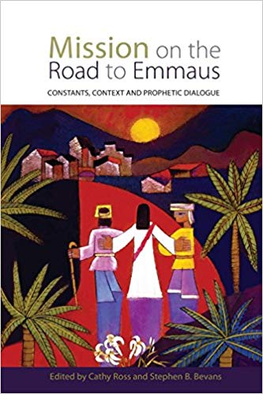
Paul Hertig, Young Lee Hertig, Sarita Gallagher Edwards, Robert L. Gallagher, Breaking through the Boundaries Biblical Perspectives on Mission from the Outside In, Orbis, 2019
Cathy Ross and Stephen B Bevans, Mission to Emmaus Constant, Context, and Prophetic Dialogue, Orbis Books, 2015

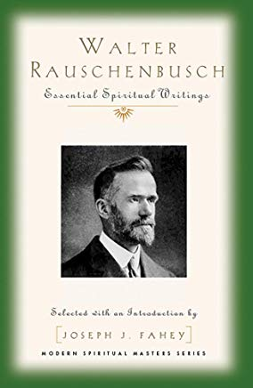
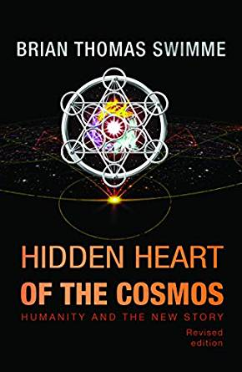
Brian Thomas Swimme, Hidden Heart of the Cosmos: Humanity and the New Story, Orbis Books, 2019
Joseph J. Fahey, Walter Rauschenbusch Essential Spiritual Writing, Orbis, 2019

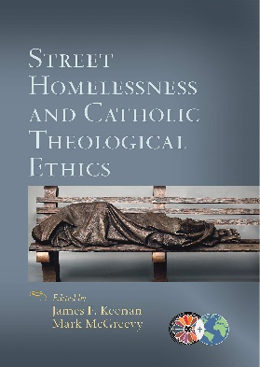
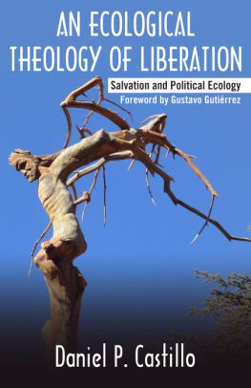
James F. Keenan, Mark McGreevy, Street Homelessness and Catholic Theology Ethics, Orbis Books, 2019
Daniel P. Castillo, An Ecological Theology of Liberation, Orbis Books, 2019

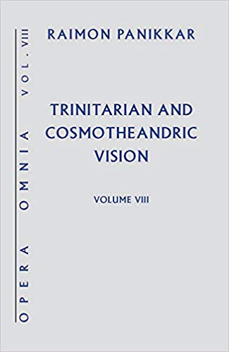
Raimon Panikkar, Trinitarian and Cosmotheandric Vision, Orbis Books, 2019

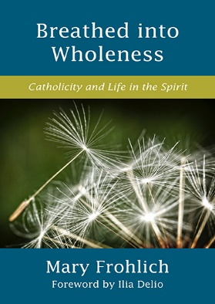
Mary Frohlich and Ilia Delio, Breathed into Wholeness, Orbis Books, 2019

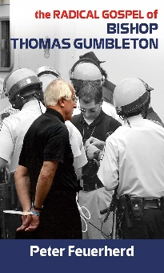
*Featured Book (August 2020)
Peter Feuerherd, The Radical Gospel of Bishop Thomas Gumbleton, Orbis Books, 2020

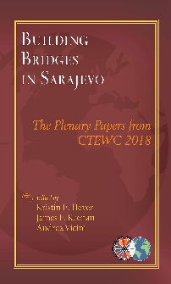
*Featured Book (July 2020)
Heyer/ Keenan/ and Vicini, Building Bridges in Sarajevo, Orbis Books, 2020

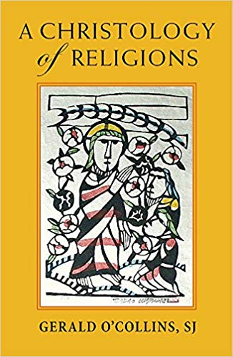
Gerald O’ Collins, SJ, A Christology of Religions, Orbis Books, 2018

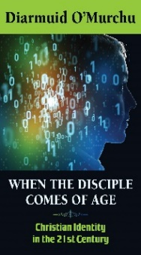
*Featured Book (November 2019)
Diarmuid O’Murchu, When the Disciple Comes of Age, Orbis Books, 2019

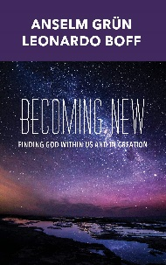
*Featured Book (September 2019)
Anselm Grun and Leonardo Boff, Becoming New: Finding God Within Us and in Creation, Orbis Books, 2019

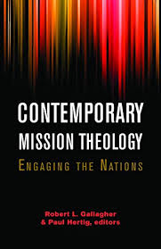
Robert L. Gallagher & Paul Hertig, editors, Contemporary Mission Theology, Orbis Books, 2017

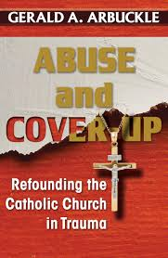
*Featured Book (December 2019) Gerald A. Arbuckle, Abuse and Cover up: Refunding the Catholic Church in Trauma, Orbis Books, 2019

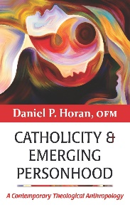
*Featured Book (October 2019) Daniel P Horan, OFM, Catholicity & Emerging Personhood: A Contemporary Theological Anthropology, Orbis Books, 2019

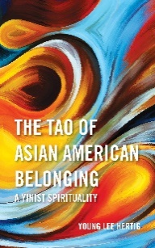
*Featured Book (August 2019) Young Lee Hertig, The Tao of Asian American Belonging – a Yinist Spirituality, Orbis Books, 2019

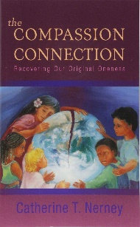
*Featured Book (April 2019) Catherine Nerney, SSJ, The Compassion Connection: Recovering Our Original Oneness, Orbis Books, 2019

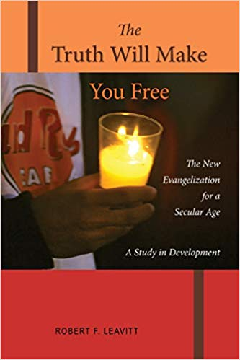
*Featured Books (February 2019)
Robert F. Leavitt, The Truth Will Make You Free

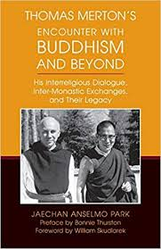
*Featured Books (March 2019) Jaechan Anselmo Park Thomas Merton's Encounter with Buddhism and Beyond, His Interreligious Dialogue, Inter-Monastic d Exchanges, and Their Legacy

James H. Kroeger, MM, Asia’s Dynamic Local Churches, Serving Dialogue and Mission, 2014

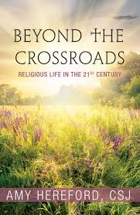
Amy Hereford, CSJ, Beyond the Crossroads, Religious Life In the 21st Century, Orbis Books 2019

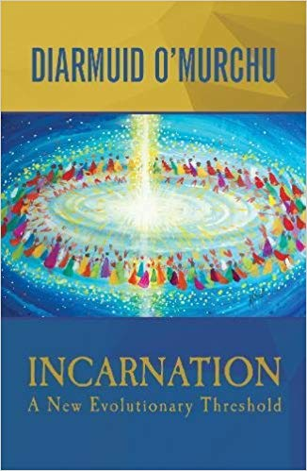
Diarmuid O’Murchu, MSC, Incarnation A New Evolutionary Threshold, Orbis Books 2017

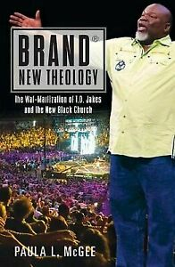
Paula L. McGee, Brand New Theology-The Wal-Martization of T.D. Jakes and the New Black Church, Orbis Books 2017

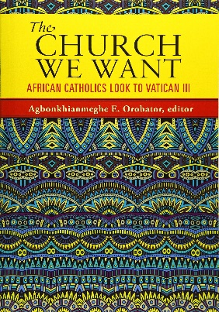
Agbonkhianmeghe E. Orobator, editor, The Church We Want, African Catholics Look to Vatican III, Orbis Books 2016

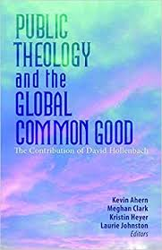
Kevin Ahern, Megan J. Clark, Kristin E. Heyer, Laurie Johnston Editors, Public Theology and the Global Common Good, The Contribution of David Hollenbach, S.J, Orbis Books 2016

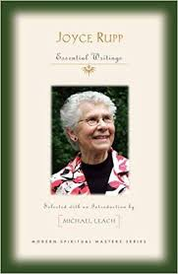
Michael Leach,
Joyce Rupp Essential Writings Selected with an Introduction, Modern Spiritual Masters Series, Orbis Books 2017

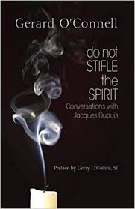
Gerald O'Connell, Preface by Gerald O'Collins, SJ, do not Stifle the Spirit, Conversations with Jacques Dupuis, Orbis Books 2017

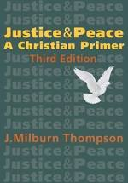
J. Milburn Thompson,
Justice & Peace A Christian Primer Third Edition Orbis Books 2019

Jim Forest, At Play in the Lions’ Den A Biography and memoir of Daniel Berrigan, Orbis Books, 2017
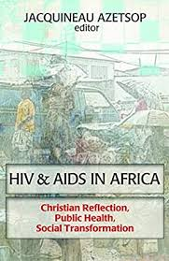
Jacquineau Azetsop editor, HIV & AIDS in Africa, Christian Reflection, Public Health, Social Transformation, Orbis Books 2016

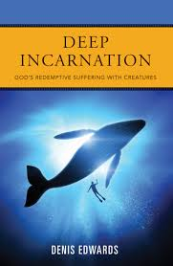
Denis Edwards, Deep Incarnation, God's Redemptive Suffering with Creatures, Orbis Books 2019

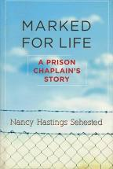
Nancy Hastings Sehested, Marked for Life, A Prison Chaplain's Story, Orbis Books 2019

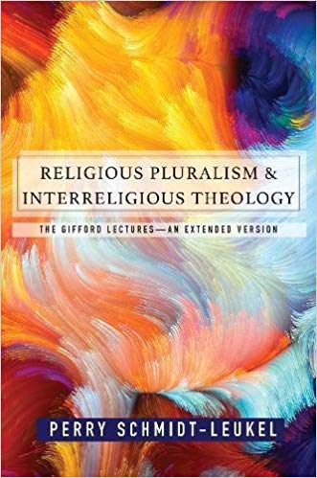
Robert Ellsberg, A Living Gospel, Reading God's Story in Holy Lives, Orbis Books 2019

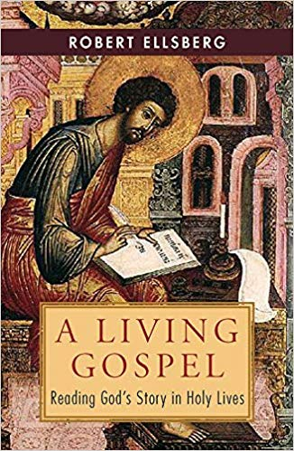

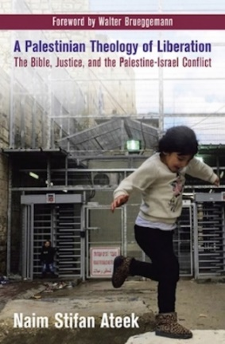
Naim Stifan Ateek, A Palestinian Theology of Liberation The Bible, Justice, and the Palestine-Israel Conflict, Orbis Books 2017
Robert J. Priest and Kirimi Barine, African Christian Leadership Realities, Opportunities, and Impact, Orbis Books, 2017
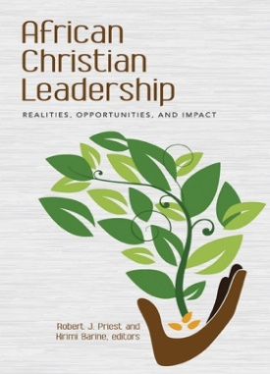
Perry Schmidt-Leukel, Religious Pluralism & Interreligious Theology, Orbis Books, 2017

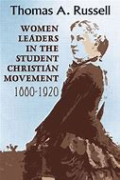
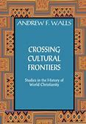
Thomas A. Russell, Woman Leaders in the Student Christian Movement, Orbis Books 2017
Andrew F. Walls, Crossing Cultural Frontiers, Orbis Books 2017

