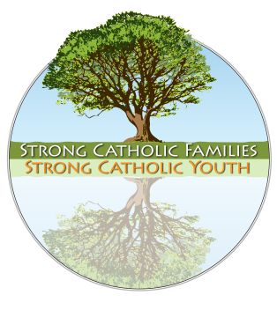
A1: Parent Response Form
Strong Catholic Families: Strong Catholic Youth
Partnering with Parents to Bring Home the Faith
Completing this form does not obligate you to anything
nor add you to any mailing list
Full Name
Address
City/State/ZIP Code
Parish E-Mail
Day Phone Cell Phone
Check those that apply:
- I am interested in meeting with other parents for sharing ideas and support. Please contact me as groups begin to form.
- I am interested in helping our parish plan some follow-up steps to creating Strong Catholic Families and Youth.
- I am interested in receiving resources (print/electronic/e-mail) to help me parent my children in the faith.
- I am interested in becoming more involved in our church:  for myself  with my family
❍ Additional comments or ideas you wish to communicate to the leadership of the parish:

Please rate today’s Parent Presentation:
Poor Ok Good Very Good
Presenter    
Content of Presentation    

One thing I learned (or was reminded of) in this presentation

One thing I (or my family) might do differently because of what I heard today:

“The joys and the hopes, the griefs and the anxieties of the people of this age, especially those who are poor or in any way afflicted, these are the joys and hopes, the griefs and anxieties of the followers of Christ. Indeed, nothing genuinely human fails to raise an echo in their hearts.”
Pastoral Constitution on the Church in the Modern World, Vatican, Dec. 7, 1965

Take a few moments to help us to better support and partner with you…

Our Catholic Church and faith are here to support you with your children, your family, and in our parish community. This means that whatever you are dealing with matters to the church. We are here to celebrate what is working and to walk with you as you face life’s expected and unexpected challenges.

Please let us know how we can be more supportive of you and your family by checking the area(s) below. If you check any of the following, we will respond to you directly and confidentially. May God bless you and your family and know that our love, prayers, and support are with you!

___ Building family traditions
___ Family prayer resources
___ Doing service for others with my children
___ Ways to volunteer in our community
___ Talking about faith and morals at home
___ Alcohol, drugs, and addiction issues
___ Dating and adolescent sexuality
___ Websites, books, & family resources
___ Making moral decisions in our family
___ Dealing with loss and grief
___ Support for my marriage
___ Family counseling resources
___ Need a parent support group
___ Stress and time management
___ Domestic violence
___ Understanding the other generation
___ Health needs for family or extended family
___ Support for single parents
___ Support for blended families
___ Support for incarcerated family members

Other requests or needs:

What is the best way to reach you during the day?
- Phone
- E-Mail
- Other:

