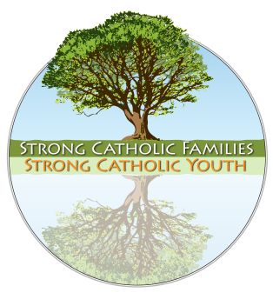
D-2: Parish/School
Coordinator’s Manual

Partnering with Parents to Bring Home the Faith

Introduction
Supporting parents in their role as heads of their domestic churches and primary facilitators of faith for their families has the potential to transform ministry within parishes and schools. The Strong Catholic Families: Strong Catholic Youth (SCF) process also will help you engage the faith community in an ongoing reflection on and assessment of how best to serve the families, parents, and young people of your community. As their needs are met, other needs certainly will surface. In this light, we offer the following process that will be reviewed with you by your diocesan consultant.

Table of Contents

Overview of the Strong Catholic Families Process 1-6
Appendix D2-1: SCF Team and Leadership Reflection Process 7-9
Appendix D2-2: Family Impact Questions 10
Appendix D2-3: Initial Inquiry and Assessment Reflection 11-12
Appendix D2-4: SCF Information Flyer 13
Appendix D2-5: Parent Response Form 14-15
Appendix D2-6: Follow-Up Session A: Parent Listening Session 16-19
Appendix D2-7: Follow-Up Session B: Living and Sharing Your Faith 20-21
Appendix D2-8: Follow-Up Session C: Intergenerational Dialogue 22-27

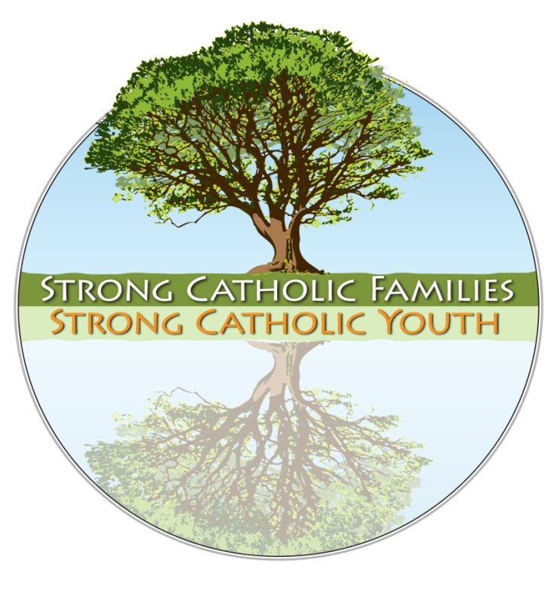
Overview of the Strong Catholic Families Process
The Strong Catholic Families: Strong Catholic Youth process is made up of four distinct steps that lead to numerous avenues of faith growth within families and the entire faith community.

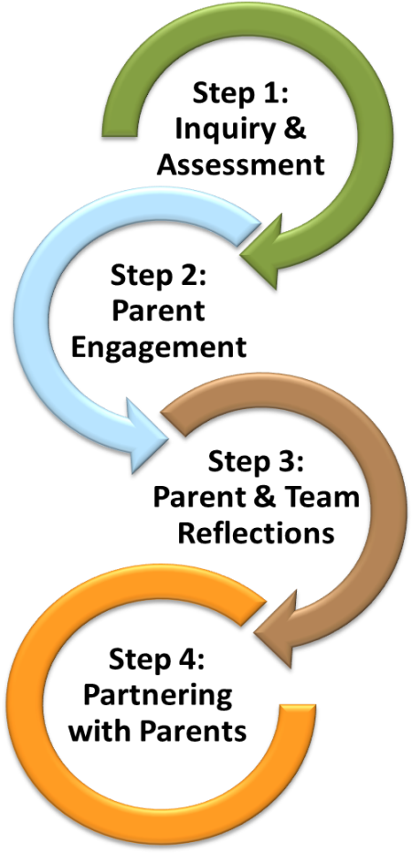
- Step 1. Inquiry and Assessment: The process begins with your leadership meeting with a diocesan consultant, who presents an overview of the Strong Catholic Families dynamic and assists the leadership in assessing your readiness to begin, as well as the impact this direction will have upon current programming and structures. Once the leadership is prepared to make this initial commitment, it begins to recruit a local Strong Catholic Families Team, composed of leaders, parents, and staff to prepare for the next steps outlined below.

- Step 2. Parent Engagement: A trained presenter provides one or more high-impact SCF Foundational Parent Presentations, including contemporary research, combined with engaging visuals, and pertinent stories to help parents understand their critical role in forming family faith.
Your SCF Team holds follow-up meetings to engage parents further in conversations about their needs and concerns, and practical strategies for growing in faith as a family.

- Step 3. Parent & Staff Reflections: Involves additional critical reflection and discernment by all involved—staff, leaders, parents, and your SCF Team—using input from Step 2 to develop next steps that will result in closer partnerships with parents in reaching the goal of empowering and supporting families to grow in faith.

- Step 4. Partnering with Parents: This is an ongoing and evolving movement of developing and implementing new strategies, further reflection and assessment, and continued commitment to supporting the partnership between the institutional church (parishes and schools) and the domestic church. This continues as more and more families become empowered to grow in their Catholic faith.

A Closer Look at the Strong Catholic Families Four-Step Process…

Step 1. Staff Inquiry and Assessment

- Initial Consultation(s)
Once a parish/school determines its interest in exploring the Strong Catholic Families process, it contacts the diocesan coordinator to schedule consultation(s) that include(s) key leaders of the parish/school. The goal of the consultations and assessment is for leaders to come to understand the Strong Catholic Families process, to have any questions or concerns addressed, and to determine the leadership’s readiness to move forward.
Prior to any onsite consultation(s), staff/key leaders are asked to spend time individually with the Inquiry and Assessment Reflection (Appendix D2-3). This is used by the consultant to help leaders assess their receptivity and readiness for becoming a Strong Catholic Families community. The consultation(s) consist(s) of conversations with key leaders and may include the full or abbreviated versions of the SCF Leadership PowerPoint Presentation, which highlights both the key aspects of the research presented in the SCF Foundational Parent Presentation, as well as a critical call to build a parent-equipping, family-centered parish or school.

- Development of your Strong Catholic Families Team
Should the leadership agree to make this commitment to become a Strong Catholic Families community or school, the next step is to recruit a Strong Catholic Families Team to lead this long-term initiative. The SCF Team is composed of six to ten people, comprised of staff, parents, and other parish/school leaders whose gifts will help contribute to the overall success of the initiative. This team then begins preparing for the SCF Foundational Parent Presentation(s) and the subsequent extended Parent Listening Session (Appendix D2-6) outlined in Step 2.

Step 2. Parent Engagement

- Hosting the SCF Foundational Parent Presentation(s)
The initial movement in engaging parents occurs through the two-hour SCF Foundational Parent Presentation(s), which are conducted in your local community by a diocesan presenter, and the follow-up Parent Listening Session(s), scheduled within two to three weeks of the SCF Foundational Parent Presentation(s), and conducted by your SCF Team. Sessions welcome all parents/grandparents as well as other interested adults.
The SCF Foundational Parent Presentation(s) focus on the current situation families face in rearing Catholic children and teens today and provide an important time for the leadership and your SCF team to listen to parents’ needs, concerns, and hopes. In order to engage a wide array of parents, including those who typically would not choose to attend such a presentation, many parishes choose to require all parents whose children are enrolled in any sacramental program (baptism through confirmation). Presentations may be offered as often as necessary to reach all parents, and ideally would be offered annually as a way of engaging new parents and community members. In this way, the leadership is assured of reaching as many parents as possible—the more who get the message, the more impact it will have. Schools may choose to use the SCF Foundational Parent Presentation(s) as part of school year kickoff gatherings with parents, parent-teacher organization gatherings, and/or other special parent gatherings. In school settings, as in parish settings, including a presentation in a mandatory parent gathering can have far broader impact.
Room Set-Up for SCF Foundational Parent Presentation(s): SCF Foundational Parent Presentation(s) require an LCD projector, large screen or blank wall area, an extension cord, plus a lectern and microphone (if warranted by the space and number of participants). The screen or wall area should be large enough (minimum of seven feet) and high enough so that all attending will have a good view. The presenter will supply the laptop computer and PowerPoint presentation.

Materials Needed:
- One each of the Family Faith Resource Booklet (A2) and Table Tent Prayer Card (A3) per family.
- One copy of the Parent Response Form (A1) and a pen/pencil per person.

In addition to organizing refreshments and making copies of handouts, the SCF Team should consider the importance of having parish/school leadership in attendance:
- Parish: Pastor, priests, deacons, staff members, catechists and ministry team members in parish faith formation, pastoral council members, finance council members, and other committees and organizations (e.g., Knights of Columbus, athletics, scouting, etc.) who are engaged in serving the youth and families of your parish community.
- School: Pastor (in parish schools), principal, administrative staff, faculty members, campus ministers, guidance counselors, etc.

- Parent Response Forms and Follow-Up Sessions
Toward the end of each SCF Foundational Parent Presentation that is offered, the presenter will invite the parents to complete a Parent Response Form (Appendix 5), which serves as an important source of information to the leadership and the SCF Team with regard to what parents need to help their families grow in faith as the domestic church of the home. (Important: the forms may elicit information about critical and immediate pastoral needs, so it is vital that leaders review them immediately so as to respond appropriately.)
The presenter, or a member of the local SCF Team, will then announce the date and time of the Parent Listening Session (or multiple sessions), an extended listening session to allow parents more opportunity to talk, pray, and share with one another about their experiences, frustrations, and success stories in parenting and passing on the faith. At this session, the local SCF Team also will report back to the parents what it has heard from them (via the Parent Response Forms and subsequent conversations) and what initial supportive responses the SCF Team is contemplating.

- Parent Listening Session(s)
These listening sessions (found in Appendix 6) typically are led by your SCF Team. The primary goal is to actively listen to parents and, using the Family Faith Inventory found in the Family Faith Resource Booklet, assist parents in discerning what initial steps they want to take in order to grow in faith as a family. These sessions may yield many ideas, suggestions, and needs, so it is important that the SCF Team actively listen and reflect back what they are hearing without trying to problem-solve, counsel, or advise. The SCF Team will share an initial summary of the responses to the Parent Response Forms as a way of building on the energy and positive forward direction that has been generated through the process thus far. The SCF Team should let the parents know that they will be meeting afterward to plan next steps based on what they learn at the session(s).

Step 3. Parent and Leadership/SCF Team Reflections

- Parent Home-Based Reflections
All parents will be encouraged to complete the Family Faith Inventory and Family Faith Plan found on pages 8-11 in the Family Faith Resource Booklet. This may be completed at home or during the follow-up sessions. This assessment allows parents to determine their family’s starting point for how they want to nurture faith within their family. Encouragement and follow-up from leadership and ongoing reference to each family’s faith plan will help families follow through on their covenants to grow stronger in their Catholic faith.

- Leadership/SCF Team-Based Reflections
After the listening session(s), the SCF Team and other leaders gather to pray, discuss, and plan, based on the Parent Response Forms and the feedback gleaned from the listening session(s) using the suggested process found in Appendix 1. Special attention should once again be given at this time to any critical and immediate pastoral needs.
This process is designed to help leaders dream and prepare for the next steps in responding to parents’ needs and to further the mutual partnership with parents. We anticipate that in Strong Catholic Families parishes and schools, the steps of listening and responding will be repeated over the years as more parent sessions are held, fresh needs emerge, and pioneering approaches give rise to new paths of partnership and support. Please contact your diocesan consultant if you have any questions about using this process or need outside assistance in facilitating your SCF Team.

Step 4. Partnering with Parents

- Ongoing Efforts & Evolution
As your SCF Team partners with parents to reflect, assess, develop, and implement new strategies, your parish/school will become more and more family-centered over time, and children reared in your families will grow more firmly grounded in their faith.

- Sharing Effective Practices
One of the ways that the Strong Catholic Families national initiative continues to grow and develop is through the sharing of effective practices among all parishes, schools, and dioceses that make up the national SCF network. As you develop effective approaches, strategies, and structures that support and enhance the development of faith growth within families, we ask that you share them with the network by e-mailing Michael Theisen (miket@nfcym.org) using the following format:
- Title: Approach, strategy, or structure you have created
- Audience: Diocesan, parish, school leaders, presenters, parents, etc.
- Contact: Name, location, e-mail, and daytime phone that people can use to reach you for more information
- Description: Include a sentence or two about this and attach any Word documents, PDFs, website links, or video/audio files that may be posted and shared with others

Visit the Effective Practices Website: http://www.nfcym.org/family/training/SCFPractices.htm
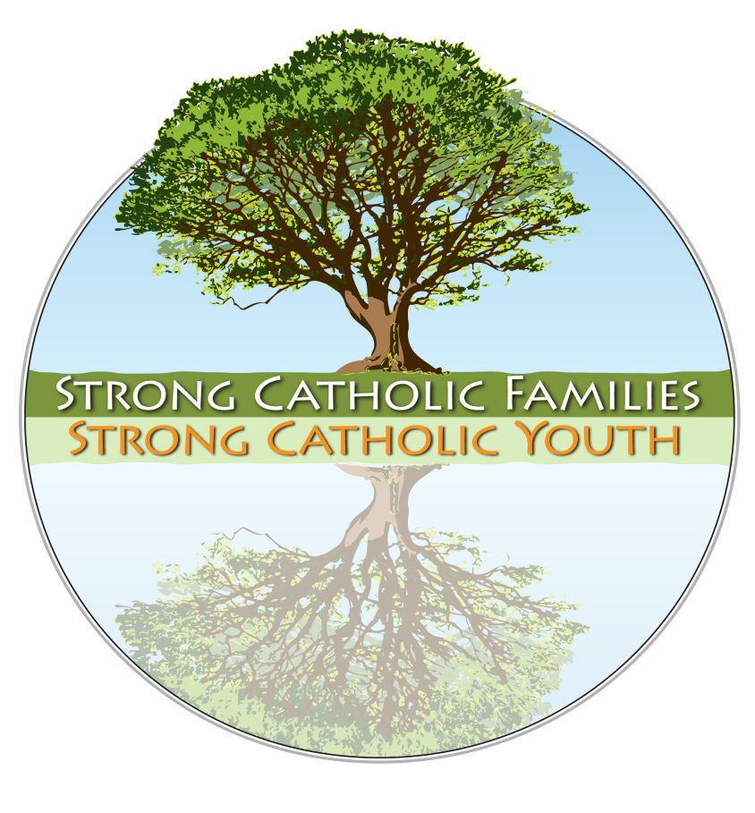
Appendix D2-1: SCF Team and Leadership Reflection Process

Outcomes: The local Strong Catholic Family Team leader or designated staff person facilitates this process, which is designed to engage the SCF Team and parish/school leadership in:
  - Discussing their thoughts, feelings, reactions, and responses to the presentation(s).
  - Identifying emerging priorities based on the information presented.
  - Discussing and identifying next steps.

Parent Response Forms and Family Impact Questions: Prior to gathering, be sure that all attending have had time to review the Parent Response Forms, a summary of the feedback gleaned from the Parent Listening Sessions, and have reflected individually on the Family Impact Questions in Appendix 2.
  - Opening Prayer: Consider using the Prayer for Families found on the back cover of the Family Faith Resource Booklet.

  - Round Robin Discussion: Each person has several minutes to provide initial responses to the information, guided by the following:
    - What surprised you?
    - What are parents in our community needing most?
    - What struck you as most significant for our parish/school? For your ministry/leadership responsibility area?
    - What does this information, along with your reflection on the Family Impact Questions (Appendix 2), suggest that our parish/school should be either strengthening or doing differently?

  - Common Threads and Emerging Themes: Leaders and SCF team members take a few moments of quiet prayer to reflect on what they have heard, focusing on emerging common themes. Following the reflection, and by way of discerning possible emerging priorities, they brainstorm responses to these sentence stems (rules of brainstorming apply, with no criticism of ideas and minimal discussion, in order to generate a list that will be prioritized in a subsequent step):
    - If we fully placed parents at the center of our faith formation efforts, it would require us to…
    - In order to help parents better form their families in faith, we are being asked to…
    - All of this says to me that our next steps should be…

  - Prioritization: After the brainstorming, the SCF Team discusses the various ideas that were generated to seek consensus on emerging priority needs. Note that consensus is not the same thing as compromising, nor is it finding the least common denominator upon which all can agree. Rather, it involves the hard work of listening, seeking understanding, and moving toward ideas that gather the most general enthusiasm because of the potential for significant positive impact. This step may be accomplished with a form of numerical prioritization (e.g., a scale of zero to five, with five being the highest ranked); however, this approach, absent of conversation, may bypass important insights and lead to less satisfactory results.
(Appendix D2-1: SCF Team and Staff Reflection Process, Continued)

  - Next Steps: Following are four possible next step scenarios. These of course may vary greatly according to parish/school, resources, demographics, size of staff, and the SCF Team, etc. They are neither mutually exclusive nor are they necessarily sequential. Parent gatherings, for instance, may well lead to more substantial pastoral planning. Conversely, either a targeted or general pastoral planning effort can make good use of more SCF presentations and parent gatherings to generate interest, further engagement, and more leadership by parents themselves.
        - Multiple Parent Presentations: If the parish/school leaders discern that broad-based consciousness-raising ought to happen so as to increase the sense of urgency, they may choose to organize additional SCF Foundational Parent Presentations for the parish, parish cluster, deanery, or school.

        - Follow-Up Parent Gathering(s): After the shared reflection process, the SCF Team will develop responses suited to the parish/school. The following list is offered only as a starting point, and your plans may include these singly, in combination, or not at all. For more ideas, see the SCF Effective Practices website:
        - Parent Networking: If the conversation led to the need to gather with parents and talk more in-depth, then the parish/school could adapt an ongoing process to gather parents together on a regular basis that will allow them to share their faith journeys, family faith practices, and other issues and concerns. See the SCF Effective Practices website for several models, including Parent Cafés.
        - Prayer & Faith-Sharing Skills Development: If the conversation led to the need for parents to further develop the skills of prayer and faith-sharing, the SCF Team may develop various approaches to helping parents with this, and/or draw upon the resources of the diocese. (Note: See Follow-Up Session B, Living and Sharing Faith.)
        - Theological Updates: If the conversation led to the need for parents to better understand their Catholic faith in order to grow in confidence and the capability of talking about that faith with their children, the SCF Team may develop various approaches to helping parents with this, and/or draw upon the resources of the diocese.
        - Understanding the Other Generation: If the conversation highlighted the need to help each generation listen to and better understand the other’s needs, hopes, fears, and faults, the SCF Team could plan on hosting Session C: Intergenerational Dialogue (Appendix 8).
        - Parent Small Groups: If the conversation led to the need for parents to join up with other parents in forming small faith sharing groups, the SCF Team could begin organizing these around willing parent leaders.

    - One or More Targeted Pastoral Responses: If the reflection outcomes call for targeted pastoral responses or strategic restructuring of current programs and processes, the SCF Team may employ one or several of these specific strategies:

(Appendix D2-1: SCF Team and Staff Reflection Process, Continued)

Parishes
          - Family-centered, parent-empowered Sacramental ministry*
          - Family-based, parent-led faith formation
          - Whole Community Catechesis
          - Community-wide Family Impact Analysis
          - Family advocates on pastoral and finance councils and other ministry committees
          - Athletics in support of the domestic church
          - Comprehensive youth ministry
          - Online resources (ongoing, current, web-based and other “best” resources made instantly or immediately available to parishes and families)
          - Other ideas building from the SCF Effective Practices website: http://www.nfcym.org/family/training/SCFPractices.htm

Schools
        - Appoint a parent subcommittee of the PTO or education commission to focus on family faith and equipping parents for their primary responsibility in forming the faith of their children*
        - Assess school policies and practices regarding their impact on families and family faith
        - Regularly and frequently collaborate with the ministries of the parish to intentionally engage parents, families, and children in the parish faith community
        - Work closely with parish leadership to develop patterns of communication and collaboration
        - Regularly and frequently invite parents into the school and classroom for faith-related activities of all kinds (e.g., feast days, liturgical celebrations, etc.)
        - Invite parents into the classroom to share their faith-witness stories with students
        - Other ideas building from the SCF Effective Practices website found at: http://www.nfcym.org/family/training/SCFPractices.htm

Appendix D2-2: Family Impact Questions
In order to incorporate a family perspective in ministry, consider the following regarding the various policies, programs, ministries, ceremonies or services offered by your parish/school:
A CHRISTIAN VISION OF FAMILY LIFE
- Does it acknowledge the family as the domestic church by showing an appreciation of family life as sacred and family activity as holy?
- In what ways does it promote and strengthen family relationships rather than tax the family system?
- Does it encourage families to reach out to other families?
- Does it promote, support, and encourage families to share and grow in faith within the home?

THE FAMILY AS A DEVELOPING SYSTEM
- Does it respond to the various life cycle issues of the participating families? Does it address the special needs of families in transition or crisis?
- Does it assist the individual/family to understand and deal with the influence of their family of origin when appropriate?
- Does it help individuals/families deal with changes that the program may encourage?
- Does it offer skills and build confidence in families so that they might hand on faith traditions and values to their children?

FAMILY DIVERSITY
- Is there a preferred family structure implicit in the program or policy? Does it reward or penalize certain kinds of families?
- Can families of ethnic, racial, or cultural minorities express their differences and richness within the policy/program/ceremony?
- Does it address families with special needs ensuring that respect and consideration are given?

PARTNERSHIP OF FAMILY AND PARISH
- Does publicity and written material about the program or policy reflect that families are partners or does it minimize parent involvement and responsibility?
- Do leaders involve families in the planning, implementation, and evaluation of the program?
- Does it strengthen the family’s ability to deal with institutions such as schools, hospitals, government, social service agencies, etc.?
- Does it concretely broaden the choices and options of participating families to lessen stress and not add to it?
- Does the program meet the family’s expressed needs and start where they are?
Adapted from Families at the Center (USCCB) by the Family Life Apostolate, Archdiocese of New Orleans
Appendix D2-3: Initial Inquiry and Assessment Reflection
Please review the Strong Catholic Family Information Flyer (Appendix 4) and complete the following questions individually prior to the meeting with your diocesan consultant.

- I am interested in Strong Catholic Families for our parish/school because…

- I believe some of the strengths of our parents and families are…

  - A success story that illustrates this is…

- I believe some of the weaknesses of our parents and families are…

  - A story that illustrates this is…

………………………………………………………………………………

- What has been your greatest success in your parish/school in engaging parents? What made it successful?

- Imagine you are a typical parent in your parish/school. What would help you deepen your faith?

  - What is holding you back?

  - What support are you (as a parent) currently getting for helping to grow your family’s faith at home? What would you like more of?

- How and when does parish/school evaluate how well it serves families and young people?

  - What have you learned from the evaluations and how have they informed your current efforts?
  - If you need more assessment, how and when will you do it?
  - How will your parish/school respond if they receive feedback that a program or approach with parents is not working?

- How well is our parish/school prepared to respond to parents who need help? What do we need in order to become better prepared?

(Appendix D2-3: Initial Staff Inquiry and Assessment Reflection – Continued)

- On a ten point scale with 1 “not well” and 10 “very well,” how does our leadership respond to angry or disgruntled parents?

The Strong Catholic Families process will be only as effective as the level of collaboration and shared vision that supports it within your community. Who absolutely needs to be on board to ensure the success of this collaborative vision and direction? Consider the list below and fill in specific names that come to mind, whether staff or volunteers:

- Catechetical Ministry:
- Clergy/Deacons:
- Children Liturgy of the Word:
- Sacramental Ministry Leaders: (Baptism, Reconciliation, Eucharist, Confirmation, Marriage):
- Family Life Ministry:
- Athletics Ministry:
- Catholic School:
- PTO President:
- Youth Ministry:
- Pastoral Ministry:
- Pastoral Council:
- Finance Council:
- Home School Association:
- Other:

- Which three families best serve as models for “living faith between the Sundays” that you would hope other families would emulate? Why?
1.
2.
3.

- Are there any potential roadblocks, previous experiences, or leadership issues (i.e., “elephants in the room”) that might undermine the success of this initiative if the community were to move forward at this time? Explain…

- How might the SCF initiative impact your parish/school mission and current priorities? Or be impacted by them?

- What type of diocesan support do you need as you approach the challenges and opportunities provided through the Strong Catholic Families initiative?
Appendix D2-4: Strong Catholic Family Information Flyer
Appendix D2-5: Parent Response Form
Strong Catholic Families: Strong Catholic Youth
Partnering with Parents to Bring Home the Faith
Completing this form does not obligate you to anything
nor add you to any mailing list
Full Name
Address
City/State/ZIP Code
Parish E-Mail
Day Phone Cell Phone
Check those that apply:
- I am interested in meeting with other parents for sharing ideas and support. Please contact me as groups begin to form.
- I am interested in helping our parish plan some follow-up steps to creating Strong Catholic Families and Youth.
- I am interested in receiving resources (print/electronic/e-mail) to help me parent my children in the faith.
- I am interested in becoming more involved in our church:  for myself  with my family
❍ Additional comments or ideas you wish to communicate to the leadership of the parish:

Please rate today’s Parent Presentation:
Poor Ok Good Very Good
Presenter    
Content of Presentation    

One thing I learned (or was reminded of) in this presentation

One thing I (or my family) might do differently because of what I heard today:

“The joys and the hopes, the griefs and the anxieties of the people of this age, especially those who are poor or in any way afflicted, these are the joys and hopes, the griefs and anxieties of the followers of Christ. Indeed, nothing genuinely human fails to raise an echo in their hearts.”
Pastoral Constitution on the Church in the Modern World, Vatican, Dec. 7, 1965

Take a few moments to help us to better support and partner with you…

Our Catholic Church and faith are here to support you with your children, your family, and in our parish community. This means that whatever you are dealing with matters to the church. We are here to celebrate what is working and to walk with you as you face life’s expected and unexpected challenges.

Please let us know how we can be more supportive of you and your family by checking the area(s) below. If you check any of the following, we will respond to you directly and confidentially. May God bless you and your family and know that our love, prayers, and support are with you!

___ Building family traditions
___ Family prayer resources
___ Doing service for others with my children
___ Ways to volunteer in our community
___ Talking about faith and morals at home
___ Alcohol, drugs, and addiction issues
___ Dating and adolescent sexuality
___ Websites, books, & family resources
___ Making moral decisions in our family
___ Dealing with loss and grief
___ Support for my marriage
___ Family counseling resources
___ Need a parent support group
___ Stress and time management
___ Domestic violence
___ Understanding the other generation
___ Health needs for family or extended family
___ Support for single parents
___ Support for blended families
___ Support for incarcerated family members

Other requests or needs:

What is the best way to reach you during the day?
- Phone
- E-Mail
- Other:

Appendix D2-6: Follow-Up Session A:
Parent Listening Session
It is highly recommended that this session be announced at and scheduled within two weeks of the Foundational Parent Presentation(s), and facilitated by the local SCF Team.

- For: Those who attended the SCF Foundational Parent Presentation(s), spouses, and other interested parents (note that at this meeting all parents are welcome regardless of the ages of their children).
- Outcomes: Parents will take away from the gathering…
- The kind words and blessing of the pastor/principal
- Ideas and stories from other parents
- Ideas for parents to support parents, and for the parish/school to support parents
- Some practical ideas and resources from the SCF Team
- The commitment to pray for one another
- Specific plans for next steps

- Materials:
- Refreshments
- Nametags, markers, pencils, or pens
- Results of the SCF Parent Response Survey
- A copy of the Family Faith Resource Booklet for each family
- Easel and newsprint, markers
- Take home resources and perhaps a small devotional gift

- Agenda (2 hour gathering)
- Hospitality (note this is vital and not to be skipped or rushed)
  - A comfortable, “adult” space, with furniture and environment conducive to a warm, welcoming, and comfortable adult conversation.
  - Food, drink, nametags, and designated greeters with a knack for putting people at ease welcome parents as they arrive. Perhaps some social time before the formal beginning of the meeting (e.g., “come fifteen minutes early for coffee, soft drinks, snacks, and conversation”).

- Welcome, introductions and prayer (15 minutes)
  - Opening Remarks: Leader warmly welcomes participants, acknowledges their interest and commitment, and commends them for their decision to come, then briefly explains the outcomes and agenda of the gathering.
  - Introductions: With the acknowledgment that we are probably our own best resources, the leader invites the participants to stand up, mingle, introduce themselves to several other people, and find out why they are in attendance.
  - Kind words and prayer: Ideally, the pastor would attend at least the first few minutes of the meeting, offer some affirming words, and lead a simple, suitable opening prayer—it is recommended that one of the family prayers found on the back of the Family Faith Resource Booklet serve this purpose.

(Appendix D2-6: Follow Up Session A, continued)

- Brief survey of participants (10 minutes)
  - Expectations: Leader asks participants to say aloud what they heard when they talked with other parents: Why did you/they come to the gathering? (these ought to be recorded on newsprint as they will be helpful in the planning of subsequent gatherings)
- Stages of Family Development: Leader describes the typical stages of families and asks participants to raise their hands to indicate roughly the stage of their family.
  - Couple without children
  - Family with mainly pre-school children
  - Family with mainly elementary school children
  - Family with mainly teenage children
  - Family with mainly college-age children
  - Empty-nesters
  - Grandparents
  - Others? (note that leader at this point can affirm any who do not fall into these typical categories, and be sure they feel welcome)

- Small group conversation (25 minutes)
  - Leader invites participants to gather in “like” groups as much as possible (e.g., parents of teens together), ensuring that everyone is included in a small group of no more than four persons (larger groups will allow insufficient time to hear from everyone). Participants arrange themselves accordingly.
- Leader distributes copies of the Family Faith Inventory found in the Family Faith Resource Booklet (the same one that was available at the Foundational Parent Session) with pencils or pens, and invites people to complete the survey. When people have completed the survey, the leader invites them to (on newsprint for all to see):
  - Describe one or two things that you do as a parent with your child(ren) to model and share faith with them—things that you feel really good about.
  - Describe one or two challenges or frustrations that you face as a parent in rearing your child(ren) in the faith.
      - Leader offers the following guidelines:
  - The goal is to share our experience, so be sure each person has a chance to talk.
  - Try not to get side-tracked, and if you find yourself on a tangent, get back on track with the conversation leads.
  - Give each person a chance to talk for three to five minutes. (Leader will be tracking and announcing expiring time.)
  - Avoid discussion and especially problem-solving or giving advice; there will be time for that later.
  - If there are people in your group who are new to you, be sure to spend a bit of time at the beginning with introductions.
  - Groups will have 15-20 minutes.

(Appendix D2-6: Follow Up Session A, continued)

  - Leader tracks time and announces when five minutes are up, when ten minutes are up, etc., and when two to three minutes are left.
  - At the conclusion of the small group time, the leader invites group members to shake hands with one other person in the group, who, the leader explains, will become the person to think about and pray for in the weeks to come (prayer partner).

- Break (10 minutes)

- Large group conversation (30 minutes)
- Leader reconvenes group after the break and describes the next step: to have small group discussions focusing on how we parents can partner with the parish/school and one another in working together to pass on the faith to our children, supporting one another, and growing as a community of faith. The small groups will be asked to spend five to seven minutes discussing each perspective as follows:
  - Parent Perspective—what can we do as parents to help, support, resource, challenge, nurture, etc. one another in this vital role of being leaders in our own domestic churches and modeling and sharing faith with our children?
  - Parish/School Perspective—how can this community best help, support, resource, challenge, nurture, etc. parents and help build up the domestic church of the home?
  - Large-group conversation—taking one perspective at a time, the leader asks small groups to share “headlines” of what they talked about. Responses should be recorded, as accurately as possible, on newsprint.
  - Leader may summarize the responses to each perspective.

- Next steps (20 minutes): to some extent, this next part of the conversation will depend upon the content of the previous one; however, some possible next steps are listed below. Let the parents know that the local SCF Team is on hand to help develop, support, and implement the most desirable responses that arise from this session and subsequent reflections.

    - Parent Networking: if the conversation led to the need to gather with parents and talk more in depth, then the parish/school could adapt an ongoing process to gather parents together on a regular basis that will allow them to share their faith journeys, family faith practices, and other issues and concerns.

    - Prayer and Faith-Sharing Skills Development: if the conversation led to the need for parents to further develop the skills of prayer and faith-sharing, once again the leader could recruit volunteers to assist in developing various approaches to helping parents with this (Note: See Appendix 7: Follow-Up Session B, Living and Sharing Faith).

(Appendix D2-6: Follow Up Session A, continued)

    - Theological Updates: if the conversation led to the need for parents to better understand their Catholic faith so as to grow in confidence and the capability of talking about that faith with their children, once again the leader could recruit volunteers to assist in developing various approaches to helping parents with this.

    - Understanding the Other Generation: if the conversation led to the need to help each generation listen to and better understand the other’s needs, hopes, fears, and faults, the leader could plan on hosting follow up Session C: Intergenerational Dialogue, found in Appendix 8.

    - Parent Faith Sharing Groups: if the conversation led to the need for parents to join up with other parents in forming small faith sharing groups, the team could begin organizing these around willing parent leaders.

- Parent “Take Away” Resources (5 minutes): the leader highlights helpful resources found in the Family Faith Resource Booklet and other existing resources already owned or used by the faith community. If applicable, a free devotional gift is presented for participating parents.

- Leader concludes the meeting with (5 minutes):
  - Concluding remarks expressing gratitude, affirmation, and support.
  - Reminder that the local SCF Team will be working to follow up on implementing the directions and ideas that were raised in this session.
  - Final reflection question: what will you do tomorrow or this week to bring this home and to help your family live their faith “between the Sundays?”
  - Evaluation of gathering.
  - Brief closing prayer (using one of the family prayers from the Resource Booklet).

- Social time (time allowing, parents are welcome to stay and chat)

Appendix D2-7: Follow-Up Session B:
Living and Sharing Your Faith
Note: This session uses the Strong Catholic Families PowerPoint Presentation B, “Living and Sharing Your Faith,” which can be obtained from your diocesan presenter or consultant.

For: Those who attended the SCF Foundational Parent Presentation, any follow up gatherings, spouses, and other interested parents (note that at this meeting all parents are welcome regardless of the ages of their children).

Outcomes: Parents will take away from the gathering…
- The kind words and blessing of the pastor/principal
- Practical skills and tools for growing in faith as a family, including faith-sharing and prayer skills
- Review of resources
- The commitment to pray for one another
- Specific plans for next steps

Materials:
- Refreshments
- Nametags, markers
- Handouts on faith-sharing and prayer ideas
- Pencils or pens
- Easel and newsprint, markers
- LCD projector, laptop, PPT presentation
- Take home resources and perhaps a small devotional gift
- Prayer handouts for opening and closing prayer

Agenda: A two hour gathering. Note that this meeting begins in the same way as the Parent Listening Session.

- Hospitality (note this is vital and not to be skipped or rushed)
      - A comfortable, “adult” space, with furniture and environment conducive to a warm, welcoming, and comfortable adult conversation.
      - Food, drink, nametags, and designated greeters with a knack for putting people at ease welcome parents as they arrive.
      - Some social time before the formal beginning of the meeting can be very helpful (e.g., “come fifteen minutes early for coffee, soft drinks, snacks, and conversation”).

- Welcome, Introductions and Prayer (10 minutes)
- Opening remarks (leader warmly welcomes participants, acknowledges their interest and commitment, commends them for their decision to come, then briefly explains the outcomes and agenda of the gathering)
- Introductions (with the acknowledgment that we are probably our own best resources, the leader invites the participants to stand up, mingle, introduce themselves to several other people, and find out why they are in attendance).

(Appendix D2-7: Follow Up Session B, continued)

- Kind Words and Prayer (ideally, the pastor/principal would attend at least the first few minutes of the meeting, offer some affirming words, and lead a simple, suitable opening prayer, perhaps modeling one of the prayer forms modeled during the PowerPoint presentation to follow.

- Dyad/Triad Conversation on Sharing Faith at Home (10 minutes)
Leader asks participants to cluster in twos and threes and share with one another:
  - One or two ways that you share faith with your family that you feel really good about.
  - One way that you wish you and your family could grow in sharing faith.

- Parent Witness on Faith-Sharing at Home (10 minutes)
One or two parents who already model a good and positive home faith life are asked in advance to prepare and offer some remarks on how they share faith at home, what works well or not, and how they feel about their efforts.

- PowerPoint Presentation on Growing in Faith as a Family (85 minutes)
  - Leader uses the Follow-Up Parent Session B PowerPoint, Sharing and Living Your Faith, to share specific skills, strategies, and other approaches to growing in faith as a family. Leader should refer to the trainer notes in the PowerPoint to walk through the various faith sharing ideas with the parents. Be sure to take your time as you review and model for them how to do the various prayer and faith sharing skills that are highlighted. All skills, and many not listed, can be found in the Family Faith Resource Booklets on pages 12-14.
  - Take a ten minute break at an appropriate time during the presentation.

- Conclusion (5 minutes)
Leader concludes the meeting with:
- Concluding remarks expressing gratitude, affirmation, and support.
- Final reflection question: what will you do tomorrow or this week to bring this home and live your faith “between the Sundays?”
- Evaluation of gathering.
- Brief closing prayer.

- Social time (time allowing, parents are welcome to stay and chat).
Appendix D2-8: Follow-Up Session C: Intergenerational Dialogue
Creating Strong Parent-Teen Connections

- Welcome and Opening Prayer (10 Minutes)
- Open the session by sharing a brief (humorous is good!) story that illustrates the “generation gap” when you were a teen.
- Make a connection with how faith/church played an important bridge for family connections at that time and express the goals of this session as follows:
  - In the words of the Prayer of St. Francis, to be able to “seek first to be understood so as to understand.”
  - To facilitate a deeper appreciation for, and knowledge of, the hopes, fears, dreams, and aspirations that the other generation holds.
  - To grow closer to one another as a family of faith.
- Ask all to bow their heads as you offer the following family blessing prayer to begin the session :
Lord of Life,
bless and sustain these families.
Hold them close, keep them connected, and protect them from all evil.
Gift them with love and patience for one another.
Help them to reconcile that which divides them
and celebrate all that unites them as one family,
where you live and reign now and forever.
We ask this through Christ, our Lord. Amen.

- Opening Activity: Back to Back Game Show (20 minutes)
1. Have one parent and one teen sit back to back in chairs.
Note: If there is an “extra” parent, he/she can play along by doing their own set of answers and comparing, but only add up the score for one parent and one teen.
2. Give each a sheet of paper and pencil and ask them to number it down the left side one through ten.
3. Ask one question (in bold) at a time and give them a few seconds to write down a response. Ask all ten questions at once without allowing them to speak to one another.
4. When the ten questions are completed, invite them to face one another, but not to share answers yet.
5. Read one question at a time and then invite them to share their responses and score it appropriately. Once done, ask the italicized question to encourage further sharing on the topic.
6. Repeat this process for each question. Then determine the top three scores and declare the winner (and award prizes if appropriate, such as bag of candy that they can share with others around them).

(Appendix D2-8: Follow Up Session C, continued)

Five Point Questions
- What is the teen’s favorite room in the house? (What’s most cherished item in that room?)
- What is the teen’s favorite meal that he/she cooks her/himself? (Who taught them to prepare that?)
- What is the parent’s favorite restaurant? (Why is this the favorite and share a favorite memory from eating there.)
- Who is the teen’s best friend? (What will that person likely be doing after high school and how will it change your relationship?)

Ten Point Questions
- Who is the parent’s best friend? (How did they meet and an early memory from the relationship.)
- What is the best part about being in high school? (What was it for the parent?)
- What’s the first thing the teen will do after graduating from high school? (What did parent do after graduation?)
- What personal trait has the teen picked up from the parent? (One thing the parent has learned from the teen?)
- In the next year, what will likely be the most challenging event for your family? (What are you doing now to get ready for it?)

Thirty Point Question
- What is your favorite memory of a family time together? (What made it so? What symbol is associated with it?)

- Who is That Other Generation? (20 Minutes)

- Divide parents and teens into two sides of the room. If it is a large group, place them into small groups of six to eight.
- Instruct each group that they are to respond to the following questions as they think the OPPOSITE GENERATION would (i.e., parents respond as teens and teens respond as parents).
- Read one question at a time and give each small group about two or three minutes to answer it within their group and then have a spokesperson call out the answer to the large group when they are invited.
- Let all groups representing one generation answer first and then ask the opposite generation if their responses seemed accurate and if not, what clarification (additions, changes) they would add and why.

(Appendix D2-8: Follow Up Session C, continued)

Questions:

- What is the main reason your age group wants money?
- What kind of music does your age group like?
- Why does your age group think school/education is important?
- Name one of the most popular TV shows for your age group.
- Which technology is your age group’s favorite? Why?
- Why does your age group go to church?
- What is often misunderstood about your age group by the opposite generation?
- What is one of the most important values for your age group?
- What worries your age group the most?
- What is your age group’s biggest hope/dream/goal for the opposite generation?
- Ask each group what they have learned from the other during this activity? What message(s) would you like the other generation to hold onto about their generation?

Ten Minute Break
Invite each person to anonymously complete a Generation Profile. Be sure the teen profiles are copied in a different color than the parents so they can be easily distinguished

- What the Other Half is Thinking (15 minutes)
- Keep teens in one group and parents in another group.
- Randomly distribute the Generation Profile surveys to the opposite generation (teens randomly get parent surveys/parents randomly get teen surveys) so that each person has or shares at least one. Give them a couple of minutes to read over them and review what the other generation is saying.
- Invite them to turn to the person next to them and share for two minutes each what struck them the most about what the other generation is experiencing today.
- Lead a large group discussion by survey category using the following questions. Be sure to have a recorder jot down the main points on newsprint as they are shared:
- What changes is this group going through right now?
- What do they need from the other generation?
- What do you need from them?
- What do you want to tell the other generation about what you’ve just learned about them?

(Appendix D2-8: Follow Up Session C, continued)
- Up Against the Wall Activity (30 Minutes)
- Pair up teens at various spaces around the room (preferably a male and female).
- Assign parents in the same pairs/triads as teens are in and invite them to stand across from their teen forming an inner circle. Then tell parents to rotate one pair to the right, so they are not standing in front of their own teen.
- Using the Generational Surveys, read a teen question that parents are asked to answer, and when done, read a parent question that teens are to answer.
- Once each has responded, ask the parent group to rotate once to the right so they are standing across from a different teen and repeat the process. Continue for about 30 minutes or until questions have been exhausted.

- Closing Comments and Prayer (15 Minutes)
- Ask parents what struck them about tonight’s gathering. Ask teens what they learned about parents. Draw some conclusions about the importance of actively listening to the other generation and how this becomes the cornerstone for family growth and the development of deeper understanding between generations.
- Talk about prayer as being one of the deepest and most profound forms of communication that a family has available to them. Share a story that illustrates the power of prayer in the life of families.
- Invite the generations to close the session by inviting each generation to pray together the blessing prayers for the “other” generation:
Invite the parents to touch the shoulder or heads of their teens as together they pray:
God of Youth,
your hope and promise abound in and through the young church.
Bless and hold our children close.
Give them eyes that see your presence each day,
ears that hear your words of everlasting life,
lips that speak your truth,
and hands that reach out to all in need.
May each step they take lead them closer to knowing you more deeply.
We ask this through Christ, our Lord. Amen.

Invite the teens to touch the shoulder or heads of their parents as together they pray:
God of All Creation,
your breath gave life to all humanity.
Breathe into these parents your love and guidance,
so that they may parent with wisdom and compassion.
Gift them with your strength and courage
so they may proclaim your presence through their words and actions.
Enlighten them with words of truth and comfort as they are needed and
bring them patience and humility as they lead our family along this journey.
Help them pass onto their children a faith that matters,
with you as the center and foundation for our family.
We ask this through Christ, our Lord. Amen.
Youth Survey: THIS IS ANONYMOUS!
Please complete it neatly and seriously (as someone else will actually be reading it). When all the surveys are done, we will shuffle them up so that each parent gets an anonymous youth survey and each youth gets an anonymous parent survey.
I. Changes
Both parents and teenagers are going through lots of changes in their lives. Some might be physical changes while others may have to do with a change in career, friendships, school, or family makeup. Below, write down two changes your age group is going through right now.

1.

2.

II. Issues
All young people have certain issues, problems, or conflicts that they want their parents to know about them or to keep in mind when they are trying to talk to them. Below list three things that you would like parents to know about teenager's lives:

1.

2.

3.

III. Expectations
We all place expectations on our parents and ourselves as to what we or they SHOULD be like. Think about what you expect from each of the people listed below and fill in the blank.

Parents should…

Teenagers should…

Families should…

IV. The Last Word
Often there are so many things we want to tell our parents—things we want them to know about us or to not do or to start doing. Think about these things and write whatever you would like to say to parents in this space:

A Question for the Other Generation: Write down one question you would like the parents to answer to teens (this will get asked out loud so be serious!)
Parent Survey: THIS IS ANONYMOUS!
Please complete it neatly and seriously (as someone else will actually be reading it). When all the surveys are done, we will shuffle them up so that each parent gets an anonymous youth survey and each youth gets an anonymous parent survey.
I. Changes
Both parents and teenagers are going through lots of changes in their lives. Some might be physical while others may have to do with a change in career, friendships, school, or family makeup. Write down two changes your age group is going through.

1.

2.

II. Issues
All parents have certain issues, problems, or conflicts that worry them about their teenager’s life or lifestyle. Below list three things that you would like teens to know about life/lifestyles both now and in the future:

1.

2.

3.

III. Expectations
We all place expectations on our parents and ourselves as to what we or they SHOULD be like. Think about what you expect from each of the people listed below and fill in the blank.

Parents should…

Teenagers should…

Families should…

IV. The Last Word
Often there are so many things we want to tell our children—things we want them to know about us or to not do or to start doing. Think about these things and write whatever you would like to say to young people in this space:

A Question for the Other Generation: Write down one question you would like the teens to answer to parents (this will get asked out loud so be serious!)

