#### February 6, 2022

Ordinary Time

Fifth Sunday



***God Calls, We Respond!***

**Featured in today’s Gospel are Peter, James and John, who thought they had found their place in life as fishermen. It all changed when they met the Lord. Their spiritual horizons were broadened and they realized that their lifes’ search had only just begun. They would help others experience God in Jesus. We continue their mission as we in our turn help others recognize the presence of God in their lives.**

**MASS INTENTIONS**

Thursday, February 10

4:30 p.m. Victor, Hattie & Jerome Hermis

Saturday, February 12

4:30 p.m. Patsy Tydlacka & Mary Tydlacka

Sunday, February 13

8:00 a.m. Emma & Julius Stryk

­ Individual Confessions in Moulton and Praha

- Available anytime by appointment. Call the office.

- On Fridays in the Family Room after Mass in Moulton.

- On Thursdays after the 4:30 p.m. Mass in Praha.

- During Advent/Christmas season and in Lent.

**Full, Conscious and Active Participation in the Liturgy**

Next weekend is *The Sixth Sunday in Ordinary Time.* Prepare for the liturgy by reflecting on these passages from your Bible.

**First Reading: Jeremiah 17:5-8**

**Responsorial Psalm: 1**

**Second Reading: 1 Corinthians 15:12, 16-20**

**Gospel: Luke 6:17, 20-26**

**.**



**The Sanctuary Light**

**will be lit this week**

**in memory of Robert R. Schaefer.**

**St. Mary’s Restoration Endowment Fund**

**Maintaining & Preserving Matička Praha**

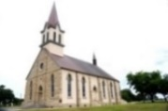

We thank the following for their recent contributions:

***In Memory of Leo Janak***

*Robin & Gary Cerny - $50*

*Rhonda & David Stryk, Pearland, TX - $50*

**ST. MARY’S MEMORIAL FUND**

***In Memory of Leo Janak***

*Carol & Randy Barta*

*Kenny French & Staff*

*B-H Genetics Services, Inc.*

**WORLD DAY OF THE SICK – FEBRUARY 11**

***Be Merciful, Even As Your Father Is Merciful***

Thirty years ago, Saint John Paul II instituted the [World Day of the Sick](https://www.vatican.va/content/john-paul-ii/en/messages/sick.index.html) to encourage the people of God, Catholic health institutions and civil society to be increasingly attentive to the sick and to those who care for them. 

The theme chosen for this Thirtieth World Day of the Sick, “Be merciful, even as your Father is merciful” (Lk6:36), makes us first turn our gaze towards God, who is “rich in mercy” (Eph 2:4); he always watches over his children with a father’s love, even when they turn away from him. Mercy is God’s name par excellence; mercy, understood not as an occasional sentimental feeling but as an ever-present and active force, expresses God’s very nature.  It combines strength and tenderness. For this reason, we can say with wonder and gratitude that God’s mercy embraces both fatherhood and motherhood (cf. Is 49:15). God cares for us with the strength of a father and the tenderness of a mother; he unceasingly desires to give us new life in the Holy Spirit.

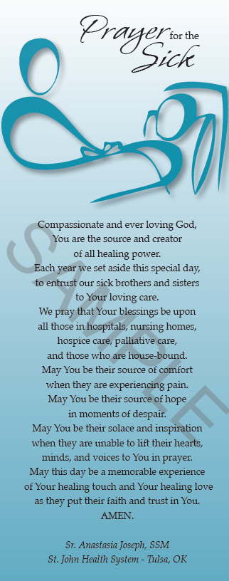

*Merciful Jesus, during Your life on earth You showed great concern for the sick and the infirm. Have compassion now on all those who are sick or in pain. Grant them a healing of mind and body and restore their strength and spirit. Comfort them with knowledge that we are praying for them, and give them peace with a sense of your presence. May they know that in a special way they are united with You, their suffering Christ. May they contribute to the welfare of the whole People of God by associating themselves freely with your Passion and death for the salvation of the world. Bless, too, those who take care of the sick. In their own time of need, bestow on them a hundred-fold the blessings they have given to others. Amen.*

**REFLECTION**

**Isaiah 6:1-2a, 3-8 Psalm 138 1 Corinthians 15:1-11**

**Luke 5:1-11**

***A Call From God***

Each of today’s readings recounts a “call” from God to one sent forth to speak in God’s name: the prophet Isaiah, the apostle Paul and Jesus’ disciple Peter. These are important figures in the history of God’s dealing with people, yet each one’s imperfections are paramount in these accounts. Isaiah laments his uncleanness when confronted with the majesty of God; Paul says he is the least of the apostles, one who had persecuted the nascent church. In the gospel, Peter, in the face of a miraculous catch of fish, recognizes his unworthiness. Jesus does not argue with Peter’s claim to be a sinner; he does not assure Peter that he is “good enough” to be a disciple, a student of Jesus. Instead, he comforts Peter as though the decision had already been made, and he announces that Peter “will be catching people” instead of fish.

If God chooses to act through such admittedly impure individuals – even one who had persecuted God’s people – then what excuse do we have for refusing to heed God’s call? Certainly, we say, *someone* needs to speak up in the face of injustice, *someone* needs to spread the gospel, *someone* needs to minister to the followers of Jesus – but not me! Perhaps we are really afraid, not of being unworthy but of what God’s calling will cost us. What will people think? Will I have to give up what I enjoy? How painful will it be? (Isaiah, after all, was purified with a burning coal to the lips!)

Perhaps most striking is the story told of Peter and his fishing partners: “They left everything and followed Jesus.” This was no casual Sunday afternoon outing by the lake. These people gave up the sources of their livelihood; they quit their jobs to follow an itinerant preacher.

Speaking for God carries a price. It is demanding. It is uncomfortable. It is our calling, too.

**HAPPY BIRTHDAY!**

February 6 – Gene Patalik, Jr.

February 12 – Matt Cerny

– Mikey Decker, Jr.

**PRAHA PANCAKE SUNDAY – TODAY**

*The Altar Society is hosting Praha Pancake Sunday starting at 9 a.m*. *Join us at the Praha Hall for a delicious breakfast, and fellowship. All are welcome.*

**LOOKING AHEAD**

***The Season of Lent Begins March 2nd***

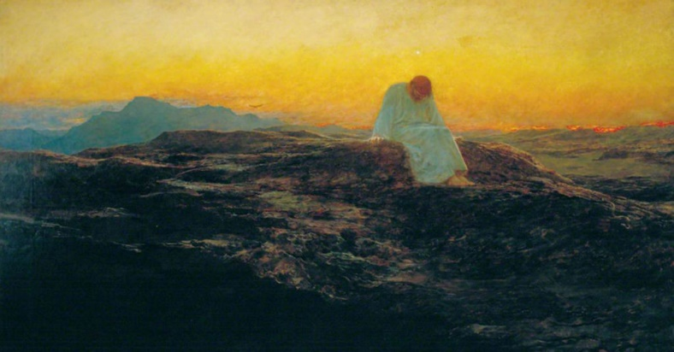

As described in the gospel readings, following his [baptism](https://media.ascensionpress.com/2019/01/13/why-did-christ-have-to-be-baptized/) by John the Baptist in the Jordan River, Jesus was led by the Holy Spirit into the desert, where he fasted for forty days and was subject to temptation by Satan. To honor this sacrifice and conquest over the devil, the Season of Lent is set aside to refocus on Jesus as we look ahead to his death on the Cross and rejoice over his miraculous return.

Just as Jesus fasted in the desert for forty days, we, too, are called to forgo something when observing Lent. It is during this time we can deepen our awareness of his sacrifice on the Cross, as well as Jesus’ daily forgiveness of our sins and unconditional love for us.

**Orientation – Fear of God**

Simon Peter’s humble exclamation illustrates what is often referred to as the fear of God, one of the gifts of the Holy Spirit. The word “fear” gives us the impression of something dark, negative, and harmful, but the fear of God is better defined as a moment of clarity and light. When we experience the fear of God, the Holy Spirit illuminates for us God’s holy presence in our lives. In the face of God’s holiness, we can often recognize, like Peter, the long way we have to go in our own holiness. The moment of the fear of God is a moment of awe and humility, when we recognize God’s amazing power, love, and grace and become aware of our human weakness and limitations. It is an honest and inspiring moment of conversion, inviting us to God’s holy presence, no matter the distance we find ourselves from it.

On Monday, February 14, 2022, Bishop Branden Cahill will celebrate a Mass at 10:30 a.m. inaugurating Saints Cyril and Methodius Church in Dubina as a diocesan pilgrimage site. Lunch will follow in the parish hall. Everyone is invited, especially those with an affection for the first parish of seven in Texas having the Apostles to the Slavs, Saints Cyril, and Methodius as their patrons. Those attending and having lunch are asked to RSVP to (832) 437-4077 or [mmarek1212@gmail.com](mailto:mmarek1212@gmail.com) by February 10, 2022.

Marvin J. Marek, President Czech Catholic Foundation of Texas

Rosary every Wednesday at 9:00 a.m. Come join a group of church ladies at the Zdrávas Maria Plaza to pray.