Lenten Communal Penance Service
2026

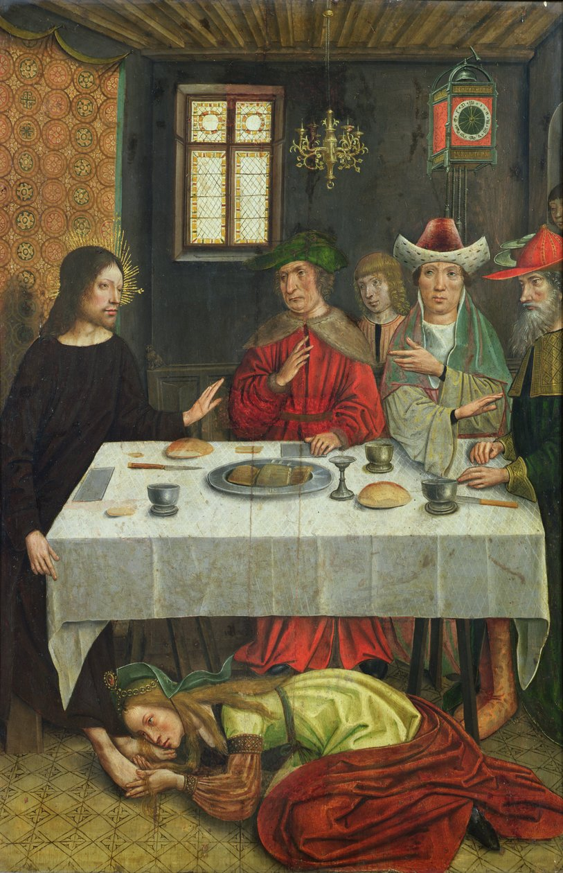

The Meal at the House of Simon the Pharisee
c. 1500, Anonymous
Lille Museum, France
In the public domain.

Introductory Rites
Hymn

How firm a foundation, you saints of the Lord,
Is laid for your faith in his excellent Word!
What more can he say than to you he has said,
To you, who for refuge to Jesus have fled?

Fear not, I am with you, O be not dismayed,
For I am your God, and will still give you aid;
I’ll strengthen you, help you, and cause you to stand,
Upheld by my righteous, omnipotent hand.

When through the deep waters I call you to go,
The rivers of woe shall not you overflow;
For I will be with you, your troubles to bless,
And sanctify to you your deepest distress.

The soul that on Jesus still leans for repose,
I will not, I will not desert to its foes;
That soul, though all hell should endeavor to shake,
I’ll never, no never, no never forsake.

Text: 2 Peter 1:4; “K” in Rippon’s A Selection of Hymns, 1787, alt.
Tune: FOUNDATION, 11 11 11 11; Funk’s Compilation of Genuine Church Music, 1832.

Most hymn tunes with the metrical marking “11 11 11 11” will fit with this text.
Examples include:
ST. DENIO (Immortal, Invisible, God Only Wise)
CRADLE SONG (Away in a Manger)

Greeting
After the song the presider greets the people:

Presider:
May God open your hearts to his law
and give you peace;
may he answer your prayers
and restore you to his friendship.

All: Amen.

Then the presider or another minister speaks briefly about the importance and purpose of the celebration and the order of the service.

The faithful are briefly reminded that they are linked with each other in sin and in repentance so that each should take their calling to conversion as an occasion of grace for the whole community.
Opening Prayer

Presider:
Father of mercies
and God of all consolation,
you do not wish the sinner to die
but to be converted and live.
Come to the aid of your people,
that they may turn from their sins
and live for you alone.
May we be attentive to your word,
confess our sins, receive your forgiveness,
and be always grateful for your loving kindness.
Help us to live the truth in love
and grow into the fullness of Christ, your Son,
who lives and reigns for ever and ever.

All: Amen.

The Liturgy of the Word
The following suggested reading may be found in the Lectionary at number 93, cycle “C”, Eleventh Sunday in Ordinary Time.

First Reading 2 Samuel 12: 7-10, 13

The Lord has forgiven your sin: you shall not die.

Reader: A reading from the second book of Samuel

Nathan said to David:
“Thus says the LORD God of Israel:
I anointed you king over Israel.
I rescued you from the hand of Saul.
I gave you your lord’s house and your lord’s wives for your own.
I gave you the house of Israel and of Judah.
And if this were not enough, I could count up for you still more.

“ ‘Why have you spurned the LORD and done what is evil in his sight?
You have cut down Uriah the Hittite with the sword;
you took his wife as your own,
and him you killed with the sword of the Ammonites.

“ ‘Now, therefore, the sword shall never depart from your house,
because you have despised me
and have taken the wife of Uriah to be your wife.’ ”
Then David said to Nathan,
“I have sinned against the LORD.”
Nathan answered David:
“For his part, the LORD has forgiven your sin:
you shall not die.”

Reader: The word of the Lord.
All: Thanks be to God

The psalm should be sung.
The following suggested psalm is the proper psalm for the Eleventh Sunday in Ordinary Time, cycle “C”.

Responsorial Psalm Psalm 32: 1-2, 5, 7, 11

R. Lord, forgive the wrong I have done.

Blessed is the one whose fault is taken away
whose sin is covered.
Blessed is the man to whom the LORD imputes not guilt,
in whose spirit there is no guile. (R.)

I acknowledged my sin to you,
my guilt I covered not.
I said, “I confess my faults to the LORD,”
and you took away the guilt of my sin. (R.)

You are my shelter; from distress you will preserve me;
with glad cries of freedom you will ring me round. (R.)

Be glad in the LORD and rejoice, you just;
exult, all you upright of heart. (R.)

Lenten Gospel Acclamation
If the acclamation is not sung, it is omitted.

R. Praise to you, Lord Jesus Christ, king of endless glory!

God loved us and sent us his Son
as expiation for our sins. (R.)

The following suggested gospel reading may be found in its short form in the Lectionary at number 93, cycle “C”, Eleventh Sunday in Ordinary Time.

Gospel Luke 7: 36-50

Her many sins have been forgiven, because she has shown great love.

Deacon: The Lord be with you.
All: And also with you.
Deacon: + A reading from the holy gospel according to Luke.
All: Glory to you, Lord.

A Pharisee invited Jesus to dine with him,
and he entered the Pharisee’s house and reclined at table.

Now there was a sinful woman in the city
who learned that he was at table in the house of the Pharisee.
Bringing an alabaster flask of ointment,
she stood behind him at his feet weeping
and began to bathe his feet with her tears.
Then she wiped them with her hair,
kissed them, and anointed them with the ointment.

When the Pharisee who had invited him saw this he said to himself,
“If this man were a prophet,
he would know who and what sort of woman this is
who is touching him,
that she is a sinner.”

Jesus said to him in reply,
“Simon, I have something to say to you.”
“Tell me, teacher,” he said.

“Two people were in debt to a certain creditor;
one owed five hundred days’ wages and the other owed fifty.
Since they were unable to repay the debt, he forgave it for both.
Which of them will love him more?”
Simon said in reply,
“The one, I suppose, whose larger debt was forgiven.”
He said to him, “You have judged rightly.”

Then he turned to the woman and said to Simon,
“Do you see this woman?
When I entered your house, you did not give me water for my feet,
but she has bathed them with her tears
and wiped them with her hair.

You did not give me a kiss,
but she has not ceased kissing my feet since the time I entered.
You did not anoint my head with oil,
but she anointed my feet with ointment.
So I tell you, her many sins have been forgiven;
because she has shown great love.
But the one to whom little is forgiven, loves little.”
He said to her, “Your sins are forgiven.”

The others at table said to themselves,
“Who is this who even forgives sins?”
But he said to the woman,
“Your faith has saved you; go in peace.”

Deacon: The gospel of the Lord.
All: Praise to you, Lord Jesus Christ.

Homily

Examination of Conscience

The assembly is now invited to make an examination of conscience.

This may be done:

- in silence
or
- by using the examination of conscience below.

Presider:
We examine our thoughts, words and deeds [in silence].

One reader alone may read it, or two readers might alternate.

Allow a brief period of silence between each one.

Reader(s):

I am the Lord your God: you shall not have strange Gods before me.
  - Have I treated people, events, or things as more important than God?

You shall not take the name of the Lord your God in vain.
  - Have my words, actively or passively, put down God, the Church, or people?

Remember to keep holy the Lord’s Day.
  - Do I go to Mass every Sunday (or Saturday Vigil) and on Holy Days of Obligation (Jan. 1; the Ascension; Aug. 15; Nov. 1; Dec. 8; Dec. 25)?
  - Do I avoid, when possible, work that impedes worship to God, joy for the Lord’s Day, and proper relaxation of mind and body?
  - Do I look for ways to spend time with family or in service on Sunday?

Honor your father and your mother.
- Do I show my parents due respect?
- Do I seek to maintain good communication with my parents where possible?
- Do I criticize them for lacking skills I think they should have?

You shall not kill.
- Have I harmed another through physical, verbal, or emotional means, including gossip or manipulation of any kind?

You shall not commit adultery.
- Have I respected the physical and sexual dignity of others and of myself?

You shall not steal.
- Have I taken or wasted time or resources that belonged to another?

You shall not bear false witness against your neighbor.
- Have I gossiped, told lies, or embellished stories at the expense of another?

You shall not covet your neighbor’s spouse.
- Have I honored my spouse with my full affection and exclusive love?

You shall not covet your neighbor’s goods.
- Am I content with my own means and needs, or do I compare myself to others unnecessarily?

Copyright © 2013, United States Conference of Catholic Bishops, Washington, DC. All rights reserved. Permission is hereby granted to duplicate this work without adaptation for non-commercial use.

If read aloud, this Examination of Conscience should conclude with a period of silence so that each person may personally examine his or her conscience.

Rite of Reconciliation

General Confession of Sins

Presider:

Directing the assembly.
[Please kneel, as you are able.]
Our God seeks out what is lost,
leads the abandoned to safety,
binds up what is broken
and gives strength to the weak.

Let us remember his goodness
as we acknowledge our sins.

After a brief period of silence, all say together:

I confess to almighty God
and to you, my brothers and sisters,
that I have greatly sinned
in my thoughts and in my words,
in what I have done
and in what I have failed to do,
through my fault, through my fault
through my most grievous fault;
therefore I ask blessed Mary ever-virgin,
all the Angels and Saints,
and you, my brothers and sisters,
to pray for me to the Lord our God.

Litany of Repentance

Presider:

Directing the assembly.
[Please stand.]
By human weakness we have clouded the holiness of the Church:
pardon all our sins
and restore us to full communion with you
and with our brothers and sisters.
Please respond: Hear our prayer.

Give us the strength
to turn away from sin. (R.)

Keep us steadfast
in our trust of your goodness. (R.)

Help us to be sorry for our sins
and resolve to abandon them. (R.)

Show us the path to a humble heart
as we seek the good of others. (R.)

Forgive us our sins,
have pity on our weakness. (R.)

Teach us to trust in your goodness,
make us generous in serving you. (R.)

Guide our generosity
in response to those who need us. (R.)

Help us to be true followers of your Son
and living members of his Church. (R.)

Presider:
Let us conclude our prayers with the Lord’s Prayer:

All say or sing together:

Our Father...

The presider concludes:

Presider:

Father, our source of life,
you know our weakness.
May we reach out with joy to grasp your hand
and walk more readily in your ways.

We ask this through Christ our Lord.

All: Amen.
Invitation to Individual Confession

Presider:

Directing the assembly.
Please be seated.

Before we begin the Sacrament of Reconciliation, I’d like to take this opportunity to thank our priests who have joined us tonight.
Frs. ____________, ____________, and ____________.

I would also like to thank all of you who have come together to pray, seeking Christ’s mercy.

While we sing the next song, our confessors will process to their confessional stations. They are located in these places in the church:

Fr. _______________ will be ____________________________.
Fr. _______________ will be ____________________________.
Fr. _______________ will be ____________________________.
I will be ____________________________.

At the end of the song I invite you to stay and to quietly move to one of the stations.

For those of you who decide not to partake of the sacrament at this time, I invite you to come back when confessions are heard here at the parish:

on ___________(day) from _______ to ________ (time)

Prayer and Blessing

Presider:

Gesturing for the assembly to stand.
Let us pray.

All pray in silence for a brief period.

Lord God,
in your great love for the world
you gave us your only Son
for our salvation.
Through him we ask you
to be always present among your family.
Teach us to be reverent in the presence of your glory;
fill our hearts with faith,
our days with good works,
our lives with your love;
may your truth be on our lips
and your wisdom in all our actions,
that we may receive the reward of everlasting life.

We ask this through Christ our Lord.

All: Amen.

May almighty God bless you,
the Father, and the Son +
and the Holy Spirit.

All: Amen.

Confessors process to their stations during the song.

Hymn
O for a heart to praise my God,
A heart from sin set free,
A heart that always feels your blood
So freely shed for me.

A heart resigned, submissive, meek,
My great Redeemer’s throne,
Where only Christ is heard to speak,
Where Jesus reigns alone.

A humble, lowly, contrite, heart,
Believing, true and clean,
Which neither life nor death can part
From Him that dwells within.

A heart in ev’ry thought renewed
A heart whose love endures,
So perfect, right and pure and good,
A copy, Lord, of yours.

Your nature, gracious Lord, impart;
Come quickly from above;
Write your new name upon my heart,
Your new, best name of Love.

Text: Psalm (50) 51; Charles Wesley, 1707, 1788, alt.
Tune: O FOR A HEART, CM; Malcom Williamson, b. 1943.

Most hymn tunes with the metrical marking “CM” (Common Meter – 86 86) will fit with this text.
Examples include:
LAND OF REST (Jerusalem, My Happy Home)
NEW BRITIAN (Amazing Grace)
ST. AGNES (Shepherd of Souls)
ST. ANNE (O God, Our Help in Ages Past)

Individual Confession and Absolution

Then the penitents go to the priests designated for individual confession, and confess their sins. Each one receives and accepts a fitting act of satisfaction and is absolved. After hearing the confession and offering suitable counsel, the priest extends his hands over the penitent’s head (or at least extends his right hand) and gives him or her absolution. Everything else which is customary in individual confession is omitted.

After receiving absolution the penitents may return to the main body of the church and spend some time in private prayer, but are otherwise dismissed.

Soft, unobtrusive instrumental music may be played for a time during the transition to individual confession.

