Welcome to this exciting time of preparing your child(ren) for the Sacraments of First Reconciliation and First Eucharist! As you look through the chart, keep in mind the following:
- The U.S. Bishops ask that children be prepared for the Sacrament of Reconciliation prior to preparation for First Eucharist (Communion).
- Vacations: Plan your vacations so that you do not miss the parent sessions, First Reconciliation evening, and First Communion retreat.
- Questions: Contact Nichole Chang, Elementary Faith Formation Coordinator 763-762-7370 or nicholechang@saintvdp.org .

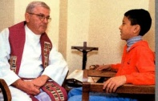
First Reconciliation (Penance/Confession)
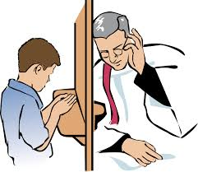
The U.S. Bishops ask that children be prepared for the Sacrament of Reconciliation prior to preparation for First Eucharist (Communion).

Requirement | Date Due
Mass | Go to Mass every Sunday (Sat. eve.)
Parent Session: Attend one of the two sessions: Regan Hall  - Monday, November 11, at 6:00 pm – 7:15 pm  - Wednesday, November 13, at 6:00 pm - 7:15 pm | Monday, November 11 or  Wednesday, November 13
Sacramental Information Form  - Received at Parent Session. | Wednesday, December 11
Child’s Baptismal Certificate  - If your child was NOT baptized at St. Vincent’s, a newly issued Baptismal Certificate with embossed seal from Church of Baptism must be requested from the Church of Baptism.  - If baptized in another faith, your child will need to make a profession of faith at a time to be determined, prior to receiving their First Eucharist. | Wednesday, December 11
Family Formation – First Reconciliation Home Lesson Book:  - Picked up at parent sessions on November 11 or 13.  - Be sure all pages are completed.  - Turn the book in to:  - St. Vincent de Paul School: Your child’s teacher  - Faith Formation: Your child’s catechist  - Home Study or another Catholic School: Parish Office | Wednesday, January 8
First Reconciliation Celebration: New format, details at meeting.  - 6:00 pm – 8:00 pm in the Church | Wednesday, January 22

First Eucharist (Communion)

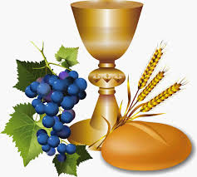
Requirement | Date Due
Mass | Go to Mass every Sunday (Sat. eve.)
Preparation and Reception for First Reconciliation Completed. | Before First Eucharist
Parent Session: Attend one of the two sessions: Regan Hall  - Monday, February 24, at 6:00 pm – 7:15 pm  - Wednesday, February 26, at 6:00 pm – 7:15 pm | Monday, February 24 or  Wednesday, February 26
Register for First Communion Date and Mass Time:  - Register ONLINE: at saintvdp.org/first-eucharist-mass-sign-up  - Opens Thursday, February 27 at 8:00 am. | Register No LATER than  Friday March 14
First Communion Retreat: Regan Hall. At least one parent/guardian must attend with child.  - Monday, April 21, at 6:00 pm – 7:15 pm  SVDP & Other Catholic School families will attend the April 21st retreat.  - Wednesday, April 23, at 6:00 pm – 7:15 pm  Family Faith Formation will the attend the April 23rd retreat.  - If your family is not able to attend the above assigned retreat, please contact Nichole Chang at: nicholechang@saintvdp.org. | Monday, April 21 or  Wednesday, April 23
First Eucharist Banner:  - Directions and felt piece given out at parent sessions in February.  - Turn in at the parent/child First Communion retreat. | Monday, April 21 or  Wednesday, April 23
Family Formation – First Eucharist Home Lesson Book:  - Picked up at parent session in February.  - Be sure all pages are completed. (Please have your child write in answers on the pages.)  - Turn in your book at the First Communion Retreat. | Monday, April 21 or  Wednesday, April 23
First Communion Mass Schedule:
More details for the First Communion Mass will be given out at a later date.

Saturday, May 3 at 5:00 pm
Sunday, May 4 at 9:00 am
Sunday, May 4 at 11:00 am

