Introducing:

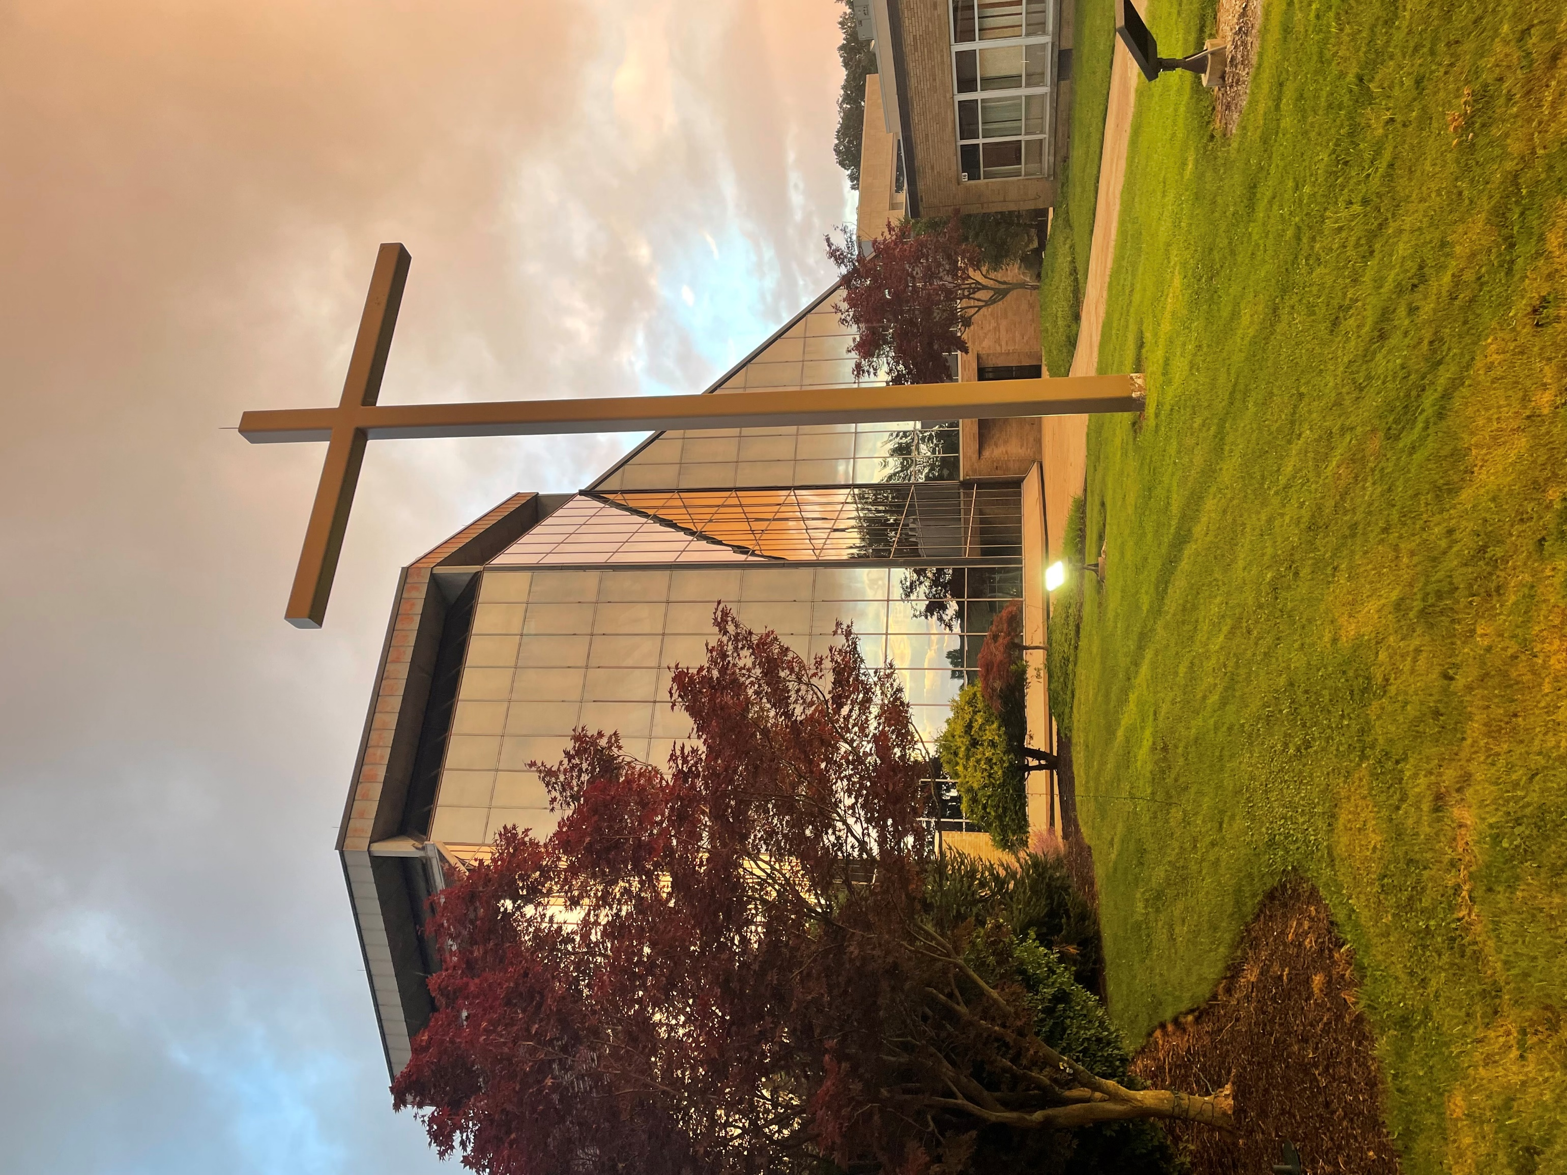
Our PARISH FAMILY, THE
ROMAN CATHOLIC COMMUNITY OF Saint Paschal Baylon

The blessing of the Lord be upon you.
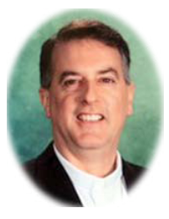
. . . Psalm 129:8
OUR MISSION

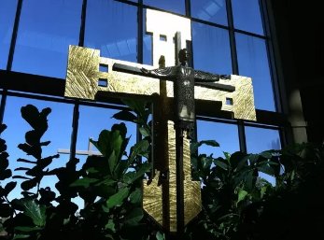
Saint Paschal Baylon is a joyful, welcoming community centered in the Eucharist. We are administered by the Congregation of the Blessed Sacrament (SSS) in the Diocese of Cleveland. Through our liturgy and prayer, we are empowered to grow in faith, love and service.

WORSHIP AT SAINT PASCHAL BAYLON

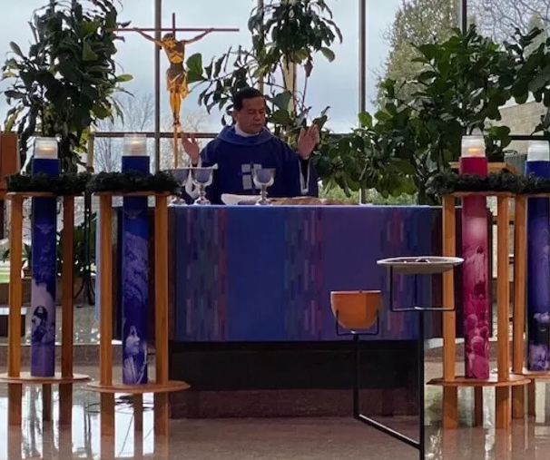
Worship of the Eucharist
Saturday: 9:00_{AM} & 4:30_{PM} (in church)
Sunday: 8:30_{AM}, 10:30_{AM}, & 6:30_{PM} (in church)
Weekdays: 9:00_{AM} (in church) & 11:30_{AM} (in Saint Ann Shrine)

Confession
Monday: 6:00-6:30_{PM} (in church) or by appointment
Communal Services during Advent and Lent
Saturday: 3:30 – 4:15_{PM} (in church) or by appointment
Communal Services during Advent and Lent

Anointing of the Sick
First Sunday of the month after 8:30_{AM} Mass (in church) or by appointment

Liturgy of the Hours
Morning Prayer: 8:00_{AM} church
Evening Prayer: 4:45_{PM} OLBS Chapel in church (M–F only)

The Rosary
Monday – Saturday: 8:30_{AM} (in church)
Wednesday: 11:00_{AM} (in Saint Ann Shrine)

Veneration of the Relic of Saint Ann
Tuesday: 11:20_{AM} (in Saint Ann Shrine) or ask a priest before or after Mass to prepare for surgery or for other spiritual needs

HEARING ASSISTANCE: If you need support and a listening device to hear better in our church, please see the musicians for a special device that you may wear in church.

LOW-GLUTEN HOSTS OR THE PRECIOUS BLOOD OF CHRIST: If you wish to participate in Holy Communion with a low-gluten host, or to also receive the Blood of Christ during Mass, with your very own chalice, please come to the sacristy before Mass to let the priest or sacristan know and share with you the procedure.

PARISH SERVICES

Contact the Parish Office: 440-442-3410:
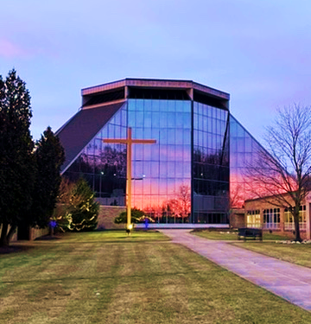
- Communion for the Sick and Homebound
- Mass Intentions: Your intentions and requests for prayers are spoken aloud as you will hear, and then all pray for them at Mass. The Blessed Sacrament Community thanks you for your generosity. These Mass dedications may be requested and paid for at the parish office for $15.00 per Mass. You may also request Mass intentions for the Masses held in the Saint Ann Shrine. We mention these names with our regular intentions.
- Special blessings: (Your home for example)
- Food and clothing distribution: Helping Hands Ministry
- Helping parishioners in financial need: Manna Ministry
- Pregnancy Guidance: Call Birthright at 800-550-4900 or the Gabriel Project at 800-910-0191
We are Here to Support and Serve with You!
Our Pastoral Staff and Blessed Sacrament Community are here to support you and your family. Please feel free to contact us for appointments via phone or email. Reach out during normal office hours, and know we are available as well for emergencies after office hours.

CELEBRATE THE HOLY DAYS AND SPECIAL TIMES OF THE LIGURGICAL YEAR WITH US

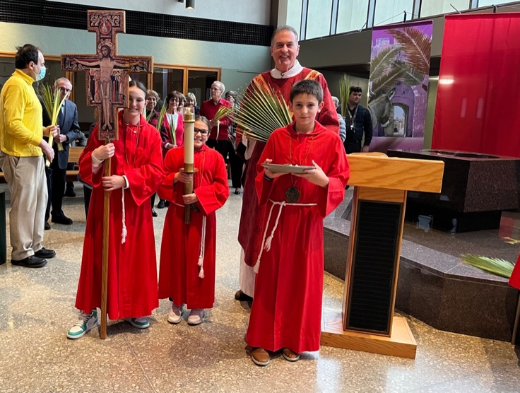
PREPARING FOR THE TRIDUUM: Please refer to our annual Triduum schedule below. We are grateful that the Liturgy Commission has chosen Fr Roger to lead us in the Sacred Triduum Retreat. We will have short reflections each night that will unite the 3-days, but all in one liturgy: The Sacred Triduum! Here’s a few things to keep in mind:
- The children’s choir will sing at the Easter Sunday at 10:30_{AM} Mass. That’s our annual “children’s/family” Mass for Easter.
- There are rehearsals for each of the liturgies! We take our rites seriously and invite the ministers to come to the special rehearsals to check in and practice on the parts that they will have. Here is the order during Holy Week when we practice:
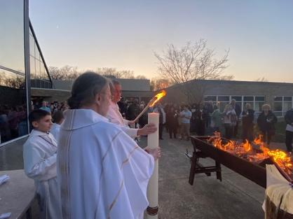
- 7 MINISTERS WILL EXPERIENCE FOOT-WASHING, and all are welcome, (but not required) to celebrate this ancient custom of the liturgy on this special night of Holy Thursday.

KEEP THE CUSTOM OF VISITING THE CHURCH FOR PRAYER on Holy Thursday from 9:00_{PM} - Midnight, by making a visit to the Blessed Sacrament Chapel in the church.

THE EASTER VIGIL IS THE MOST IMPORTANT NIGHT OF THE YEAR: That’s why it’s two hours long! It’s not a Mass, it’s a vigil: the ancient night of blessing the holy fire, the new Paschal Candle, the proclamation of ancient scriptures, the welcoming of new Roman Catholic Christians with baptism, confirmation and First Communion, and our OWN renewal of our baptismal promises by going to the font to make our renewed commitment. Many like to compare the Vigil to the “Super Bowl” of liturgies as it is 4 parts; but no commercials or extended time outs could ever drag the beauty out of the rituals, prayers, and music. If you have never attended Easter Mass before, make this the year you start!

PRAYER IN THE PRESENCE OF THE BLESSED SACRAMENT

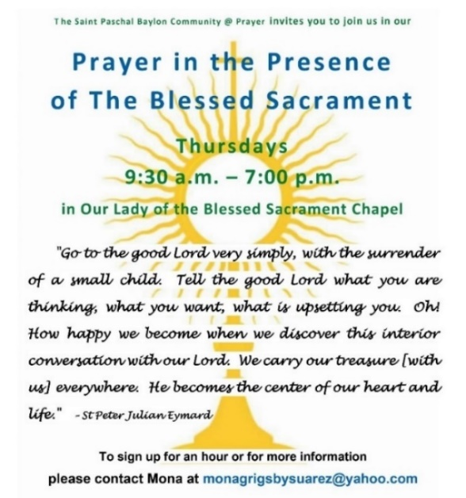
Our Community at Prayer ministry continues the tradition of keeping vigil until the Lord Jesus Christ returns in glory. Our prayer extends the blessings of the Mass where we share in the Risen Christ’s Body and Blood. Exposition of the Blessed Sacrament (a liturgical act) occurs Thursdays from 9:30_{AM} until 8:00_{PM} with special exposition time throughout the year (i.e., Taizé Eucharistic Holy Hours, Saint Ann Triduum, Saint Peter Julian Eymard Triduum, etc.). The church is always open for prayer in the presence of the Blessed Sacrament in the tabernacle (“adoration”). Please make a visit to pray, as Saint Peter Julian Eymard would say, the “4-ends” of adoration, forgiveness, thanksgiving and petition. When the church is locked, see the pastor for the special parking area and code to enter the church to pray throughout the night in the tradition of nocturnal prayer in the presence of the Blessed Sacrament.

SAINT ANN SHRINE
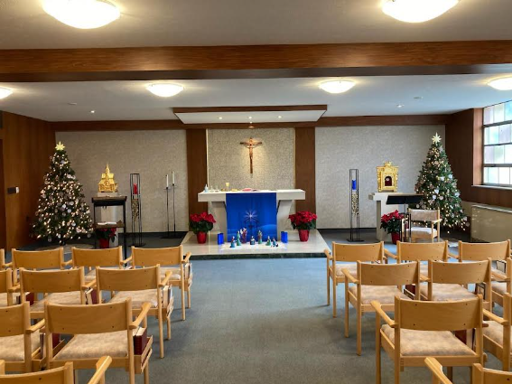
Saint Ann Shrine is administered by the Congregation of the Blessed Sacrament, a Roman Catholic community of priests and brothers dedicated to forming Christian communities centered around the Eucharist. Saint Ann Shrine helps support their ministries.
Saint Ann Shine website: https://www.blessedsacrament.com/st-ann-shrine/
Click on the history of the Saint Ann Shrine link on the parish website: https://church.saintpaschal.com/saint-ann-shrine

Mass is celebrated Monday – Friday at 11:30_{AM}

STAY IN THE KNOW AND JOIN US FOR ANNUAL HAPPENINGS

MINISTRY FAIR
AGAPE DINNER
SPRING FLING FESTIVAL
GREEN KNIGHT GALA
SPB AMERICAN RED CROSS BLOOD DRIVES
YOUTH MINISTRY HOSTED EVENTS

LITURGY AND SACRAMENTS

Funerals
Liturgy Commission
Liturgical Ministries
Mass Times
Sacraments
FUNERALS
To schedule and plan a funeral, please contact the front office at (440) 442-3410. Additional information can be found on the website regarding music and reading selections as well as a Mass planning document.
LITURGY COMMISSION
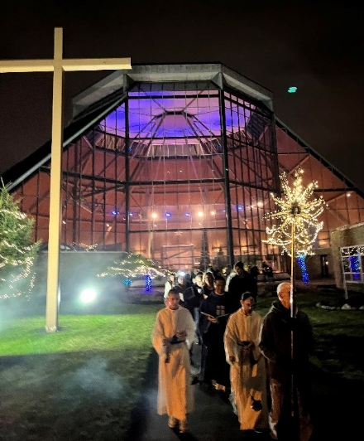
Purpose: To plan and implement the goals of the Constitution of the Sacred Liturgy and ensure quality liturgies in our parish. Members are the leaders of the different liturgical ministries and other interested members of the parish who would like to assist in the preparation of the liturgy.

LITURGICAL MINISTRIES
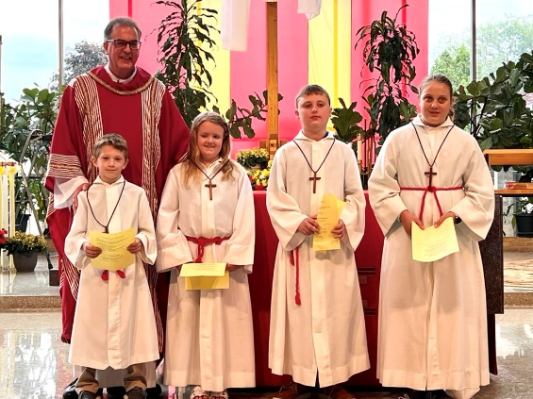
Altar Servers
Purpose: Boys and girls participating in this ministry will assist the priests during the weekend liturgical celebration. This ministry is available to children beginning in third grade.
Commitment: One hour on various weekends, per scheduled rotation.
Training: Training sessions are held throughout the year.
Leader, Christine Verdone: Christinezak@hotmail.com.
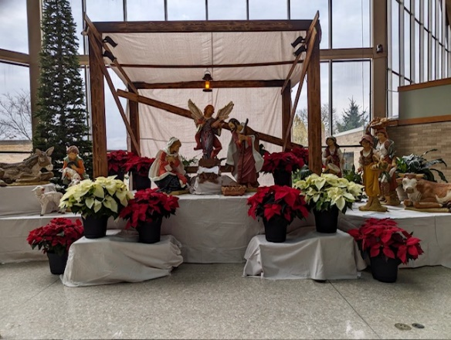
Arts and Environment Committee
Purpose: To create, execute and oversee all visual presentations related to specific liturgical seasons and holidays in the church. This includes display arrangement, setup, removal, and organization and maintenance of supplies and items used for the liturgy.
Commitment: Two-hour work sessions on Friday mornings. Two to four hours set up for special holidays in the daytime. These may be Saturday or the day before the Solemnity.
Background: Committee members should have a flair for space usage and arrangement. Skills in carpentry, plumbing, electrical wiring, sewing, drawing, and craft skills are beneficial.
Volunteers: We need help in the weekly work sessions to create display items. We also need added support for set up and take-down of liturgical season changes.
Leader, Cheryl Arstein at cheryarstein@gmail.com.

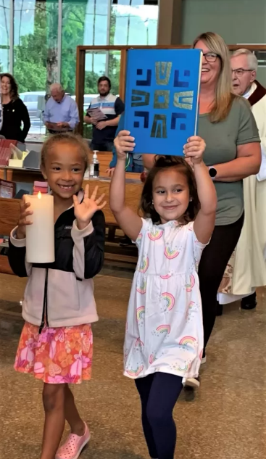
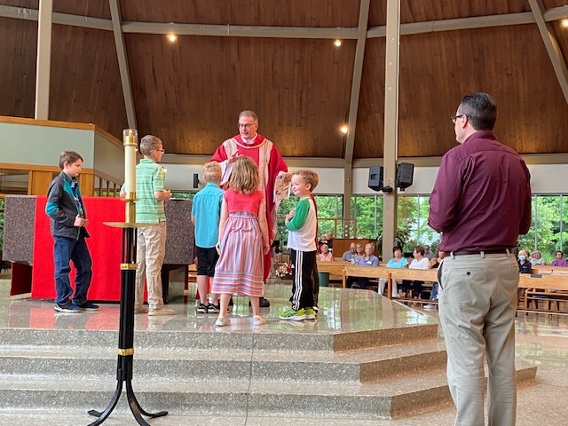
Children’s Liturgy of the Word
Purpose: To share God's Word with our children ages four through nine during the 10:30 AM Sunday Mass.
Leader, Anita Reddi-Chatterjee at achatterjee981@gmail.com

Extraordinary Minsters of Holy Communion (EMHC)

Purpose: Extraordinary Ministers for the distribution of Holy Communion (EMHC) are properly formed, instructed and commissioned lay persons. EMHCs may be male or female. These ministers are appointed for a given parish community to aid in the distribution of Holy Communion at Mass and to the sick and homebound when ordinary ministers of Holy Communion are unavailable. EMHCs are not to function apart from their parish community. Ordinarily, EMHCs do not perform any other liturgical ministry at the Mass at which they serve as an EMHC.
Commitment: The Eucharistic Ministers are divided into six teams. They are expected to serve as many Masses as possible with that team.
When the situation requires, the presider of the Mass may call upon members of the faithful who are not EMHCs to aid him in the distribution of Holy Communion on that one occasion. Those called must be Catholics in good standing who are themselves able to receive the Eucharist.
Selection Criteria: For a person to be appointed as an EMHC, the following conditions must be met:
- Be a Catholic living in harmony with the teachings of the Church and be able to receive the Eucharist
- Be of sufficient age and maturity to perform the duties of an EMHC at Mass or to the sick and homebound in various locations (i.e. private homes, nursing homes, hospitals)
Formation and Training: Prior to beginning their ministry, EMHCs should be formed and trained in the following:
- Theology of the Eucharist and understanding of the Mass
- Theology and spirituality of ministry
- Universal church, archdiocesan and parish guidelines and procedures for their ministry EMHCs should participate in ongoing theological and ministerial formation at the parish and/or Archdiocesan level.
- Extraordinary Ministers of Holy Communion are to distribute the Body and Blood of Christ at weekend Masses (on a rotating basis), major holidays of the year and special occasions.
Leader, George Zagar zagarga@gmail.com
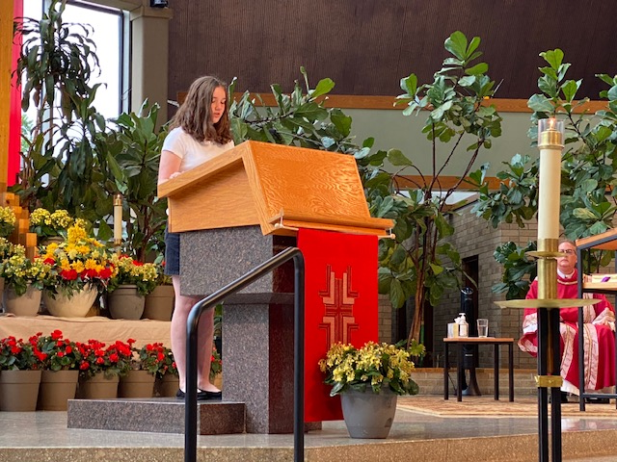
Lectors
Purpose: This liturgical ministry proclaims the Word of God at various liturgies throughout the year, especially for Sunday Eucharist. Different teams for Sunday and weekday Masses and leaders support the coverage of the proclamation.
Commitment: A lector would spend half an hour preparing for weekend readings.
Background: Lectors should be able to speak with confidence before the assembly.

Leader, Vera DiCianno Thorton JJVThornton@gmail.com.
Music Ministry
Music is an important part of the liturgy and combines the Arts & Environment in the church to enhance our worship experience of the Eucharist, the center of our life. It inspires the Scripture Readings in all the liturgical seasons and brings a certain emotion to our understanding of our faith. We encourage congregational singing in all parts of the Mass, especially at Communion time, as we receive the Body and Blood of Christ. The Congregation of the Blessed Sacrament, its founder, Saint Peter Julian Eymard, and our patron, Saint Paschal Baylon, are dedicated to the Eucharist. Our Music Ministry Ensembles lead us in worship. No experience is necessary. One needs only the desire to give glory and praise to God through song.
- Adult Choir Rehearsals - Rehearsals are Wednesday evenings from 6:30_{PM}. -7:30_{PM} most weeks from September through May in the church. All singers from every Mass are invited and encouraged to come and prepare and learn new music. Warm-ups are 30 minutes before each liturgy in the church.
- Adult Choir Ensembles - Ensemble Mass times are Saturday at 4:30_{PM}, Sunday at 8:30_{AM}, 10:30_{AM} and 6:30_{PM}. Each Mass has its Ensemble. We are delighted to welcome anyone who wishes to join their voices in song.
- Cantors - Many members of our Ensembles serve as Cantors, making announcements, proclaiming the Psalm and Acclamations, and Universal Prayers at every Mass.
- Celebration Choir - For Christmas and Easter, the Ensembles combine to form a Celebration Choir.
- Children’s Choir - Rehearsals are Thursday afternoon from 3:30_{PM} – 4:30_{PM} in the church. The children lead the singing once a month, usually at 10:30_{AM} Mass. Children of all ages to 5th grade are welcome to join.
- Funeral Choir - A dedicated group of singers, The Lazarus Singers, assist and lead the singing at Funerals, bringing comfort and consolation to families. Warm-up is 30 minutes before the liturgy. We welcome anyone to this important ministry.
- Instrumentalists - We welcome anyone who can play piano, organ, guitar, percussion, flute, violin, handbell, or any other instrument for our Masses. Added instruments support the singing and make a difference in lifting our hearts and voices in worship and celebration.
- Liturgies - Special liturgies throughout the year include 1st. Communion, Confirmation, PSR Masses, Holydays, Taize’ Prayer, Saint Ann Triduum, Saint Peter Julian Eymard Triduum, Holy Thursday, Good Friday, Easter Vigil, Interfaith Prayer Service, Bereavement Mass, Morning Prayer, Corpus Christi Procession. Other celebrations come up, and all voices that join together make these liturgies special.
- Schola - Our 6th-8th grade students make up the Schola, our Student Ensemble for school Masses throughout the school year. They proclaim the Psalm, announce the songs, play instruments, and lead the singing.
Leader, Roberta Modica robertamodica@juno.com
Society of Saint Therese
Our ministry is to provide beauty in our church, office, and Family Life Center areas, using and reusing flowers and plants donated to our parish and assisting in the church's art and environment.
Leader, Sue Divito 216-268-9337.
Society of Saint Matthew
Purpose: Volunteers assist the parish by counting and recording the financial donations made by our parishioners after the Saturday and Sunday Masses.
Ushers
Purpose: To assist those attending Mass in finding seating, attending to the offertory collections, and a variety of other duties that enhance the experience of those attending Mass.
Commitment: Approximately one and one-half hours per week, at an assigned Mass on the weekend or other Holy Day. Annually, ushers are trained in emergency techniques.

SACRAMENTS

Guidelines for Sacraments: Our parish community enjoys celebrating the special moments in your life faith journey. The policies are designed to assist in the preparation for the sacraments or sacramentals. While these are internal policies, from time to time, they may be requested by parishioners to be seen for clarification and support to a Pastoral Staff decision.
Sacraments are gifts from God and the church. The church facilitates the programs and preparation for each sacrament. While the sacraments are free or at no cost, the different programs, supplies and preparation aids have varying financial obligations. If a family is not able, please let us know of the scholarship needs. These are our current figures, subject to change and will be noted. View our website to review the policy document.

Leader, Anna Peko annapeko11@gmail.com

Anointing of the Sick
Baptism
Confirmation (Adult)
Confirmation (Youth)
Holy Communion
Holy Orders
Reconciliation
Sacrament of Matrimony

ANOINTING OF THE SICK
Offered on the First Sunday of the month after 8:30_{AM} Mass in the Our Lady of the Blessed Sacrament Chapel. Or you can call the Parish Office at 440.442.3410 to arrange.

BAPTISM

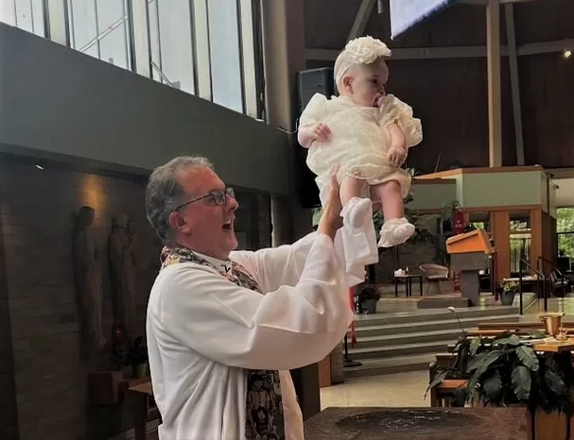
Infant Baptism: Under the age of 7

Step 1: If this is your first child being baptized, you must attend a one-time baptism class. If this is not your first baptism, please proceed to step 2. Classes are held every other month on Sunday at 9_{AM} in the parish offices. There is a $40 fee for the class. Parents must attend the class before the baptism.
Step 2: Godparents: One Confirmed Catholic is required to witness the baptism, and a family may document one male and one female for the records. A family is permitted to have other special honorary people be a part of the rite. Please complete the registration before scheduling the baptism.
Step 3: There are two types: during Mass and outside of Mass. During Mass: the baptism will be a part of the Mass. Outside of Mass: your family only (20 minutes). Please complete the registration before scheduling the baptism. If none of the dates work for your family, you may contact Fr. Rosario to check his availability at rosa15raj@gmail.com.

- We will email you the week of the baptism with some additional information.
- If your child is over the age of 7 or if you have additional questions, please contact the parish office.

CONFIRMATION

“Be Sealed with the Gift of the Holy Spirit!”
Confirmation, together with Baptism and Eucharist, form the Sacraments of Initiation that are all intimately connected. In the Sacrament of Confirmation, the baptized person is "sealed with the gift of the Holy Spirit" and is strengthened for service to the Body of Christ.
The prophets of the Old Testament foretold that God's Spirit would rest upon the Messiah to sustain his mission. Their prophecy was fulfilled when Jesus the Messiah was conceived by the Spirit and born of the Virgin Mary. The Holy Spirit descended on Jesus on the occasion of his baptism by John.
Jesus' entire mission occurred in communion with the Spirit. Before he died, Jesus promised that the Spirit would be given to the Apostles and to the entire Church. After his death, he was raised by the Father in the power of the Spirit.
Those who believed in the Apostles' preaching were baptized and received the Holy Spirit through the laying on of hands. The Apostles baptized believers in water and the Spirit. Then they imparted the special gift of the Spirit through the laying of hands. "'The imposition of hands is rightly recognized by the Catholic tradition as the origin of the sacrament of Confirmation, which in a certain way perpetuates the grace of Pentecost in the Church'" (CCC, no. 1288, citing Pope Paul VI, Divinae Consortium Naturae, no. 659).
By the second century, Confirmation was also conferred by anointing with holy oil, which came to be called sacred Chrism. "This anointing highlights the name 'Christian,' which means 'anointed' and derives from that of Christ himself whom God 'anointed with the Holy Spirit'" (CCC, no. 1289, citing Acts 10:38).

- Confirmation (Adult)
Adult Confirmation classes are usually available in January. The class is 6 weeks. Confirmation will be celebrated with the youth when the Bishop comes in the spring.
- Confirmation (Youth)
A child in the 8th grade will automatically be registered for this program, and the parents will be emailed information about the program.
Confirmation is the Sacrament that completes the grace we receive in Baptism. It seals or confirms this grace through the seven gifts of the Holy Spirit that we receive as part of Confirmation. This Sacrament also allows us to participate in the worship and apostolic life of the Church. Like Baptism, Confirmation is received only once in a person’s life– Confirmed in the Spirit.
HOLY COMMUNION
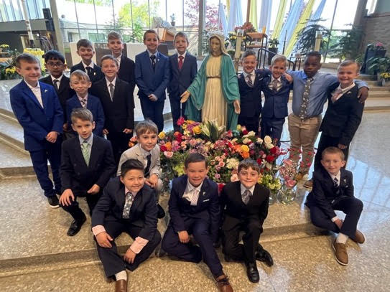
Students receive this sacrament in the second grade. Both First Reconciliation and First Communion classes will occur separately from regular catechism classes. Parents with children in the second grade will receive communication about the program.
RCIA participants will also receive this Sacrament.

HOLY ORDERS

Holy Orders (Deacon & Presbyter) & Religious Life: Our Parish Staff assists in the discernment process for one contemplating becoming ordained or vowed in consecrated life. We are all encouraged to pray for vocations and to encourage and affirm people to a life of service in the church. Once a year, the weekend Masses at Saint Paschal Baylon focus on religious life or the ordained ministry.

RECONCILIATION

First Reconciliation: Registered Religious Education students receive this sacrament in the second grade. Students must be enrolled for two years of preparation, beginning in the first grade. The sacrament is celebrated in February or March in the second grade. Both Penance and First Communion classes include a $40 donation for materials.
Those enrolled in RCIA will also be instructed and receive this Sacrament.
Parish Reconciliation: Reconciliation is offered every Saturday from 3:00_{PM}-4:00_{PM} in the Church or at any time in the Parish Office. You may also call the Parish Office and schedule an appointment.

SACRAMENT OF MATRIMONY

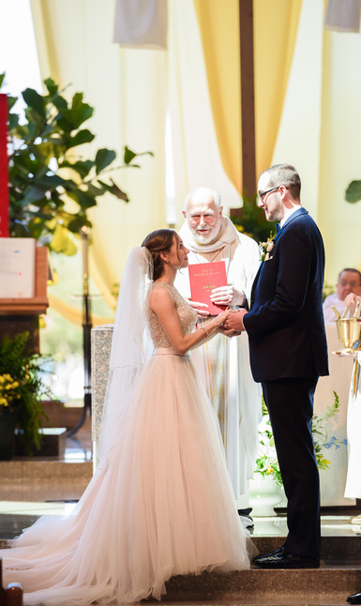
Marriage Preparation: A priest will assist you in the process of celebrating the Sacrament of Marriage. Every couple will be given a sponsored couple from our parish who will meet with you on mutually agreed times in the sponsor's home.
- Natural Family Planning
- Pre-Cana
Pre-Cana is a course our consultation couples undergo before they can be married in a Catholic Church. The name is derived from John 2:1-12, the wedding feast at Cana in Galilee, where Jesus performed the miracle of turning water into wine.

The engaged couples of Saint Clare and Saint Paschal parishes are invited to attend a one-day marriage preparation day hosted by parishioner married couples. Pre-Cana is scheduled one Sunday a year in the Saint Clare gym. For more information contact the parish office at 440.449.4242 Ext #101.
Wedding Guide: Check our website and click to find out more wedding notes, guidelines and procedures.

COUNCILS

Finance Council
Pastoral Council
School Advisory Council

FINANCE COUNCIL - Phone: 440.442.3410
Purpose: To ensure financial stability for the Parish and review Saint Paschal Baylon’s monthly financial statements to review actual vs. planned revenues and expenses. This group is responsible for preparing the annual budget for the Church and the School to ensure the proper financial direction for the Parish. The Finance Council reviews and coordinates major capital expenditure projects. This group is also responsible, with the assistance of an outside advisor, for managing the investments of the School Endowment Fund.
Background: A basic understanding of financial statements and the ability to help prioritize financial demands.
PASTORAL COUNCIL - Phone: 440.442.3410
Purpose: To advise the pastor on various subjects related to the parish. Information is gathered from the parish ministries and committees. We assist in the vision and implementation of the parish's mission statement.
Commitment: One meeting per month for two hours

SCHOOL ADVISORY COUNCIL
Purpose: The SPB School Advisory Council is a volunteer group consisting of nine parent members, the school principal, pastor, and teacher representative. The Advisory Council is a consultative group (i.e., does not have decision-making authority) that advises the Principal and Pastor on various areas related to the school. The primary functions of the group are to be a source of ideas, input, and recommendations in areas such as curriculum, school environment, technology, communication, marketing, and policies & procedures. The Advisory Group is also a liaison to address broader parent questions and concerns.
If you are concerned about something going on in the school or have positive feedback regarding school operations, contact your grade representative. All questions, concerns, and feedback are discussed with respect for anonymity and confidentiality.
FAITH FORMATION

Aggregation of the Blessed Sacrament
Becoming Catholic (RCIA)
Bible Studies
Community at Prayer
Intercultural Cooking Club
Life in the Eucharist
PSR
Spiritual Formation Commission

AGGREGATION OF THE BLESSED SACRAMENT
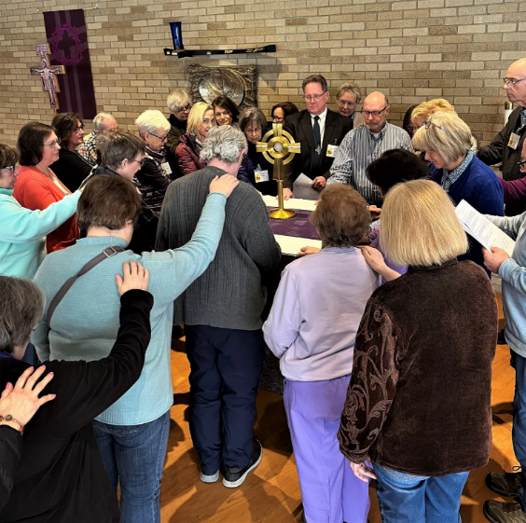
Purpose: Associates of the Blessed Sacrament are lay men, women, and clergy who have experienced a call to be and do more in living and sharing the mission and charism of the Congregation of the Blessed Sacrament. Saint Peter Julian founded the Aggregation to assist women and men in their life and the Eucharistic vocation ministry of making the Eucharist known and loved as a transformative force in the church and society.
Commitment: Associates engage in a year-long formation process and make public promises to live their lives centered on the Eucharist. This is an annual process with the promise shared in November after a day-long retreat. In partnership with the priests, deacons, sisters, and brothers of the Blessed Sacrament, they engage in service, especially at our parish, outreach to the poor, liturgical ministries, prayer in the presence of the Blessed Sacrament (adoration), encouraging a eucharistic way of life among family and friends, visit the infirm and elderly and perform other acts of charity that manifest the presence of Christ given to us in the Eucharist.

BECOMING CATHOLIC (RCIA)
Rite of Christian Initiation of Adults or RCIA. Call Parish Office: 440-442-3410
Conversion, a gradual process:
+ The RCIA as a rite, marks stages along the path to full commitment in the Roman Catholic Church; the RCIA as a process, describes in broad terms what this gradual commitment means.
+ The RCIA as formation gradually looks to the inner transformation of the individual to God's call as given week by week in the lectionary of Scripture readings. It also looks to Sunday Eucharist and to the gradual transformation of the person to become an active member of Saint Paschal Baylon Roman Catholic Church.
Commitment:
+ Catechumens and Candidates meet every Sunday after celebrating the liturgy with the Saint Paschal Baylon Community to further pray over the Sunday Scriptures. This also includes a weekly study session to familiarize everyone with the doctrines and teachings of the Church. Every person has a Catholic sponsor who “walks with” the candidate, prays for him, and participates in the various blessings and rituals connected with the process of initiation.
BIBLE STUDIES
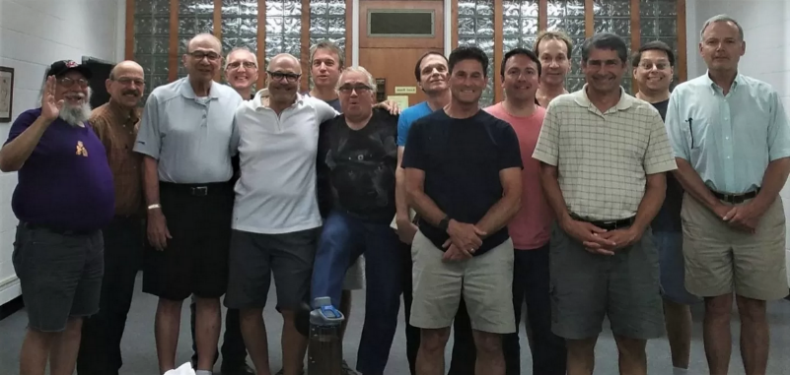
Men’s Bible Study:
The Men's Bible Study has been active since 2003, meeting on Tuesday evenings in the Kazel Room and the Parlor from September through May from 7:00-8:00_{PM}. to study the Word of God. Many different area churches are represented as these Christian men grow in their faith and love of their Lord and Savior, Jesus Christ.

Leader, Rick Costanz0 rick_costanzo@ameritech.net

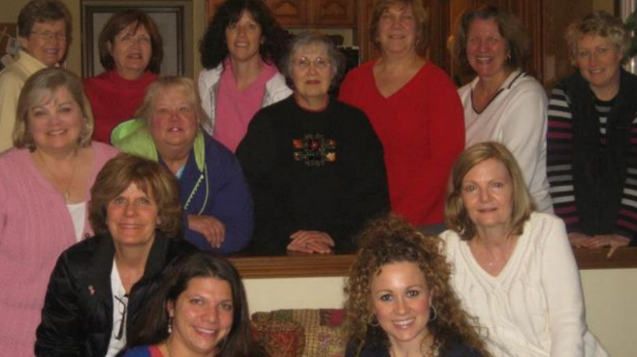
Women’s Bible Study:
Purpose: To learn about our faith through answering questions from the Bible and the Catechism. We share our answers and watch a DVD on the topic each week during the school year.
Commitment: Weekly gatherings. Call the Parish Office for more information.
Whether you are a novice or an expert, all are welcome to join us. Feel free to come a time or two to see if this is what you are looking for in a study. This is a friendly group of women who look forward to learning and sharing our faith.

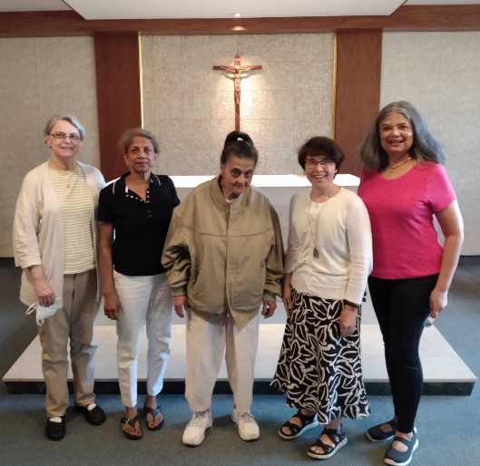
Agape Women's Bible Study: A small faith formation/sharing group to build community around the Word of God. Bring your own Roman Catholic Bible to join in the multi-media resources that enhance your learning with hymns, praise and worship, intercessory prayer, reading aloud from the Bible and more. This group meets on Tuesday, from 9:30_{AM} to 11:00_{AM}.
For additional information please contact Leader, Anita Reddi-Chatterjee at achatterjee981@gmail.com

COMMUNITY AT PRAYER

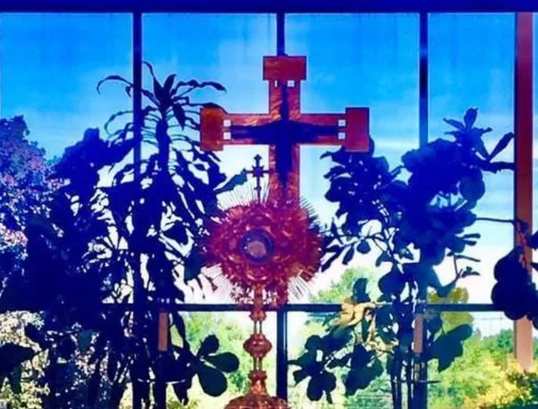
Purpose: To encourage parishioners to devote one hour each week of on-site prayer with the Blessed Sacrament.
Commitment: One regularly scheduled hour per week.
Please email me with any questions you may have. Thanks so much. monagrigsbysuarez@yahoo.com

Why do Adoration?
a) To provide an easy, attractive, and practical way of rendering God adoration which is His due as our Creator; of giving Him thanks for our redemption; of making reparation for our sins and the sins of mankind; of petitioning the good God for the constant help we need.
b) To show our gratitude to our Lord for remaining among us in our tabernacles and to make at least some atonement for the many sacrileges, indifferences, and ingratitude which He receives in His Sacrament of Love.
What spiritual benefits and graces can be attributed to an Adoration program?
a) An increase in Mass attendance and reception of the Sacraments.
b) Return of fallen-away Catholics and an increase in the number of conversions.
c) Increase in religious and priestly vocations.
d) Renewal of Catholic family life.
e) The spiritual level of the people is raised with a resulting desire and courage to spread the "good news" to others.
f) Creates a greater community spirit, centered as it is on the heart of the parish, Jesus' presence in the Blessed Sacrament.
Visit the website to view a parishioner’s reflection

LIFE IN THE EUCHARIST
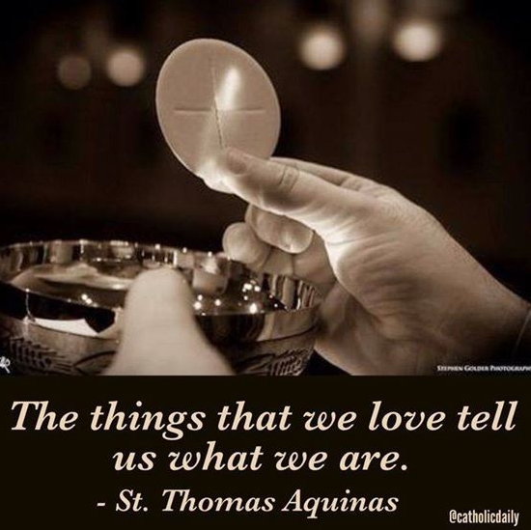
Teams of laypersons have been trained by Blessed Sacrament Community’s Center for Eucharistic Evangelizing. The Saint Paschal Baylon Life in the Eucharist Team has trained members of several other parishes to continue this program in their parishes.
Purpose: Our purpose is to make known the love of God manifested in the paschal mystery of Jesus Christ celebrated and contemplated in the Eucharist and lived in communion with others. Sent by the Spirit, we give witness to the effects of the Eucharist in our lives and in the life of the Church. Emulating the charism of Saint Peter Julian Eymard, we engage in the ministry of Eucharistic Evangelizing.
Commitment: All are invited to participate in the Life In The Eucharist presented in two formats: (A) Sacramental Reflections on the Eucharist, (B) Scriptural Reflections on the Eucharist. Those who would like to join a Life In The Eucharist team take part in a Formation Process and become active as team members in presenting the programs.

PSR
The Saint Paschal PSR teaching staff hopes to share with you the meaning of Christian life through teaching the message of Jesus as revealed to us by God and proclaimed by the Church. We hope to encourage the development of your family's God-given talents for service to others in building one true Christian community. The registration form and the calendar are below.
Saint Paschal Baylon PSR is for students in grades K-8. We meet on Monday evenings at Saint Paschal Baylon School from 6:30-7:30_{PM} from September through May.

Leader, Anna Peko annapeko11@gmail.com

SPIRITUAL FORMATION COMMISSION

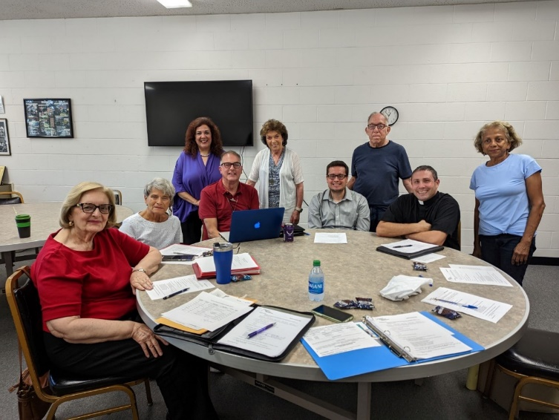
Purpose: We collaborate with our cluster parish, Saint Clare, to provide adult faith formation opportunities. In the fall, we have either a guest speaker or a class that deepens our knowledge and love of God. During the fall session, we focus on Church Documents or Scripture Study. In the fall and during Lent, we publicize and encourage participation in our Small Faith Sharing Groups. The Small Group Program started in the fall of 2015. At present, we have six groups. They meet during the morning, afternoon, and evening. During the fall session, we focus on Church documents or Scripture study. During the six weeks of Lent, the focus is on studying and putting into practice the Mass Readings to prepare ourselves for the celebration of the Resurrection. We plan, organize and sponsor the yearly parish mission held during Lent. We also prepare the Epiphany Packets, which contain prayer, chalk, and Holy Water to bless our homes for the New Year. We usually make 1500 packets. The Spiritual Formation Commission meets four times a year, and meeting dates are posted on both Saint Paschal's and Saint Clare's yearly calendars.

Leader, Rosalie Lewis raflewis48@gmail.com

MINISTRY

A Green Knight to Remember
Bereavement
Catholic Men’s Fellowship
Credit Union (Federal)
Divorce/Annulment Ministry
Flock of Friendship (Ages 40 and up)
Intercultural Cooking Club
Knights of Columbus Gilmour Council #310
Marriage Encounter
Ladies Guild
Marketing Committee
Spring Fling Parish Festival
Welcoming Committee
Wellness Ministry
Youth Activities

A GREEN KNIGHT TO REMEMBER

This highly anticipated event serves as a vital fundraiser for our school, providing essential funding for various educational programs, scholarships, and facility improvements. A portion of the proceeds from the evening will be used to fund campus security needs and other facility improvements to ensure that our children and teachers continue to have access to great technology and learn in a safe environment. Leader Cheryl Pietrafese at 440-840-7599 greenknightgala@saintpaschal.com

BEREAVEMENT
Cluster Ministry through Saint Paschal Baylon and the Church of Saint Clare. Each of us grieves the loss of a loved one differently, yet many experiences are common to all. Saint Paschal and Saint Clare support widows and widowers, parents who have lost a child, or anyone who has lost a significant person. There are two six-week sessions, one in the fall and one in the spring. The group meets at Paschal’s in a relaxed atmosphere with discussion, guest speakers, support materials, and refreshments. This support group is open to parishioners and non-parishioners.

Leader, Allison Krebs 440-725-9949 Corky Mondello at 440-449-3584.

CATHOLIC MEN’S FELLOWSHIP

Purpose: Catholic Men's Fellowship is an organization of men, who gather regularly to help each other grow spiritually and develop a closer relationship with our Lord Jesus Christ. If you are interested in joining, please contact Jerry or attend a meeting as you consider a fuller response to God's call in your life!
Check out the Catholic Men's Fellowship of Northeast Ohio's website at www.cmfneo.com!

CREDIT UNION (FEDERAL)

Purpose: The Credit Union is a cooperative with a specific aim: to help members reach their financial goals. The Credit Union achieves this through savings and loan opportunities for parish members. Six directors and their employees manage the Credit Union. The Credit Union is open on Sundays from 9:00 a.m. until Noon and during the week by appointment.
Commitment: The directors meet monthly to review the Credit Union’s operation and plan for the future.
Training: To be a director, a person must have a willingness and ability to serve the membership, to continually learn and think creatively and embrace the Credit Union’s philosophy.

DIVORCE/ANNULMENT MINISTRY

Purpose: To assist those who were married here in the church to begin the process of annulment. There are three types of annulments, and while meeting with one of the priests, one answers questions, asks for assistance from others (witnesses) who can put together a "case statement" that is submitted to the Diocesan Tribunal Office for a decision. There is no cost for annulment in the Diocese of Cleveland.

FLOCK OF FRIENDSHIP (AGES 40 & UP)

Purpose: For Christian singles, age 40 and over, who have never married, who have been divorced or widowed. This is a safe environment to be yourself among single friends looking for support, social activities, and community service together.
Commitment: We meet for a dinner/general meeting every Friday of every month.

Leader, Jim Lis jimlis1612@att.net.

INTERCULTURAL COOKING CLUB

The Intercultural Cooking Club was founded by members of Saint Paschal Baylon and those of the Turkish Muslim Community who are members of the Northern Ohio Intercultural Association (NOICA). Our original purpose was to get to know one another by sharing recipes and fellowship as we ate what had been cooked together. Meetings have been on Saturday mornings or other special occasions, such as USA Thanksgiving and a Ramadan Iftar meal cooked by NOICA members.

Leader, Jo Ann Lane jlane7824@sbcglobal.net

KNIGHTS OF COLUMBUS GILMOUR COUNCIL #310
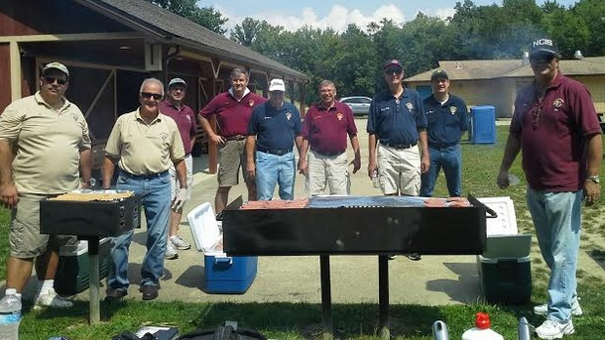
KofC Gilmour Council #310, chartered in 1898, serves Saint Paschal Baylon, Saint Clare, and Saint Francis of Assisi parishes. In addition to annual gifts to these parishes, Gilmour supports vocations, special needs programs, women’s shelters and maternity centers, Coats For Kids, Catholic education, Catholic radio and more. Gilmour knights run the Keep Christ In Christmas art contest and the KofC Free Throw competition in our parish schools. The council has recently purchased an ultrasound machine for Veranova Health.
The Knights of Columbus is an Order of practicing Catholic men, true to its founding principles of charity, unity, fraternity and patriotism. Founded by Blessed Michael J McGivney in 1882 to provide security to its members’ widows and orphans, the Order has grown from Saint Mary’s Church in New Haven, CT to 18,000+ councils and more than 2 million members in the Americas, Europe and Asia, the largest laymen's organization in the Catholic Church.
Website: kofc310.org
Leader, Jerry Wisniewski 440-221-1468 jerry_barb12@att.net

MARRIAGE ENCOUNTER
Worldwide Marriage Encounter is a weekend for married Christian couples who value their relationship and desire a more prosperous, fuller life together. Attend a Marriage Encounter weekend and learn how to keep your marriage strong. This site is dedicated to promoting and continuing the Worldwide Marriage Encounter movement in Eastern Ohio and parts of West Virginia. Worldwide Marriage Encounter emphasizes communication between husband and wife, who spend a weekend together away from the distractions and the tensions of everyday life to concentrate on each other. It's not a retreat, a marriage clinic, or group sensitivity. It's a unique approach aimed at revitalizing Christian Marriage. This is a time for you and your spouse to be alone together. To rediscover each other and focus on your relationship for an entire weekend. Every marriage deserves that kind of attention!
- Rediscover the spark that was there on your wedding day!
- Rediscover the best friend you had when you were first married!
- Join the millions of couples worldwide who have learned how to keep their marriage vibrant and alive!
WWME is faithful to the Roman Catholic Church's teaching that marriage is a covenant between one man and one woman. Any reference to marriage or couple made by WWME is in this context. https://greatmarriagesohio.org for more information.
Leader, Audrey & Dan Barrer 440kiva@gmail.com or visit the website https://greatmarriagesohio.org.
LADIES GUILD
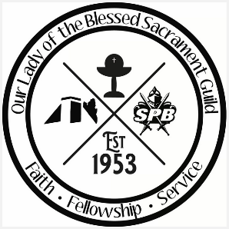
Established in 1953, The Ladies Guild is a volunteer organization that serves the parish and school community through Faith, Fellowship, and Service. Membership is open to all women of Saint Paschal Baylon. Meetings are held once a month in the parlor.
The Guild does the following activities:
- Holds an annual “Ladies Night Out” - A free social event that supports parishioner-owned businesses
- Coordinates and prays a Living Rosary & Living Divine Mercy Chaplet after Masses
- Works with the PTO to provide receptions for various occasions - Kindergarten & 8th Grade graduations and teacher/staff luncheons
- Provides a scholarship to an 8th-grade student attending a Catholic High School
- Provides Bibles for 5th-grade students
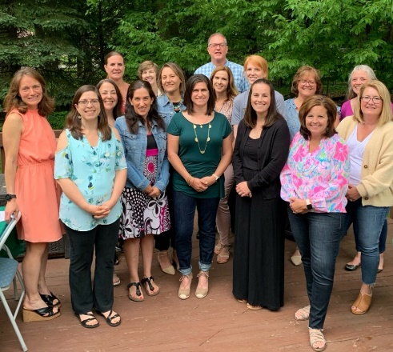
- Sponsors school programs - 7th & 8th Choose Life, 5th Grade Honor & Harmony, 4th Grade Connections, and 2nd Grade Jesus Day
- Runs Fall & Spring Craft Shows, which are our only fundraisers
- Staffs receptions for special events, makes baskets for raffles, and donates to various campaigns
- Hosts a yearly speaker, retreat, and puts on a Lenten Family Service Night

Come join this amazing group of women!

SPBGuild@saintpaschal.com

MARKETING COMMITTEE

Our vision is to create a sustainable marketing campaign to continue the success of SPB. Our mission is to provide promotional strategies and media that will focus on increasing enrollment by relaying the values of SPB to the community in a positive, faith-filled manner.

Leader, Nicole Waggle nicole.waggle10@gmail.com or Nick Babic babicna@gmail.com

SPRING FLING PARISH FESTIVAL COMMITTEE

Purpose: To provide a parish festival that is a fundraiser and fun for the entire family, with a raffle, games, entertainment, and more. This event is held around the feast day of our patron saint, Paschal Baylon.
The Committee meets once a month for most of the year and twice a month as we get closer to the opening day. Please call the number above to ask how you can share your gifts and assist us in holding this yearly festival!

WELCOMING COMMITTEE

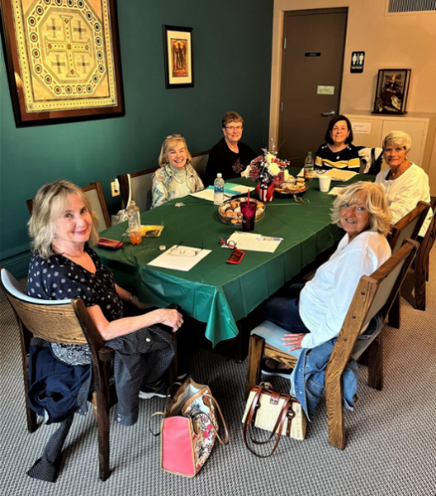
Purpose: The focus of this committee is to welcome newly registered parishioners to Saint Paschal Baylon Parish. Our goal is to make all registrants comfortable in their new faith community. The Welcoming Committee maintains the registration packet and assists new parishioners with their concerns or needs. A Welcome Card is sent to the new registrants extending a warm personal welcome. Periodically “Newcomers Brunches” are scheduled, allowing new registrants to learn more about the parish, particularly the many ministries and activities at Saint Paschal Baylon. The monthly meeting is usually held on the 2nd Tuesday of the month in the evening.
Commitment: Meetings are held monthly at the parish rectory. Beyond the monthly meeting, each member may spend another half an hour placing calls to new parishioners.

Leader, Jan Smerglia smergjm@sbcglobal.net

WELLNESS MINISTRY
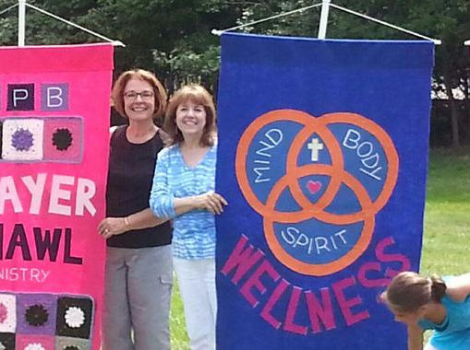
Purpose: To assist parishioners in their health needs by providing opportunities to learn about their well-being. Periodically, nurses provide blood pressure screening as well as hold workshops that benefit the parishioners.

YOUTH ACTIVITIES

Athletic Association
Bible Camp (Summer)
Children’s Liturgy of the Word
Cub Scouts 555
Day School
Girl Scouts
Teen and Children Choirs
Youth Ministry

ATHLETIC ASSOCIATION

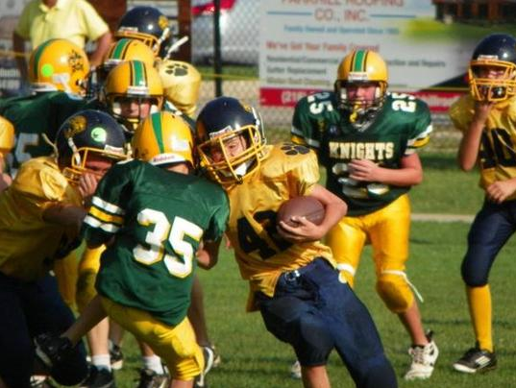
Purpose: The Athletic Association is dedicated to supporting and encouraging parish youth athletic activities for both day school and PSR students. The various athletic activities are coordinated through the school, PSR program, Parish and Diocesan CYO athletic programs. The Athletic Association Board directs the overall administration of the CYO athletic programs.
Commitment: Athletic Association meetings are held once a month. Check the parish bulletin for meeting dates and times.

Leader, Brian Herberth bherberth@kelley-ferraro.com

BIBLE CAMP (SUMMER)

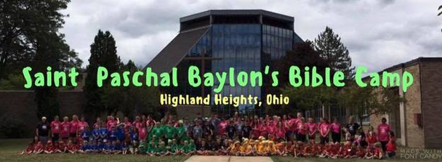
Who we are: Saint Paschal Baylon Bible Camp is a five-day, Catholic based camp for children ages 4 to entering the fourth grade.
Who can come: Bible Camp is opened to any child in any parish. What makes this camp different? Saint Paschal Baylon Bible Camp is unlike any other camp in our area. We do not purchase any VBS camp kits. Our camp is unique because everything we do is created by our directors. Come see for yourself!
Leader, EvaMarie Cross ecross@saintpaschal.com

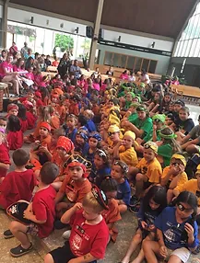

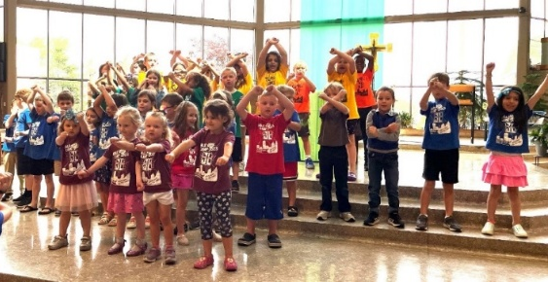

CHILDREN’S LITURGY OF THE WORD
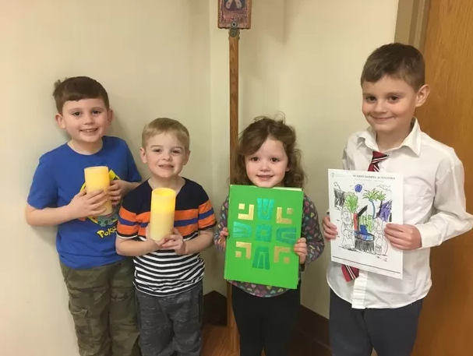
Purpose: To share God's Word with our children during the 10:30_{AM} Mass on Sunday.
Commitment: An initial training to go over procedures and order items. Volunteers will lead a CLW session about once a month.

Leader, Anita Reddi-Chatterjee achatterjee981@gmail.com

CUB SCOUTS 555

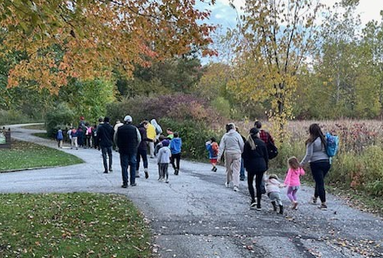
Our pack has served youth (K-6th) for 36 years.

Mission Statement: The mission of the Boy Scouts of America is to prepare young people to make ethical and moral choices over their lifetimes by instilling in them the values of the Scout Oath and Law.

Commitment: Pack meetings are held on Wednesdays about every other week. Additional meetings for leadership and parents to plan events/outings.

Leader, Patrick DeHaven dehaven.patrick@gmail.com

ELEMENTARY DAY SCHOOL
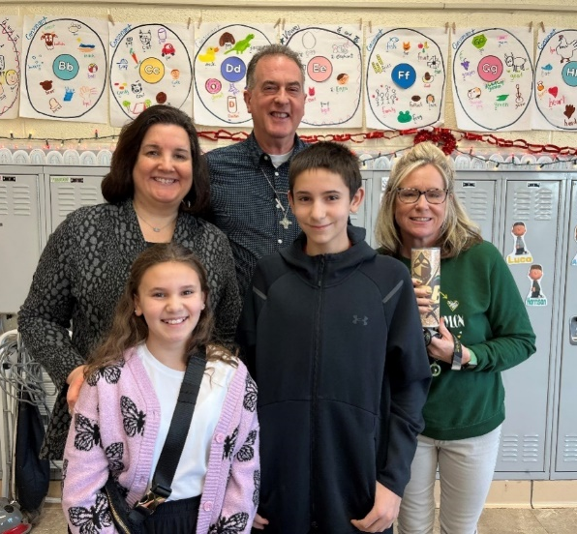
Enriching Minds, Nourishing Souls!
Visit Saint Paschal Baylon Catholic School's website! https://www.saintpaschal.net/
Mission Statement: The mission of Saint Paschal Baylon School is to recognize the dignity of each person by providing a unique and quality education. We strive to develop students who are permeated with Gospel values and are dedicated to reaching full academic and spiritual potential within the community. Special emphasis is placed on social and personal responsibility so that the students will meet the challenges of life in a global and technological society.
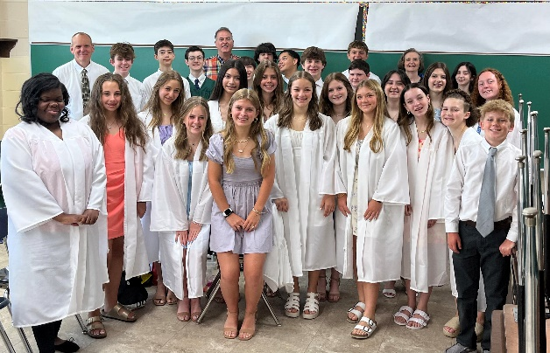
Commitment: Volunteerism opportunities are available in various capacities such as PTO, CPO, Ladies Guild, classroom assistance, library, lunchroom, playground, clerical, and others as needed. Time commitment is variable depending on the activities chosen. In 2009, the United States Department of Education recognized our school as a "blue ribbon school of excellence."

SCHOOL PTO

PTO@saintpaschal.com

GIRL SCOUTS

Purpose: Scouting provides young girls in grades K - 8 with opportunities to express, explore and widen their horizons as well as offering them non-school time to bond with other girls in their grade.
Commitment: On average, there are 2 one and a half hour meetings per month. Volunteer opportunities for parents/grandparents as well.

TEEN AND CHILDREN’S CHOIR
Teen Choir: 7th through 12th grade (September through June)
Mass: Sunday 7:00_{PM} (year-round)
Rehearsals: Sunday 6:00_{PM} in the church
Children’s Choir: 2nd through 6th grade (September through June)
Mass: Various regular parish Masses and times
Christmas Mass 11:00_{AM}
Easter Sunday 10:30_{AM} Mass
Rehearsals: Thursdays from 4:45_{PM}-5:45_{PM} in the School Music Room (on occasion in the church).

YOUTH MINISTRY

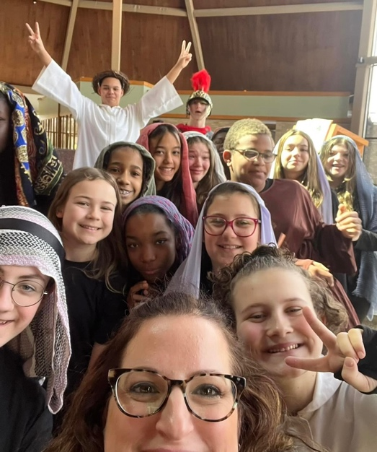
https://emickol.wixsite.com/spbyouthgroup

Purpose: Saint Paschal Baylon Youth Groups (Junior and High) focus on four areas of a young person’s life: Educational, Spiritual, Service, and Social. We have Gathering Sessions once a week, retreats, participate in NCYC, sponsor various 'outreach' fundraisers, and service-oriented activities. We encourage participation and always welcome newcomers. Our goal is to foster the total personal and spiritual growth of each young person in the life, mission, and work of the faith community.
Commitment: Involvement in the gatherings and various activities is open to each volunteer's timeframe of availability.

Youth Group for grades 6 through High School

YOUTH GROUP MINISTRY MEMBERS
Questions? Contact Mrs. Cross, Director of Youth Ministry at ecross@saintpaschal.com



Scan above to find our Scan above to sign up for
schedule upcoming events meetings, volunteer/service
forms & more opportunities, trips & more

OUTREACH

Blood Drive
Catholic Charities
Clown & Helping Hands Ministry
Communion to the Homebound
Manna Ministry
Prayer Shawl Ministry
ProLife Committee
Rosary Makers
Social Action Commission

BLOOD DRIVE
Saint Paschal Baylon sponsors frequent blood drives throughout the year, utilizing both the American Red Cross and LifeShare Community Blood Services. All eligible donors are encouraged to donate blood if they are able. The benefits of donating blood are many. First and foremost, blood donations save lives! It is also a great opportunity to help our school financially, as both LifeShare and the American Red Cross offer educational grant programs as an incentive to donors. Donors benefit themselves by giving blood as well.
Leader, Ann Marie Moore am-moore@hotmail.com
CATHOLIC CHARITIES

Purpose: To raise funds through parish donation for roughly fifty Catholic Charities operating locally in the diocese. Also, to raise awareness for those these charities serve.
Commitment: Attend two meetings a year and help execute the publicity plan.
Background: Ability to help produce publicity materials that will create a favorable impression of Catholic Charities to parishioners.

CLOWN & HELPING HANDS MINISTRY

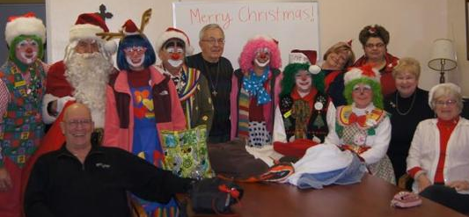
Clown Ministry

Purpose: We, as a ministry of clowns from Saint Paschal Baylon, are called to proclaim and be a sign of the loving presence of our Lord Jesus Christ. Through our actions of clowning, we will recognize every person’s dignity and uniqueness. We will strive to develop the meaning of unconditional love to all in this Ministry. Our intentions are to share and express genuine care for one another as members of the family of God. We are committed to bringing love, joy, and meaning into the lives of those we touch through clowning. Our goal is to make God happy by making His people happy. When you make my people smile, YOU MAKE ME SMILE!
Commitment: All are welcome ages 9-99. Participation varies depending on the individual’s desire to participate in various activities such as parades, nursing home visitations, and other church and school functions.
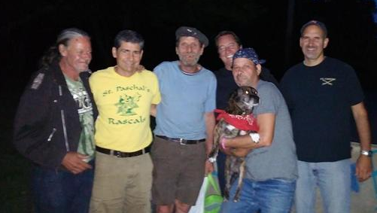
Helping Hands Ministry

Purpose: The Helping Hands Ministry members reach out to the poor and homeless in the Greater Cleveland area. We help those in need by providing food, clothing, toiletries, and sharing ourselves. Our monthly schedule has regular outings. We work in conjunction with the Clown Ministry to help those less fortunate and spread God’s peace, love, and joy.
Commitment: Meetings are held once a month and on an as-needed basis. Involvement is as little or as much as individuals prefer.
Leader, Bob Ukovic bobojangles@sbcglobal.net

COMMUNION TO THE HOMEBOUND

Purpose: This ministry serves the sick, the homebound, and those who are hospitalized or in nursing homes. Our primary function is to bring the Eucharist to parishioners who cannot get to church and to offer our companionship. We try to bring the church to them.

MANNA MINISTRY

Purpose: The purpose of Manna Ministry is to meet the emergency needs of parishioners due to illness, being laid off from work, utilities being shut off, needing help with food, and more. Members meet once a month in the Arkins Room on the second Sunday of the month after the 10:30_{AM} Mass.
Commitment: We meet on the first Sunday of the month in the Family Life Center after the 10:30_{AM} Mass.

Leader, Chris Berne cberne12@gmail.com
PRAYER SHAWL MINISTRY

The Prayer Shawl Ministry combines the love of knitting and crocheting with compassion for those in need of comfort and healing. Our ministry has shawls available now for anyone who would like one and may be picked up at the rectory office Monday – Thursday 9:00_{AM} – 4:00_{PM}. Each shawl is presented with a prayer tag attached. There is no charge for the shawls as it is the mission of the Prayer Shawl Ministry to provide prayerful comfort and remembrance to those in need. Knitters and crocheters are invited to join this prayerful ministry. Shawl makers meet once a month [on the third Thursday] or can be involved at home. Contributions for yarn are also greatly appreciated.

Leader, Kay Vincent katvincent@sbcglobal.net
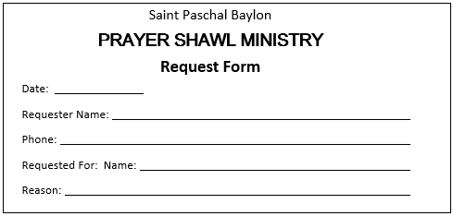
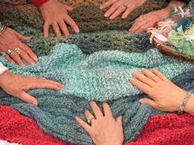

PROLIFE COMMITTEE
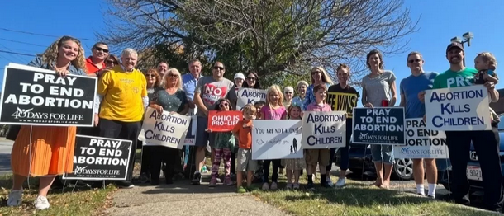
The ProLife Committee meets to hold events to support parishioners' involvement in critical Catholic causes of Respect for Life; by praying for the end of abortion, by being a voice for the unborn, and by recognizing that all life is sacred from conception to natural death.

ROSARY MAKERS

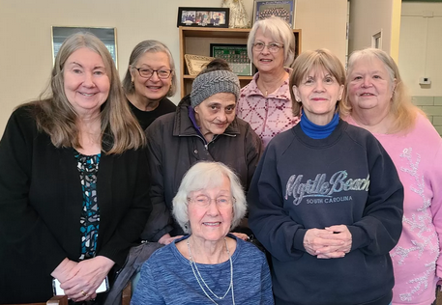
Purpose: We meet the first Wednesday of each month at 11:00_{AM} in the Arkin room. We make rosaries sent to overseas missions, patients in local hospitals, seniors in retirement facilities when requested, and church school children preparing for a significant Sacrament if requested by the teacher and for other formation or catechetical programs at SPB if requested. Materials and lessons on how to fashion these rosaries are provided. All are welcome!

Leader, Mary Jane Iacco mjginger@live.com

SOCIAL ACTION COMMISSION
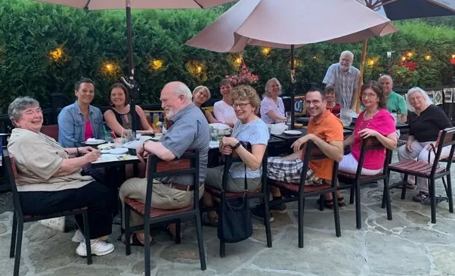
The Social Action Commission meets monthly to support parishioner engagement in critical social issues facing our neighborhoods, country, and world today by promoting Catholic Social Teaching through education, advocacy, and action.
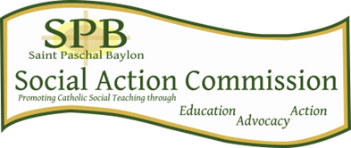

STEWARDSHIP

Through our baptism, we are called to live as Christ's disciples by contributing to our parish and our communities with generous acts of stewardship. The practice of stewardship is our response of gratitude to God for the blessings we receive. Acts of stewardship include a regular financial contribution and use of your offertory envelopes as well as contributions of time and talent through our parish organizations and ministries, worship and prayer. All registered parishioners are asked to contribute to the life of the parish through acts of stewardship. Individuals must decide how they can best share their gifts and resources. Members of the Pastoral Staff are happy to meet with you to help you discern how your gifts may best be used at Saint Paschal Baylon. Information about our ministries may be found on our parish website (church.saintpaschal.com) and in this brochure. Traditionally, the Pastoral Council hosts an annual Ministry Fair to provide an opportunity for you to learn, participate, develop your time and talent, and share your life blessings with God and our parish family.

MASS INTENTIONS/STIPENDS: Thank you for your generosity to the Blessed Sacrament Community for the Mass Intentions and requests for prayers. We speak aloud the names we pray for as you hear at each Mass. We mention these names with our regular intentions.
Angel Scholarship
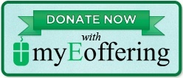
#weGiveCatholic
JOIN IN USING MYEOFFERING: See our website: www.church.saintpaschal.com Call Michelle Mazza in the Business Office, 440-442-3410 extension 101. PLEASE REMEMBER TO UPDATE YOUR CREDIT CARD INFORMATION – MANY ACCOUNTS HAVE OR WILL EXPIRE SOON.

Thank you for placing SPB in your will or trust! We appreciate you leaving a legacy that will strengthen the ministries of our parish into the future!
Charitable Contribution Statements are available each year. Please call the parish office to request your statement or email us at parishoffice@saintpaschal.com at the beginning of each year.

We are so grateful for you and your participation in the life of our parish!

OUR MONTHLY EXPENSES: We are so grateful for the many ways you choose to give your treasure: whether though the weekly envelope in the basket, dropped off at the Business Office, mailed in or your electronic giving; we are so appreciative of our common stewardship for the common good of our beloved parish SPB. We are so appreciative too for those who give special attention to our second collections and fill out the special form in MyEoffering. Second collections are assigned by the USCCB, the Diocese of Cleveland and the requests from our parish groups.

We love having you here, and we are so grateful for your tithing to God through this your parish, faith family!

CATHOLIC CHARITIES APPEAL: An annual pledged commitment donation amount that will be used to serve in our Catholic Charities organizations.

CATHOLIC COMMUNITY FOUNDATION:
As Christian stewards, we share the responsibility of making our Church a true community of faith and a vibrant source of service to the larger community. That includes providing financial support for today's needs -- and building a firm financial foundation for tomorrow. Your IRA can be a tool to help you do this. If you are 70 ½ years old or older, you can make a Qualified Charitable Distribution today for up to $100,000 from your IRA directly to your parish. It will not count as taxable income, and it can satisfy your “required minimum distribution”. Looking to the future, consider naming our parish as a beneficiary IRA. Speak with your financial advisor or visit https://www.catholiccommunity.org/ira for more information.

CREATE YOUR CATHOLIC LEGACY: When you make plans to leave a gift to our church, you demonstrate your gratitude to God for all the gifts with which God has blessed you. You also give witness to family and friends as to the importance of your faith, and at the same time, blessing the lives of those who will benefit from your generosity. Whether you make a gift to continue a ministry at your parish to help sustain the good works of Catholic Charities, to provide a Catholic education to students, to ensure the formation of priests, or to help another ministry of the Diocese of Cleveland, or the Blessed Sacrament Community, you are passing along the tradition of our Catholic faith. Your gift is part of your legacy and builds on the faith of so many and the facilities we enjoy because of them. Questions? Contact our parish office at (440) 442-3410. For the Blessed Sacrament Community, contact (440) 442- 2700.

PARISH LIFE

OUR SUGGESTION BOX - MAY I SUGGEST? As part of our Strategic Plan, our Saint Paschal Baylon Pastoral Staff and Pastoral Council are always interested in your ideas, suggestions, improvements and more! Look for the “new suggestion box” in the Fickel Narthex where you may add your written suggestions. Through our ombudsman, Tom Kelley, you can share your input by sending him an email at tjk12@case.edu.

COME PLAY! What: Tuesday Table games | When: Tuesdays 2:00 – 4:00_{PM} | Where: Sr Dorothy Kazel Room
Bring your favorite table game and a snack for yourself! For more information, please contact Mona – monagrigsbysuarez@yahoo.com 505-239-1019.

HOLY HOURS: Held one Thursday evening every month at 7:00PM

Leader, Mona Grigsby-Suarez monagrigsbysuarez@yahoo.com

DIOCESE VARIA

EUCHARISTIC MINISTERING AT HILLCREST HOSPITAL: Are you a Eucharistic Minister? If so: Would you like to bring Holy Communion to the sick at Hillcrest Hospital? Looking for Eucharistic Ministers for Friday and Sunday. Please contact: Christine Young by phone at 440-312-3739 for more information. Thank you.

NATIONAL CATHOLIC SINGLES: National Catholic Singles has an online group that connects singles from all over the United States. They have a Facebook page, as well as an app. They also host an annual National Conference. The Marriage and Family Diocesan webpage includes this information, as well as information about dating and retreats. Check it out!

CONNECT WITH US

View our website: Church.SaintPaschal.com
Join us on other social media: Facebook and Instagram
YouTube Channel: Please click on our website, church.saintpaschal.net, and subscribe to our YouTube channel for our regular videos, worship events, broadcast and archived videos.
Paschal Life: Email bulletin@saintpaschal.com with your name and email requesting to be added to our weekly eNewsletter, Paschal Life.
Parish Office Hours: Monday–Friday, 8:00_{AM}–4:00_{PM}

Pastoral Staff:
5384 Wilson Mills Road Highland Heights OH 44143-3092
(440) 442-3410

- Evamarie Cross, Associate of the Blessed Sacrament & Youth Minister, ecross@saintpaschal.com, ext. 127
- Jon Detzel, Director of Facilities and Capital Projects, jondetzel@yahoo.com, ext. 109
- Stephanie Evans, Parish Administrator & Bulletin Editor bulletin@saintpaschal.com ext. 105
- Sheila Klepcyk, Assistant Principal, sklepcyk@saintpaschal.com, ext. 318
- Michelle Mazza, Business Manager, mmazza@saintpaschal.com, ext. 101
- Roberta Modica, Music and Liturgy Director, robertamodica@juno.com
- Fr. Louis Demba Ndione, SSS, Parochial Vicar, ludovicus24@gmail.com, extension 215
- Diane Raguz, Principal, draguz@saintpaschal.com, ext. 312
- Fr. Sebastian Rosario Pushparaj, SSS, Pastor, rosa15raj@gmail.com, ext. 111
- Reverend Martin Hien Tran, SSS, Parochial Vicar, martinhien2022@gmail.com, Extension 107

Blessed Sacrament Community (SSS) in Residence:
5384 Wilson Mills Road
Highland Heights OH 44143-3092
(440) 442-3410

- Fr. Roger Bourgeois, SSS, Saint Ann Chaplain, rbourgeois41@gmail.com, ext. 234
- Fr. William Fickel, SSS, ext. 237
- Fr. Louis Demba Ndione, SSS, Parochial Vicar, ludovicus24@gmail.com, extension 215
- Reverend Martin Hien Tran, SSS, Parochial Vicar, martinhien2022@gmail.com, Extension 107
- Fr. Dr. John Keenan, SSS, Clinical Psychologist, ssspsyd@gmail.com, ext. 232
- Fr. Joseph Kiet Nguyen, SSS, Hillcrest Hospital Chaplain, huykiet104@gmail.com, ext. 210
- Fr. John Thomas Lane, SSS, Provincial, jtlanesss@gmail.com, ext. 229
- Bro. Thomas Mella, SSS, Diocesan Shrine of Saint Ann Shrine
- Bro. Gary LaVerdiere, SSS, House Manager, Brgarysss@aol.com, ext. 201
- Fr. Norman Pelletier, SSS, Student Director, nbpelletier@aol.com, ext. 237
- Fr. Rosario Pushparaj, SSS, Pastor, rosa15raj@gmail.com, ext. 111

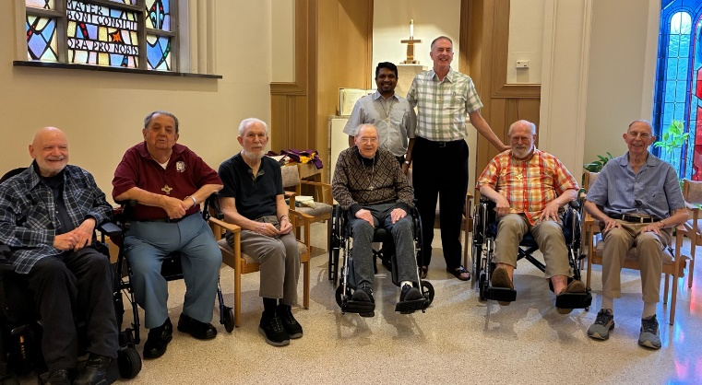
SSS at Regina Health Center:
Our Blessed Sacrament Community who are not in residence on the main grounds any longer stay and receive care at Regina healthcare center. They would love to see and hear from you! Stop for a visit, mail a letter or call one of our retired clergies.
5232 Broadview Road
Richfield OH 44286-9608
(330) 659-4161
- Bro. Allen Boeckman, SSS, boeckmana@juno.com
- Rev. Paul Bernier, SSS, pbernier@earthlink.net
- Dcn. Joseph Bourgeois, SSS, joeyappytheclown@yahoo.com
- Rev. Dr. Ernest Falardeau, SSS, Ecumenist, Efalardeau0@gmail.com
- Bro. Michael Perez, SSS, Assistant Superior, michaelangelsss@yahoo.com
- Rev. William Young, SSS, wtyoung@blessedsacrament.com

Sisters of Notre Dame
- Sister Mary Ann Baran, SSS, Local Leader
- Sister Sharon Kovalcik, SND, Julie Billiart School
- Sister Kelley Rush, SND, Novice Director & Spiritual Director
- Sister Rita Schroeder, SND, Vocation Ministry

