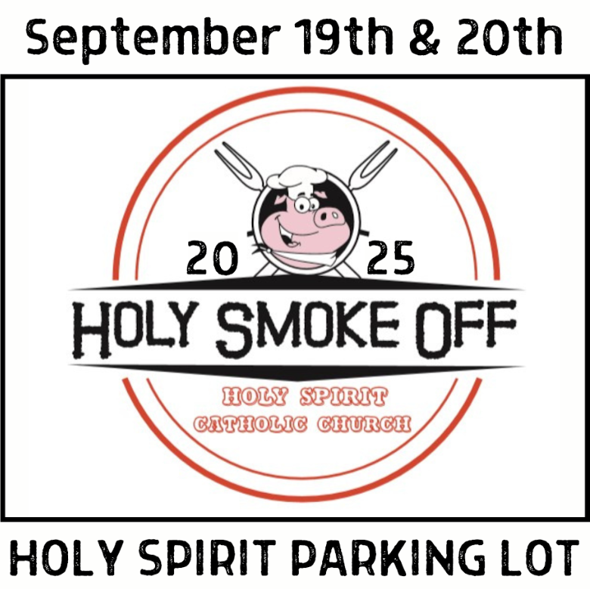

2025 HOLY SMOKE OFF SCHEDULE

# FRIDAY, SEPTEMBER 19, 2025

9:00am – 4:00pm BBQ Team Load In and Setup

5:30-6:30pm Kids’ Baking Contest Turn In (Martha and Mary Room)

6:00pm Kids Baking Judges Meet (Martha and Mary Room)

6:30pm – 7:30pm Kids Baking Judging (Martha and Mary Room)

7:30pm Kids Baking Contest Winners Announced (HS Parking Lot)

7:30pm – 8:00pm Pick Up Kid’s Baking Containers (Martha and Mary Room)

6:00pm – 8:00pm Parish Grill Out – Hot Dogs, Chips Served (HS Parking Lot)

11:00pm Quiet Hours Begin

# SATURDAY, SEPTEMBER 20, 2025

11:30am Judge’s Meeting (Martha and Mary Room)

12:00pm-2:00pm Meat Judging (Martha and Mary Room)

11:55am – 12:05pm Chicken Turn-In

12:25 – 12:35 pm Rib Turn-In

12:55 – 1:05pm Pork Turn-In

1:25-1:35pm Brisket Turn-In

2:30 pm Awards Ceremony

2:45pm-3:30pm Tear Down (Teams should be out no later than 3:30 to allow parking for 5pm Mass)

Questions? – Contact Bill Ramsey at knights11661@gmail.com