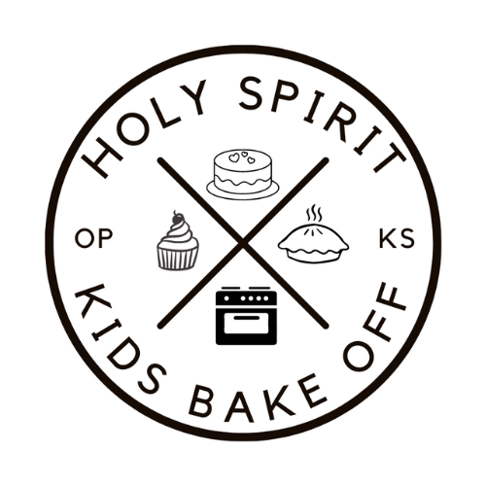

2025 HOLY SMOKE OFF KIDS BAKE OFF

# Rules

* There is no charge to enter the Holy Smoke Off Kids Bake Off.
* This is a kid’s baking contest, so entries should be prepared by kids with limited help from an adult.  Store-bought entries are not allowed.
* Entries will be separated into two groups: Grades 1-5 and Grades 6-8. Both groups will be judged independently with winners declared for each group.
* Rules, submissions, timing and judging is the same for both Grade groups.
* Entry may be any type of dessert, but keep in mind that no refrigeration will be available during turn-in or judging time.  Entries will be judged as they appear at the time of judging.
* Entries can be individual portions or one large portion. If individual portions, please provide at least six portions.
* Entries shall be turned in on contestant provided serving platters, contains, trays.
* All platters, containers and trays will be available for pickup after judging and must be picked up by 8:00pm on Friday night. Holy Spirit is not responsible for lost platters, containers, or trays.

# Entry Submission

* All entries shall be brought to the Martha and Mary room between 5:30pm and 6:30pm on Friday, Sept 20.
* If you intend to submit a dessert, please pre-register using the QR code at the top of the page.
* You may still enter the contest if you do not pre-register but will need to register with the judging coordinator when dropping off your entry during the turn in time.

# Judging

* Each entry will be numbered and placed on a random table in the judging area. Each table will have an approx. the same number of desserts.
* Each table will be assigned a judge who will score all table entries on appearance and then use a clean utensil to sample a bite from each entry.
* Each entry will be judged and scored 1-10 on three criteria weighted as follows:
  + Appearance - 1.25, Creativity - 0.5, Taste 2.5
* The judge will record their scores for all entries on their table and tally the results.
* The highest scoring entry from each table will be selected for the final round of judging.
* In the final round of judging, all the table judges will use a clean utensil to sample at least one bit from each of the entries and score based on the same criteria as the first round.
* Those scores will be tallied and the highest score from the final round of judging will be awarded the championship.
* The top three scores in each in the final round will receive:
  + 1st - $25 Gift Card, Championship Banner and Name Listed in the Holy Spirit Bulletin.
  + 2nd - $15 Gift Card and a Ribbon
  + 3rd - $10 Gift Card and a Ribbon