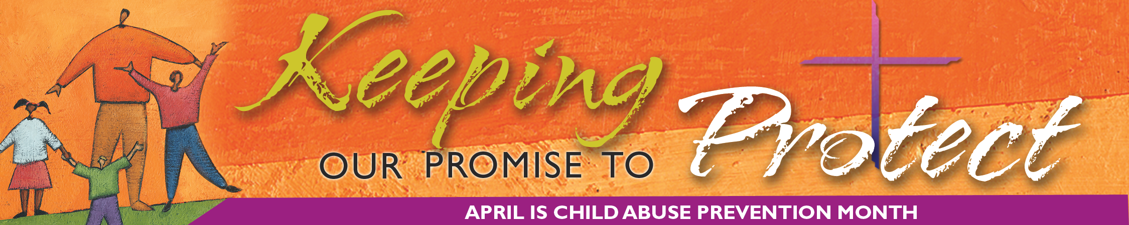
SECRETARIAT of Child and Youth Protection • United States Conference of Catholic Bishops

Church Still Challenged to Deal with Clerical Abuse of Minors

By Beth Griffin

The church has made significant progress in dealing with clerical sexual abuse of minors, but it must continue to be vigilant because healing is a long-term process. Part of the challenge is to incorporate the Charter for the Protection of Children and Young People into the fabric of church life.
Since 2002, dioceses have taken unprecedented steps to confront the issue, assist the victims, seek forgiveness, ensure the safety of minors, and restore credibility.
Healing of victims is a primary concern moving forward, said Bishop Gregory Aymond of Austin, Texas, chair of the U.S. bishops’ Committee for the Protection of Children and Young People. “First and foremost, we must reach out to those who have come forward and look for those who have not. We have to give them love and be a source of healing.” Some victims want to deal with the issue on their own, but “others cannot and should not.”
The church also needs to let people know what efforts have been made.
“The church is the only group that has undertaken a comprehensive program to educate children and the people who work with them,” said Archbishop Harry Flynn of St. Paul and Minneapolis, chairman of the Ad Hoc Committee on Sexual Abuse (which became the Committee for the Protection of Children and Young People). “There is a huge success story to tell, and we’ve told it, but I don’t know if anyone is listening.”
The success includes safe environment training for more than six million people and background evaluations for more than 1.6 million people who work with children in the church, according to Teresa Kettelkamp, executive director of the USCCB Secretariat of Child and Youth Protection. The training is a centerpiece of the Charter, which the bishops adopted and called to be implemented in each of the 195 dioceses in the United States.
“We are challenged to be vigilant,” said Archbishop Wilton Gregory of Atlanta, former USCCB president. “We’re dealing with a situation that may have taken many years to come to the surface. We have to be vigilant that we are doing the right thing as we move forward and not grow despondent that the issue has not been completely settled. The victims and their families have been deeply hurt and still need our support.”
Archbishop Gregory recalled being asked: “How long is this going to go on?” “In truth,” he replied, “it will be years. It won’t make headlines, but the process of healing will go on for the rest of my episcopate. I will be responding to the needs of people.”
“We have apologized and we want the church to be purified,” said Bishop Aymond. “Our leadership has been challenged and our credibility has been lost. We have to restore credibility by proving that we are honest and straightforward. Credibility requires words and, more importantly, actions, and it takes time.” Specifically, he said, “We have to live out the spirit and letter of the Charter. We must reach out to victims and do justice, and we have to fulfill the mandate of Pope John Paul II, who said, ‘There is no place in the priesthood or religious life for those who would harm the young.’”
If there is any possible silver lining to the dark cloud of the abuse crisis, it may be, as Bishop Aymond said, that “the sexual abuse crisis in the church uncovered the fact that sexual abuse in the United States is far more common than we imagined.”
“We have an opportunity to be agents of change for the society,” he said. “Our Charter gives some guidance on how we expect situations to be dealt with, and we have developed the safe environment program,” which can be used as a model for others.
# # #

