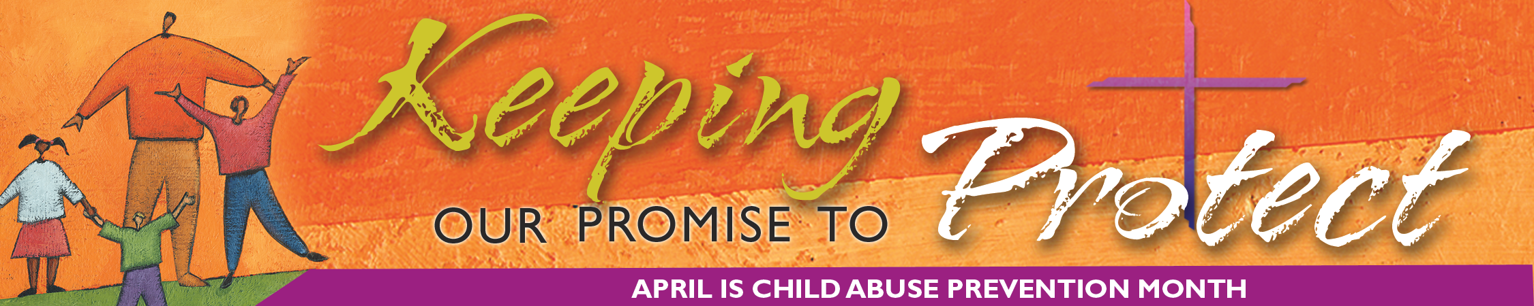
SECRETARIAT of Child and Youth Protection • United States Conference of Catholic Bishops
Learning from Clergy Abuse of Minors Scandal Can Help Others

By Joseph Young
The clergy sexual abuse scandal that rocked the U.S. Catholic Church five years ago was a painful period but a teachable moment. Healing and preventive measures have gained momentum since the U.S. bishops adopted the Charter for the Protection of Children and Young People in June 2002 and formed an independent National Review Board.
Subsequently across the nation, in accordance with the Charter, diocesan review boards have been formed, safe environment programs put into place, annual audits on abuse implemented, and procedures for more careful screening of priesthood candidates adopted at seminaries.
There is also much that others can learn too, said Bishop Gregory Aymond, chair of the USCCB’s Committee for the Protection of Children and Young People and bishop of the Diocese of Austin, Texas. He noted that two other Christian denominations and one school system already have asked his committee how to deal with sexual abuse by those in authority.
Ann Riggs, PhD, a member of the Religious Society of Friends (the Quakers) and associate general secretary for Faith and Order for the National Council of Churches of Christ in the U.S.A., said that from the Catholic Church’s experience with clergy sexual abuse, other churches have learned that ignorance is no excuse.
“You have to educate yourself so you are not naive,” she said. Another lesson learned, Riggs said, is that supervisors cannot give candidates for positions in Church leadership the benefit of the doubt and dismiss questions about their background.
“You can’t just assume their mental health and spiritual honor,” she said. Finally, Riggs said, churches have learned from the Catholic experience that abuse compromises an institution’s capacity to carry out its mission. Some funding for ministries is diverted to legal fees and settlements for victim/survivor counseling. Also, in a church wracked by scandal, those in the pew, if they remain in the pew, are less likely to contribute monetarily.
But it is not only institutions that can learn from the Catholic Church’s experience, Bishop Aymond said.
“At every level of society, consciousness has been raised about sexual abuse. More and more, even families sitting around the table are discussing it openly,” he said.
One topic is the importance of being vigilant, which Bishop Aymond said is perhaps the primary lesson to learn.
“You need to be very, very vigilant about picking up any signals that sexual abuse may be occurring,” he said.
Robert Bennett, Washington attorney and charter member of the National Review Board, said, “People need to realize that child abuse occurs in all sorts of places; you can’t be self-righteous and say, ‘It can’t happen here.’”
Closely related to vigilance is prevention. One preventive measure to be learned, Bennett said, “is not to allow dysfunctional men into the clergy.”
Bennett warned against using the “geographic cure”—which is no cure at all—of moving abusive pastors to other churches, and he also advised against “burying the abuse for fear of scandal, only to have a bigger scandal emerge” when the abuse is eventually revealed.
Another lesson is the importance of transparency and truth.
When allegations of abuse are made, Bishop Aymond said, the first order of business is to “find the truth of the matter” by prayerfully listening to all sides without bias.
All allegations must be investigated, Bennett said. Bishops, or whoever is in authority, must meet with victims and, in the process, not assume that they are not telling the truth. “You don’t want to act like you’re some risk assessment manager for an insurance company,” he said.
# # #

