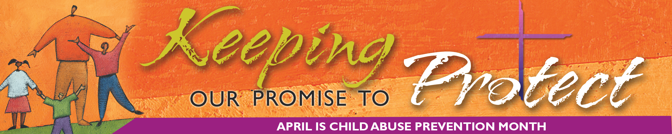
SECRETARIAT of Child and Youth Protection • United States Conference of Catholic Bishops
Preventing and Identifying Child Sexual Abuse

By John Gehring

Safe environment coordinators, researchers, and psychologists agree there is no definitive profile of a child sexual abuser. Instead, these experts speak about patterns of behavior, or “red flags,” that should alert adults that a young person may be in an abusive situation.
“If you start looking for a typical abuser in your mind, you are going to miss a lot of people,” said Paul Duckro, the director of the Office of Child, Adolescent, and Adult Protection in the Diocese of Tucson, Arizona. “Your net will have a lot of holes in it.”
A former medical school professor who specializes in the behavioral aspects of illness, Duckro said that people who are unusually secretive, shun supervision, or demand special rules that do not apply to others should raise concerns.
Sexually inappropriate behavior with a child often begins with a process psychologists call “grooming”—often subtle actions that can make children feel special, protected, and comfortable in situations that may lead to more deviant activities.
An adult could be grooming a potential victim, for example, when he or she frequently singles a child out for special gifts or looks for opportunities to be alone with a child. Abusers often attempt to view pornography or use alcohol with children to create intimacy and trust. While abusers cannot be easily classified and will demonstrate a range of personality types, Duckro pointed to a common characteristic they do share.
“Narcissism is a concern, with my needs at the exclusion of yours,” he said. “There is no empathy for other people or their needs.”
Msgr. Stephen Rossetti, the president and chief executive officer of St. Luke Institute, a Silver Spring, Maryland, residential treatment center for priests and religious who have psychological problems, believes the media has presented a caricatured view of abusers.
“The media has reinforced stereotypes like the ‘dirty old man’ when in reality there are many kinds of offenders,” said Msgr. Rossetti, a licensed psychologist. Despite their differences, he said, abusers do generally fit into subtypes that include the compulsively sexual person, the narcissist who uses others for pleasure, and the dependent person who is emotionally immature.
“Red flags” include adults who do not respect a child’s physical or emotional boundaries, lack peer relations, exhibit extremes in sexual experiences, show confusion about their sexual orientation, or have a personal history of childhood sexual abuse. He was quick to note, however, that most adults who have been abused as children do not grow up to be abusers.
Msgr. Rossetti believes the Catholic Church has come a long way in addressing sexual abuse and points to the Charter for the Protection of Children and Young People.
“Right now the Catholic Church has one of the strongest anti-abuse policies of any organization in the country,” he said. “But one case of abuse is always too many.”
Karen Terry, an associate professor at the John Jay College of Criminal Justice, the City University of New York, said there are several biological and psychological theories for why adults sexually abuse children.
“The most important point is that abusers constitute a heterogeneous population of individuals who begin abusing for a variety of reasons,” she said. “In addition, there is no clear ‘best practice’ as to how to treat or manage abusers, largely because the treatment and management plans should be tailored to their specific needs and risks. The best that I can recommend for prevention of child sexual abuse is education.”
# # #

