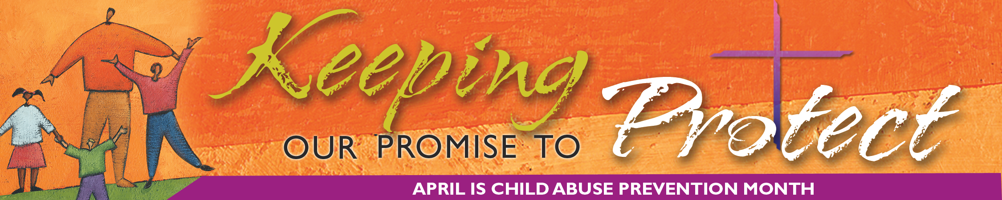

Growth in Transparency Marks Church

By Joe Towalski

William Gavin knows the skeptics are still out there.
The head of the Gavin Group, which has conducted annual audits of U.S. dioceses since the bishops passed their Charter for the Protection of Children and Young People in 2002, acknowledges that a little skepticism is a good thing when it comes to monitoring compliance to programs designed to prevent child sex abuse.
But, Gavin added, the time has come for doubters to acknowledge that the Church has made considerable progress on the issue.
“The Catholic bishops are the only group in the United States that has stood up and said, ‘OK, here’s our problem,’” Gavin said. “Maybe they were pushed into it a little in the beginning, but they’ve embraced it, and now they’re driving it because it’s the right thing to do. I think that’s part of what the church should be about.”
Gavin and others who have worked closely with the church during the last several years say it is making strides to be more transparent and accountable.
In addition to the Charter, for example, the bishops established a National Review Board of lay people to independently monitor how their child safety policies are implemented. The board commissioned a study, first published in 2004, documenting the nature and scope of the sexual abuse crisis. A further study will focus on the causes and contexts of the crisis.
Yearly reports of Charter compliance based on the audits, coupled with annual reports from the Center for Applied Research in the Apostolate (CARA) at Georgetown University regarding the number of old and new abuse cases, have “proven to be an excellent example of transparency,” said Kathleen McChesney, former executive director of the bishops’ Secretariat of Child and Youth Protection.
In addition to the national figures, dioceses that publish more detailed local reports about abuse cases “are extremely important to this initiative,” said McChesney, who is also a former executive assistant director of the Federal Bureau of Investigation. “Those bishops who are open and transparent about allegations . . . are admired for their candor and have obviously gained or regained the trust of the laity.”
Gavin said the church has come to see organizations like his as an ally, not an enemy, in the common cause of making the church a safer place.
“The people in the pews now also understand in a broader fashion what it is the church really does,” he said. “A lot of people received the sacraments and attended Mass, and that was about as much as they knew about their church. Now they understand codes of conduct, and they understand how to report child abuse cases, and they understand a whole lot more about their church. I think [the church] is becoming more participatory.”
One way Catholics have become more participatory is through mandatory diocesan programs that help to train and educate children and adults—from bishops to lay volunteers—in creating and maintaining safe environments.
“I think this has been a learning process for all of us in the church—first of all simply to have become aware of the signs and signals of abuse,” said Bishop William Skylstad of Spokane, Washington, president of the United States Conference of Catholic Bishops (USCCB) from 2004 to 2007.
“We’re far more astute now than we were, say 15 or 20 years ago,” he said. “I think across the board we’ve learned that sexual abuse of children occurs not only in the church, but everywhere, and that’s really important. I think that people are now better prepared to spot abuse and to provide a safe environment.”
The church also is working to make further improvements in the area of child safety, Gavin said. Compliance auditors who ask questions of bishops and other church officials are also being sent into parishes to ask questions and verify information, Gavin said.
“More and more I’m hearing bishops and their staffs say, ‘We have a program whereby we go out and audit parishes,’” he added. “I couldn’t be more thrilled with that. That’s exactly the way we have to go.”
# # #

