Enrollment Forms
Each Enrollment Form must be completely filled out and must include:
- Date of Employee participation, for example, 9/1/19 or whatever date participation is to start.
- Date of Hire (can include date with other Diocesan Employers).
- Date of Birth (must be on the form).
- Beneficiary Form must be completed.
- Print or type the Employer’s Name with City and Address on the top of each form. (MassMutual will need to know whose employees are enrolled).
MassMutual requires the above information so that they may assist in the determination as to possible regulatory catch up provision calculations.
On these Enrollment and Beneficiary Forms, cross out this wording “Plan Administrator Signature” and replace wording with “Employer Signature” and sign.
If your employees have questions in filling out these forms, contact:
MassMutual Financial Services Participation Information Center Contract Code 61183 1-800-743-5274
Each Parish, Agency or School is to send completed enrollment forms to:
Lori Ensom
Diocese of Worcester 49 Elm Street
Worcester, MA 01609
Keep a copy of the completed forms for your Files (Forms not completely filled out will be returned)

Employer Information about Non-MassMutual Accounts
Employees can obtain assistance from MassMutual Financial Services Consultants in order to get a better understanding of whether to transfer their current 403(b), 401(k), IRA accounts, etc. into a new 403(b) Plan with MassMutual.
Are there surrender fees? If so, what are they? Are they at different amounts or at different maturity time periods? Should I consider transferring all or partial funds without surrender fees to possibility save on former TSA mortality charges, etc.?

How do I find out Information on Non-MassMutual Accounts?
Fill out the MassMutual Financial Services Roll-In Consultant Form and fax your information to the number on the form attention of Mass Mutual Contact Code 61183 or call the Rollover Information Line at 1-800-743-5274. The contract code is 61183. MassMutual will be in contact with you to assist you in contacting your former TSA carrier so you can obtain information so you may be informed in order to consider your plan of action.

Notice of Weekly, Semi-Monthly, Monthly, Etc. 403(b) Payroll Deductions
ADMIN Partners is our 3rd Party Administrator who will be working with MassMutual and you, our Parish/Agency/School Bookkeepers and Accountants, to assist in the coordination of the Employee payroll deductions and fund transmittal process.

ADMIN Partners will be notified each payroll period through their computer generated template with information on each person and amount deducted and transmitted for the 403(b) that pay period.

Once you have entered the data into the Excel file please be sure your file name includes your Parish/Agency or School name and city along with the payroll date. Example:
StEdmund-Worcester-06302019.xlsx Do not use any special characters besides a hyphen.

Here is a direct link to use to upload your files. https://www3.mydocsonline.com/cuploadcustom.aspx?id=youradminpartners

The identifying information you must provide when you submit your file is:
- Name: Enter your full name.
- Email address: Enter your email address. [You can Click the Remember Me button if you wish].
- Name of Diocese: Enter Diocese of Worcester.
- Name of Church/School: Enter the name of your location.
- City of Church/School: Enter the city of your location:
- Click the “I am not a robot button”
- Click on the “Next” button. A new window will open allowing you to find and select the file you wish to send.

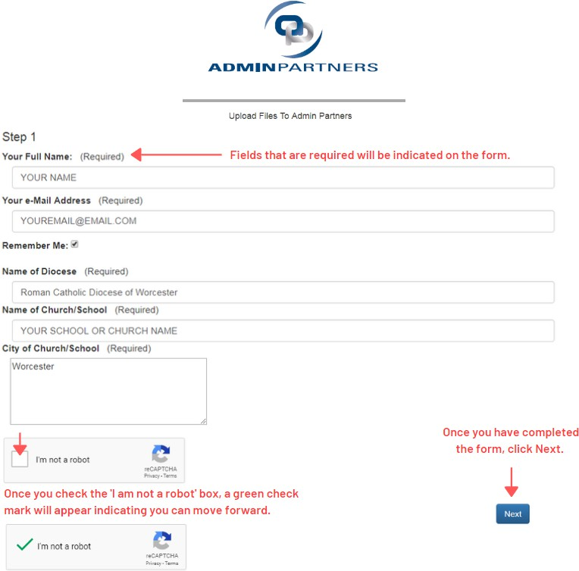

- Click on “Choose File” button to open a window in your computer. Select the file you wish to upload. The file you selected is displayed in green on the top right section of your screen.
Alternatively, you can “drop” a file by highlighting the desired file from, then holding the left mouse button and dragging it to the Drop Files Here box. If you made any errors on the first screen, you can select the “Cancel” button on the bottom left of the screen to start over. This must be done before you upload a file. If you want to stop the process after uploading a file to the page, simply close out window of the upload page.
- Click the “Done” button to complete the process.

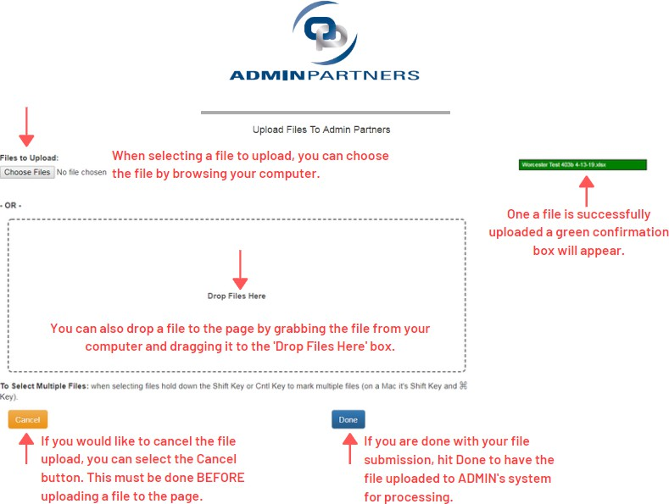
- You will receive a confirmation screen and an email confirming the file has been successfully uploaded for your records.
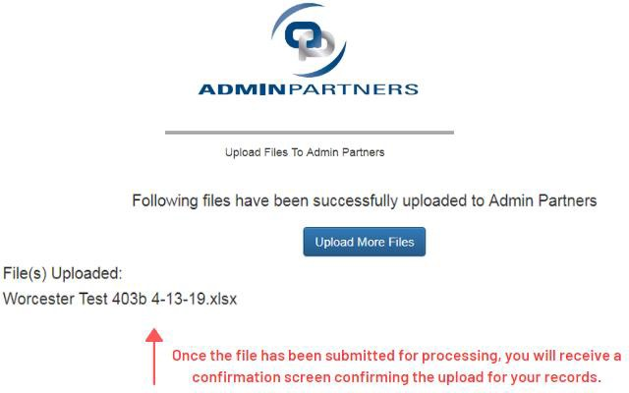

Q. Who is the point of contact at ADMIN Partners if I have any questions or issues?
Alison Ryan is the Account Manager for the Diocese. Alison’s contact information is:
Alison Ryan
Diocese of Worcester Account Manager (Direct): (856) 382-3506
Email: service@youradminpartners.com

ADMIN Partners has also assigned a back-up Account Manager, Kathleen Martorelli, to handle Diocese matters when Alison is unavailable. Kathleen’s contact information is:
Kathleen Martorelli
Diocese of Worcester Account Manager (Back-up) (Direct): (856) 382-3511
Email: service@youradminpartners.com

Q. If it is determined that there is data formatting error or a match issue with the contribution file, how will the error be corrected?
When a contribution file is received by ADMIN Partners, technology assistance is used to identify potential data formatting errors like date field formatting, or a blank name field. ADMIN is also reconciling the funds deposited to the total contribution amount indicated in the file. In the event a formatting error is found, or the contribution file data and deposit dollars do not match, ADMIN’s Account Manager will contact you to review the issue. If a correction is necessary, you will be asked to correct the error and resend the contribution file. This process is used to ensure your source file is corrected, so the error is not repeated in subsequent file submissions.

Q. What is the format our contribution file should be in?
Excel worksheet format is:
Agency Number (Column A): The five-digit number associated with your location.
Agency Location (Column B): The name of your location.
Agency City (Column C). The city your location.
Participant Social Security Number (Column D). Text with dashes or special social security format may be used.
Participant Last Name (Column E). Text
Participant First Name (Column F). Text
Pre-Tax Employee Contribution Amount (Column G): numeric DD.CC no commas.
Employer Match Amount (Column H): numeric DD.CC no commas.
Payroll Date (Column I): Date format DD/MM/YYYY
Comment (Column J): Text
Please use the following naming convention when submitting the file: Parish/Agency or School Name (hyphen) city (hyphen) payroll date (DDMMYYYY). Example: StEdmund-Worcester-04302019.xlsx

A few other reminders concerning the file format.
- The file header record should only encompass the first four (4) rows of the Excel spreadsheet.
- Please do not include any other columns or rows in the worksheet beside the required fields.

Q. Where are the funds for the retirement plan sent?
Please include your agency number and payroll date on the memo line of the check, and send to:

Check payable to: RCB of Worcester 403b Plan Mail check to: RCB of Worcester
PO Box 847228
Boston, MA 02284-7228

If you transmit your payroll deductions via ACH transmission, verify the dollar amount matches the contribution file amount. The ACH is sent to the following account/routing number:

Account Number: 7678292767 ABA Number: 2313-72691

Please ensure the information section of the ACH includes: your agency number, Church/School name, and payroll date in the transmittal.

If you have any questions regarding the new file upload process, or the contribution file format, please contact Alison Ryan at ADMIN Partners (877) 484-4400 (Option 1 – and ask for Alison or Kathleen). If you have general questions about the transition, please contact the Diocese Fiscal Office – Paul Schasel at 508- 929-4333 or Lori Ensom at 508-929-4353.

How and where do I send the 403(b) Funds?
Transmittal of Funds by Check
If you transmit your payroll deductions by check, then prepare your check for the exact amount, which you have indicated on your template. Please include the payroll date on the memo line of the check.
Check payable to: RCB of Worcester 403b Plan Mail check to: RCB of Worcester
PO Box 847228
Boston, MA 02284-7228
Please do not send any documentation along with your check and do not pay any other invoices with this check.
Transmittal of Funds by ACH:
If your deductions are currently paid via ACH transmission, set up and send as follows to:
Account Number: 7678292767 ABA Number: 2313-72691
Make sure that your information identifies your Parish/Agency or School name and city in the transmittal to Sovereign Bank.

The funds being transmitted must equal the exact amount that you reported on your template which was transmitted to ADMIN Partners. Excel template and transmitted funds will be matched by ADMIN Partners and only if both types of data match will the funds be swept by MassMutual and posted to participant accounts. Please be mindful that all dates and amounts match as you could be considered late in paying over withheld funds due to the discrepancies.

Example of template

