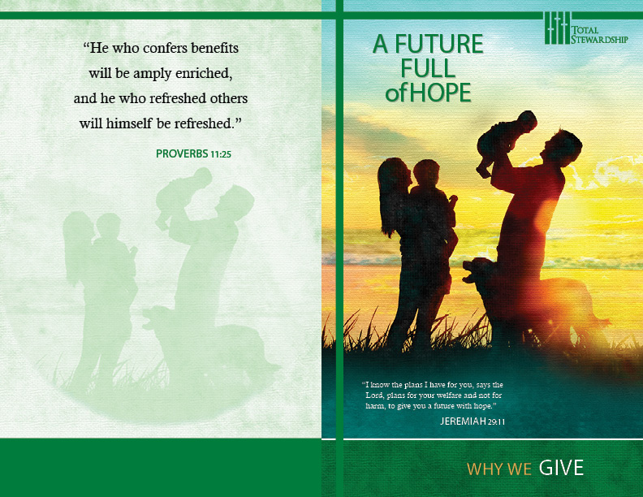

PARISH NAME
ADDRESS
CONTACT


WHY SHOULD WE GIVE?

God’s Plan for His Church Promises A Future Full of Hope
We Are Part of That Plan, and Our Gifts Ensure That Future

God Showed His Love for Us by Giving Us Life in Christ Such a Picture of Sacrificial Love Informs Our Giving

Per Income | 3% | 5% | 6% | 8% | 10%
100.00 | 3.00 | 5.00 | 6.00 | 8.00 | 10.00
200.00 | 6.00 | 10.00 | 12.00 | 16.00 | 20.00
300.00 | 9.00 | 15.00 | 18.00 | 24.00 | 30.00
400.00 | 12.00 | 20.00 | 24.00 | 32.00 | 40.00
500.00 | 15.00 | 25.00 | 30.00 | 40.00 | 50.00
600.00 | 18.00 | 30.00 | 36.00 | 48.00 | 60.00
700.00 | 21.00 | 35.00 | 42.00 | 56.00 | 70.00
800.00 | 24.00 | 40.00 | 48.00 | 64.00 | 80.00
900.00 | 27.00 | 45.00 | 54.00 | 72.00 | 90.00
1000.00 | 30.00 | 50.00 | 60.00 | 80.00 | 100.00
“We love because he first loved us” (1 John 4:19). That boundless love directed our Heavenly Father to offer us the greatest gift: “God so loved the world that he gave his only Son, so that everyone who believes in him might not perish but might have eternal life” (John 3:16). It is a picture that stretches to the earlies days of God’s relation to mankind. Do not “appear before the Lord empty-handed, but each with his own gift, in proportion to the blessing which the Lord, your God, has given to you” (Deuteronomy 16:17). There is no greater gift than the promise of eternal live. May our Gifts model such generosity.

Five giving principles help to frame an informed Stewardship of Finance commitment. Faithful stewards believe that giving is a matter of wise planning. The ongoing needs of a parish budget invite every parishioner to offer a regular percentage of monthly income, too. Personal sacrifice, and the free and generous spirit of a willing heart also echo the biblical model. And then, ultimately, giving is a prayerful response to God’s goodness and mercy.

Again, planning is important. The following chart may be helpful to you as you plan your commitment throughout the year to come. Remember that your generosity will spread the mercy of God throughout our parish, and the Lord will bless you as you give on behalf of Christ and other people.

We Give to Meet the Needs of the Church and of Others
But, Even as We Give, God Chooses to Bless Us, Too
It is God-honoring to give without hesitation, selfishly and sacrificially. However, in God’s grand plan, we also experience the Lord’s blessing when we give to bless others. “Gift and gifts will be given to you; a good measure, packed together, shaken down, and overflowing, will be poured into your lap. For the measure with which you measure will in return be measured out to you” (Luke 6:38). Because we model the gift of God’s Son, we give willingly. It is merely the Almighty’s generous grace that finds us blessed as well.

