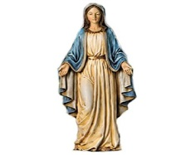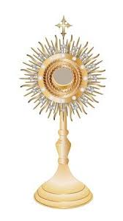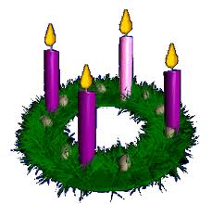v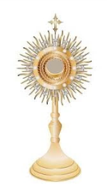

**Just for Adults: (credit given for children if parents attend)**

**Discovering Christ:** Credit given for whole family if either or both parents participate in Discovering Christ as offered by the county at OLL during Sept /Oct.

**Surviving Mass with Children Nov. 6th, 7th or 8th from 6:30—7:30.** Help!! Can we really raise Catholic children if we cannot make it through a Mass with them? Come join this discussion on ways to survive and at the same time feed your own spirituality.  **“I’m Spiritual BUT Not Religious” : Feb 20 OR 21, 2019 from 6:30 —7:30 PM** This very ‘common’ way of describing our journey of faith…. Is it really a way? Join in the discussion on Spirituality and Religion and how they need each other.

**Euthanasia– Difficult Questions for Difficult times: Jan 15 OR 16, 2019 - from 6:30 PM — 7:30 PM** DVD and discussion around this challenging yet relevant topic. (For Adults only please)

**Family Events:**

**Blessing of Animals in Honor of St Francis: Sat Oct 6th.**

Bring your pets for the Blessing of Animals on the 6th at 12 Noon. Write a paragraph on St Francis and his life and grab a photo of you, your pet and Fr. Joe or Fr. Tom to submit for Credit. (The real Feast of St Francis is October 4th)

**—————————————–——————**

**Advent Family Weekend: “Do You Hear What I Hear?”**

**Sunday, December 2nd after the 8:30 Mass (9:30am) - until 12:30 PM**

As we enter cycle C we begin to read Luke’s Gospel each Sunday at Mass. Begin Advent with us as we prepare the way! Perhaps a guest appearance by the real St. Nicholas.... Who knows?

——————————————–————–

**Shrove Tuesday: March 5, 2019 Pancakes and Lent to GO!**

Support our teens at their annual Shrove Tuesday Pancake supper and get your Family Lent ‘to go’ kit!

**Holy Thursday Pot Luck and Mass: April 18th - 5:30 PM**

Gather at a table with your family and then to Church with our Church family. This is the night we celebrate Jesus instituting the Eucharist.

**\*\* Please be sure to follow email information for the most up to date notices on Family Passport offerings.**

**O Come Let Us Adore Him—Family Adoration**

Pick up a Kit from us- Do the ‘At Home Before’ work and take the Family on Thursday anytime up until 7 PM to visit and pray with Jesus present in the Blessed Sacrament at Church for a minimum of 30 minutes. The Blessed Sacrament is exposed on Thursdays following 7 AM Mass—all day until Benediction at 7:30 PM. Complete the reflection and turn in to us!

**“Welcome to Our House Blessed Mother” :**

Take one of our Marian kits home for a week- Set up your Family Marian Shrine. Pray the rosary as a Family and report your experience to us on the forms provided.