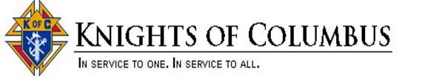
St. Michael the Archangel - KoC 12577

>>>>>> Request for Help <<<<<<
This Form is to be used for all requests for help, financial contributions or assistance/manpower for any activity. The Form must be filled out TWO WEEKS in ADVANCE of any event or need.
Please send this finalized Form to: GrandKnight@stmichaelcp.org.
Website for this Form is: https://stmichaelcp.org/knights-of-columbus

Submitter Information:
Name: < First and Last name >
Phone / Mobile: < Mobile? Office? >
Email: < email address >

Description of Event: < Please provide a description of the event in detail >

Where: < Please provide a description of the location of the event or need. At St Michael’s? After Mass? In the Parish Hall – Fr Porter Hall? Offsite? Transportation required?>

When: < Description of when this event takes place.>
- Details – After Mass? Weekend work?
- Details – Financial contribution only?
- Details – in conjunction with another team or event at St Michaels?

How: < Give a good description of what the Knights need to do for this event. The work involved.>
- Just show up at a specific time and work? Cooking?
- Work with a Parish staff member?
- Financial contribution in what amount and why?
- Other…?

Time Commitment: < Please give a good description of exactly how much time is required. >
- Details – your best guess on this event needs to be for Knights
- Details – running / ongoing event over several occasions?

Knowledgeable Contacts in addition to Submitter of request:
- Contact #2
- Contact #3

Thank you very much for providing this information in advance of the event. We will be in contact with you soon.

