Our Lady of Refuge Home, Viengkuk

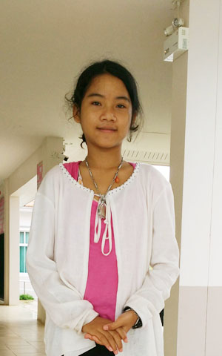
Nickname: | Aorn
Sex: | Female
Birth Place: | Phetchabun
Religion: | Buddhist
Arrival Date: | July 12, 2017

Family History and General Information

Aorn was living with her parents and she has a 4 year old sister. Her parents split up and her mother met her new husband on Facebook. Her mother went to live with him in Rayong – near Bangkok leaving the children with Aorn’s grand parents. Her grandparents work in construction driving a truck and travel around to find work. In the school holidays in March Aorn and her sister went to stay with her mother and stepfather. Then Aorn’s grandparents bought the family to stay with them in Nongkhai. The grandmother noticed Aorn was sad and quiet and discovered that her stepfather was abusing her. She immediately went to the police and social services and eventually the stepfather was arrested and is in jail. Aorn was given to Sarnelli House by the social services. Aorn has just turned 13 years old this month and will stay at Our Lady of Refuge Home for girls and study in M1 or grade 7 with the other girls.

