St. Mary of the Assumption Roman Catholic Church
210 W. Main St. Manchester, Mi 48158
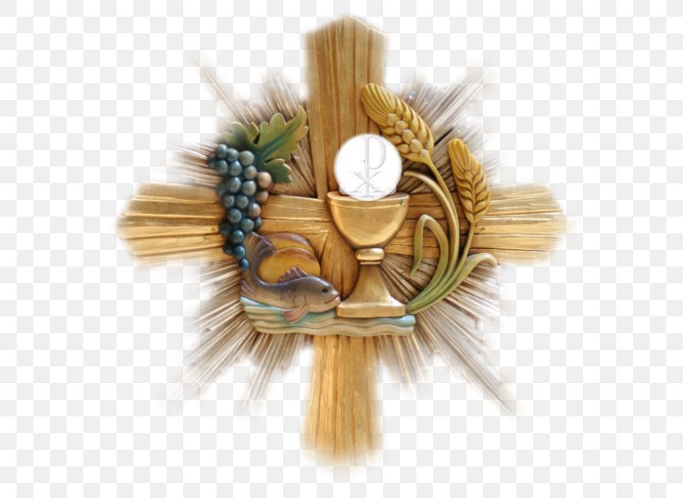

1st Reconciliation and 1st Communion
We traditionally begin preparation for First Reconciliation and First Communion in 1st Grade and the children receive the Sacrament in 2nd Grade through the Catechesis of the Good Shepherd presentations and materials. The Sacramental Preparation sessions meet weekly on Mondays at 3:30pm. This preparation provides the opportunity for the children “to understand the mystery of Christ according to their capacity and receive the Body of the Lord with faith and devotion” [Canon 913]. We begin our sessions in September after Labor Day.
Please complete the online Registration Form. Once registered you will receive a welcome email with dates/times for meetings and annual retreat as well as the dates and times of the Sacraments.
Blessings on the Journey,

Lori Feiler, Director of Religious Education
Stmarymanchester.dre@gmail.com

