For Commitment Weekend (March 1/2, 2025) and Follow-up Weekend (March 8/9, 2025)
Prayer of the Faithful
May we all join in prayer to support this year’s Annual Catholic Appeal and all the ministries it funds in the Diocese of Madison. Let us come together with hearts filled with gratitude, love, and the knowledge that “Hope Does Not Disappoint” … We pray to the Lord.
Bulletin Announcement
You may wish to use the Annual Appeal logo to call attention to the bulletin announcement. If so, you can obtain a copy of the logo by going to: www.madisondiocese.org/appeal-materials

Diocese of Madison

Annual Catholic Appeal 2025

“Hope Does Not Disappoint”

“Hope Does Not Disappoint,” is inspired by Romans 5:5, which reminds us that God’s love has been poured into our hearts through the Holy Spirit. In Jeremiah 29:11, we are assured, “For I know the plans I have for you,” declares the Lord, “plans to prosper you and not to harm you, plans to give you hope and a future.” These scriptures remind us that our hope in God is never in vain.
Each pledge to the Annual Catholic Appeal supports the many programs, resources and services that the Diocese sponsors, enabling us to share the transformative power of Christ’s love with those who are lost, forgotten, or in need. During this Year of Jubilee, we are called to reflect on God’s abundant grace, celebrate the gift of forgiveness, and shine Christ's light in the world through acts of charity and service.
Please prayerfully consider joining the Perpetual Steward Society by making a continuous monthly gift of any amount. Or consider making a pledge, payable over six months. Your gift will help enable our parish and the diocese to reach its goal and provide to the ministries supported by the appeal.
If you received your pledge form in the mail, please complete it and mail it back.
Thank you for your prayerful consideration and generous response.
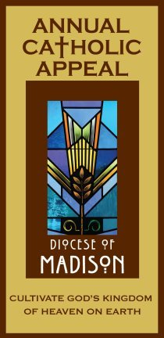

Altar Announcement
Please prepare an altar announcement encouraging a generous response to the bishop’s letter by making a pledge for six monthly payments or by joining the Perpetual Steward Society with a continuous monthly gift of any amount. Additionally, ask people to read the bulletin announcement.

