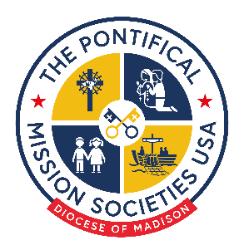
Missionary Cooperative Plan
Diocese of Madison
Best Practices

- Be Concise: Talks should last no more than 15 minutes. If incorporated into the homily, the talk and homily combined should last no longer than 15 minutes.

- Be Clear: Many pastors ask, “Will our parishioners be able to understand the person conducting the talk?” If the speaker cannot be understood, many people will simply tune them out. If this could occur, consider how you can communicate with the parishioners to keep them engaged. Do you have handouts? Is there some sort of video, if applicable in the parish, that could be shown? Check with the pastor at each parish you are speaking at to determine the best outcome.

- Don’t Beg: Begging or making the people in the pews feel guilty is not the best way to gain their support. Instead, use examples of the successes attributed to mission talks and explain how these relate to our faith expressions as Catholics.

- Relate to Scripture: Do your best to relate your talk to the Scripture of the day. Sometimes this can be challenging, but if it is incorporated with the homily, it is important to do.

- Perception vs. Reality: Provide a contrast of the American perception of your area versus the reality. For example: when we think of the Dominican Republic, many people think of the resorts of Punta Cana, but in reality most of the Dominican Republic lives in poverty.

- Give Examples: Tell what various amount will buy: $10 buys rice and beans for a family for one week; $40 feeds a family for one money; $100 provides medicine for people coming to a medical clinic for care.

- Charity is a Spiritual Decision: Remind parishioners that “giving” for Americans is not so much a financial decision (we have what we need), but rather a spiritual decision. Try to include a ling from Pope Francis’ care and support of the poor as part of our spiritual lives, or tie in how supporting the mission is a concrete way for the people in the pews to live out their missionary vocation.
Do not hesitate to contact our office if you have any questions or would like to speak with someone about your presentation. You can reach us at tpms@madisondiocese.org.

